INDEX

|  |  |  |  |  |
| --- | --- | --- | --- | --- |
| **SR NO** | **NAME OF THE EXPERIMENT** | **DATE** | **FACULTY SIGN** | **CO** |
| **1** | **Introduction to Android Application Components and UI Controls:**   1. Write a program to demonstrate activity life cycle. 2. Create an Employee Registration form using Linear Layout and Relative Layout. 3. Design a screen that displays the frame image and write a quote on that. 4. Create an android application that displays an image using frame layout and when the user clicks on that image another image should be displayed on the screen. 5. Create an android application to add two numbers and display result in Toast Message and AlertDialog. 6. Create an Android application for the student registration form using the relative layout. Display the entered details on the second page using explicit intent. 7. Create an application to implement implicit intent with functionality to open camera, Gallery, Contact, Dial, Browser. 8. Create an application which has two buttons. When the user clicks on the first button the first fragment will be displayed and when the user clicks on the second button the second fragment will be displayed. 9. Write an Android application with five check boxes to list the 5 subjects of your class and radio buttons to display gender. Display the selected subject name when you click any one of the checkboxes and gender in the alert dialog box. 10. Create a basic calculator to perform arithmetic operations with divide-by-zero validation. (using Alert box). 11. Create an Android application to demonstrate List View using an array adapter. 12. Create a mobile application for a currency converter. Use a spinner for selecting the currency. 13. Write an application to increase font size using seekbar. 14. Create an Android application to demonstrate progressbar. |  |  | **CO1** |

|  |  |  |  |  |
| --- | --- | --- | --- | --- |
| **2** | **Database Connectivity:**   1. Create an Android application to read and write content in internal storage. 2. Create an Android application to read and write content in external storage. 3. Write an android program for shared preference to store value in name-value pairs. 4. Create a login form with a remember me checkbox. Save the username and password if the checkbox is checked using shared preference and show the welcome page when the login button is clicked. 5. Create an Android application to insert, update, select, and delete records from the student table using SQLite Database. 6. Write a program to create a user registration form, after registration data will be inserted in the SQLite database, and design an activity that displays that information. 7. Android Program to perform CRUD operation using real time database Firebase. |  |  | **CO2** |
| **3** | **Animation, Multimedia and Location Based Services:**   1. Write an Android application to play, pause, and stop an audio file. 2. Write an Android application to play a video with Media controller. 3. Create an android application that applies different animations on an image. 4. Create an Android application to implement frame animation. 5. Create an Android application to display the current location of your device (display longitude and latitude values). 6. Create an Android application that displays the current location of your device from longitude and latitude values (Reverse Geocoding). 7. Create an Android application that accepts longitude and latitude from the user and marks that location on google map. |  |  | **CO3** |
| **4** | **REST API integration:**   1. Create an Android application to demonstrate JSON data parsing using OkHttp (you can use https://api.github.com/users JSON data). 2. Create an Android application to demonstrate JSON data parsing using Volley (you can use https://api.github.com/users JSON data). |  |  | **CO4** |

|  |  |  |  |  |
| --- | --- | --- | --- | --- |
|  | 3. Create an Android application to demonstrate JSON data parsing using Retrofit (you can use https://api.github.com/users JSON data). |  |  |  |
| **5** | **Introduction to Dart and Flutter:**   1. Write a Flutter program to demonstrate Text widget and its properties. 2. Write a Flutter program to display dog names (demonstrate stateless widget and column widgets). 3. Write a Flutter program that allows the user to enter a city in a text field and displays city name (demonstrate stateful widget). 4. Write a Flutter program to change the background color (demonstrate stateful widget). 5. Write a Flutter Program to display fruit list using ListView. 6. Write a Flutter program to demonstrate navigation (user should be navigated from first screen to second screen). 7. Write a Flutter program to design a Login form using TextField, Check Box, Buttons, Drop down, Switch etc.. |  |  | **CO5** |
| **6** | **Data Handling in Flutter:**   1. Write a Flutter program based on RestAPI to fetch data. 2. Write a flutter program to demonstrate JSON serialization and Deserialization. 3. Write a flutter program to perform CRUD operations using sqflite. |  |  | **CO6** |

**Module 1:**

**Introduction to Android Application Components and UI Controls:**

1. **Write a program to demonstrate activity life cycle.**

## MainActivity.java:

package com.example.myapplication; import android.os.Bundle;

import androidx.activity.EdgeToEdge;

import androidx.appcompat.app.AppCompatActivity; import androidx.core.graphics.Insets;

import androidx.core.view.ViewCompat;

import androidx.core.view.WindowInsetsCompat; import android.os.Bundle;

import android.util.Log; import android.widget.Toast;

public class MainActivity extends AppCompatActivity { @Override

protected void onCreate(Bundle savedInstanceState) { super.onCreate(savedInstanceState); setContentView(R.layout.*activity_main*); Log.*d*("lifecycle", "onCreate invoked");

Toast.*makeText*(getApplicationContext(), "onCreate invoked", Toast.*LENGTH_LONG*).show();

}

@Override

protected void onStart() { super.onStart();

Log.*d*("lifecycle", "onStart invoked");

Toast.*makeText*(getApplicationContext(), "onStart invoked", Toast.*LENGTH_LONG*).show();

}

@Override

protected void onResume() { super.onResume();

Log.*d*("lifecycle", "onResume invoked"); Toast.*makeText*(getApplicationContext(), "onResume invoked",

Toast.*LENGTH_LONG*).show();

}

@Override

protected void onPause() { super.onPause();

Log.*d*("lifecycle", "onPause invoked");

Toast.*makeText*(getApplicationContext(), "onPause invoked", Toast.*LENGTH_LONG*).show();

}

@Override

protected void onStop() { super.onStop();

Log.*d*("lifecycle", "onStop invoked");

Toast.*makeText*(getApplicationContext(), "onStop invoked", Toast.*LENGTH_LONG*).show();

}

@Override

protected void onRestart() { super.onRestart();

Log.*d*("lifecycle", "onRestart invoked"); Toast.*makeText*(getApplicationContext(), "onRestart invoked",

Toast.*LENGTH_LONG*).show();

}

@Override

protected void onDestroy() { super.onDestroy();

Log.*d*("lifecycle", "onDestroy invoked"); Toast.*makeText*(getApplicationContext(), "onDestroy invoked",

Toast.*LENGTH_LONG*).show();

}

}

**Output:**

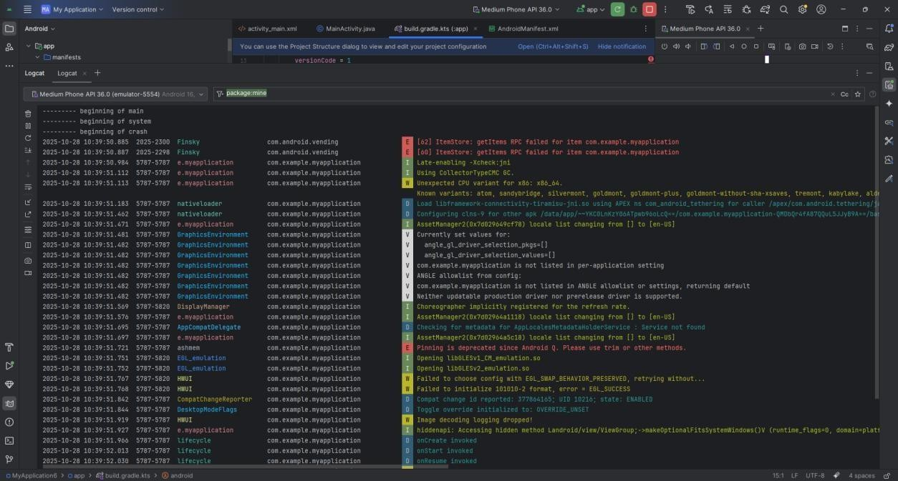

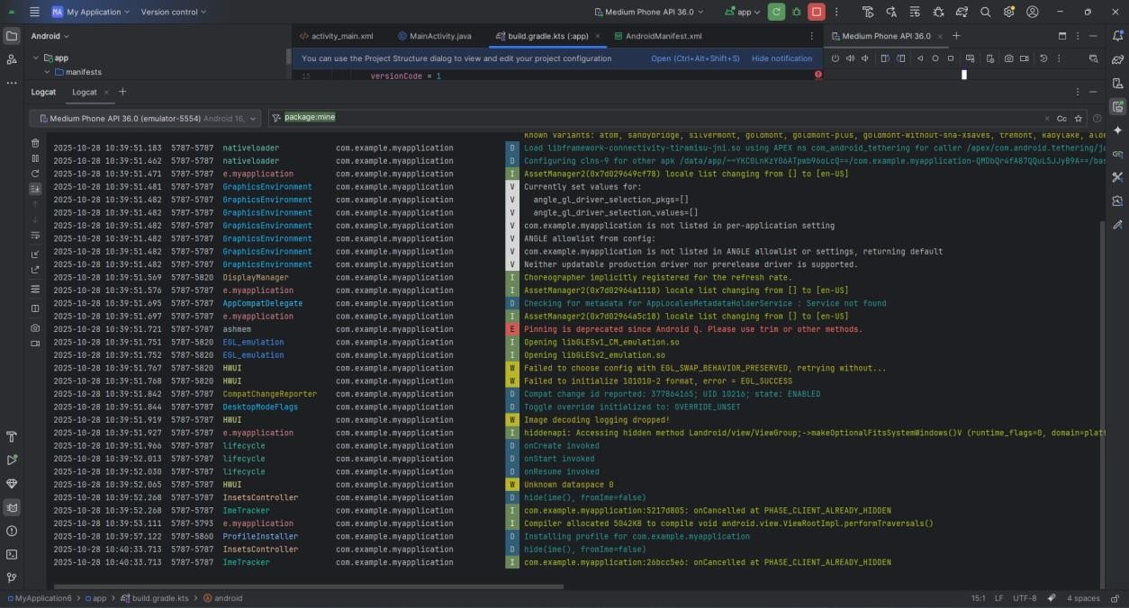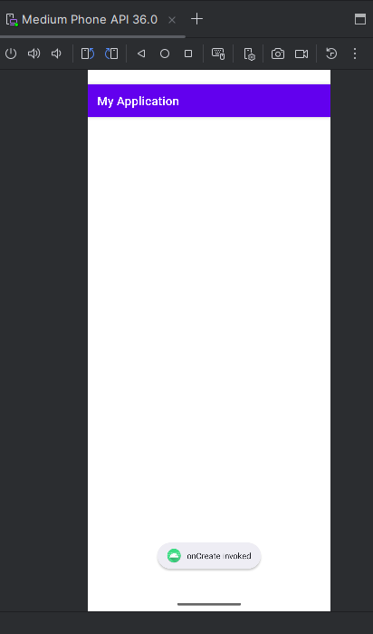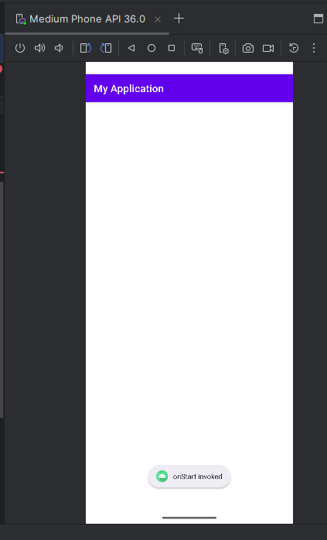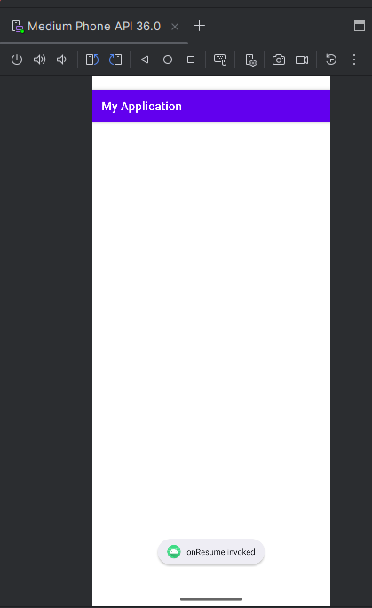

1. **Create an Employee Registration form using Linear Layout and Relative Layout.**

**activity_main.xml:**

<?xml version="1.0" encoding="utf-8"?>

<LinearLayout xmlns:android=["http://schemas.android.com/apk/res/android"](http://schemas.android.com/apk/res/android) xmlns:app=["http://schemas.android.com/apk/res-auto"](http://schemas.android.com/apk/res-auto) xmlns:t[ools="http://schemas.android.com/tools"](http://schemas.android.com/tools)

android:id="@+id/main" android:layout_width="match_parent" android:layout_height="match_parent" android:orientation="vertical" tools:context=".MainActivity">

<TextView android:id="@+id/tvHeader" android:layout_width="wrap_content" android:layout_height="wrap_content" android:text="Employee Registration" android:textSize="24sp" android:textStyle="bold" android:layout_gravity="center" android:paddingBottom="16dp"/>

<RelativeLayout android:layout_width="match_parent" android:layout_height="wrap_content" android:layout_marginBottom="16dp">

<EditText android:id="@+id/etEmployeeId" android:layout_width="match_parent" android:layout_height="wrap_content" android:layout_alignParentEnd="true" android:layout_marginStart="16dp" android:hint="Enter Employee ID" android:minHeight="48dp" android:inputType="text" />

<EditText android:id="@+id/etName"

android:layout_width="match_parent" android:layout_height="wrap_content" android:layout_below="@id/etEmployeeId" android:layout_alignParentEnd="true" android:layout_marginStart="16dp" android:hint="Enter Name" android:inputType="textPersonName" android:minHeight="48dp" />

<EditText android:id="@+id/etDepartment" android:layout_width="match_parent" android:layout_height="wrap_content" android:layout_alignParentEnd="true" android:layout_marginStart="16dp" android:layout_below="@id/etName" android:hint="Enter Department"

android:inputType="text" android:minHeight="48dp" />

<EditText android:id="@+id/etEmail" android:layout_width="match_parent" android:layout_height="wrap_content" android:layout_alignParentEnd="true" android:layout_marginStart="16dp" android:layout_below="@id/etDepartment" android:hint="Enter Email" android:inputType="textEmailAddress" android:minHeight="48dp" />

<EditText android:id="@+id/etPhone"

android:layout_width="match_parent" android:layout_height="wrap_content" android:layout_alignParentEnd="true" android:layout_marginStart="16dp" android:layout_below="@id/etEmail" android:hint="Enter Phone Number" android:inputType="phone" android:minHeight="48dp" />

</RelativeLayout>

<TextView android:id="@+id/tvgender"

android:layout_width="wrap_content" android:layout_height="wrap_content" android:text="Gender" android:layout_marginStart="16dp" android:textSize="20sp" android:textStyle="bold" android:paddingBottom="16dp"/>

<RadioGroup android:id="@+id/group_gender" android:layout_width="wrap_content" android:layout_height="wrap_content" android:layout_marginStart="16dp">

<RadioButton android:id="@+id/radioButton" android:layout_width="wrap_content" android:layout_height="wrap_content" android:layout_marginEnd="20dp" android:text="Male" />

<RadioButton android:id="@+id/radioButton2" android:layout_width="wrap_content" android:layout_height="wrap_content" android:text="Female" android:layout_marginEnd="20dp"/>

<RadioButton android:id="@+id/radioButton3" android:layout_width="wrap_content"

android:layout_height="wrap_content" android:text="Transgender" />

</RadioGroup>

<TextView android:layout_width="wrap_content" android:layout_height="wrap_content" android:text="Hobbies" android:textSize="10pt" android:textStyle="bold" android:id="@+id/TextView2" android:layout_margin="15dp"/>

<RelativeLayout android:layout_width="match_parent" android:layout_height="wrap_content">

<CheckBox android:id="@+id/checkBox" android:layout_width="wrap_content" android:layout_height="wrap_content" android:text="Cricket" android:layout_marginLeft="10dp"/>

<CheckBox android:id="@+id/checkBox2" android:layout_width="wrap_content" android:layout_height="wrap_content" android:text="Dance"

android:layout_toRightOf="@+id/checkBox" android:layout_marginLeft="2dp"/>

<CheckBox android:id="@+id/checkBox3" android:layout_width="wrap_content" android:layout_height="wrap_content" android:text="Football"

android:layout_toRightOf="@+id/checkBox2" android:layout_marginLeft="2dp"/>

</RelativeLayout>

<Button

android:id="@+id/btnSubmit" android:layout_width="wrap_content" android:layout_height="wrap_content" android:layout_gravity="center_horizontal" android:layout_marginTop="20dp" android:background="@color/purple_200" android:minHeight="32dp" android:text="Submit" android:textColor="#311B92" tools:ignore="TouchTargetSizeCheck" />

</LinearLayout>

**MainActivity.java:**

package com.example.myapplication;

import android.content.Intent; import android.os.Bundle; import android.view.View; import android.widget.Button;

import android.widget.CheckBox; import android.widget.EditText; import android.widget.RadioButton; import android.widget.RadioGroup; import android.widget.Toast;

import androidx.activity.EdgeToEdge;

import androidx.appcompat.app.AppCompatActivity; import androidx.core.graphics.Insets;

import androidx.core.view.ViewCompat;

import androidx.core.view.WindowInsetsCompat;

public class MainActivity extends AppCompatActivity { Button submit;

EditText id,phone; RadioGroup gender; @Override

protected void onCreate(Bundle savedInstanceState) { super.onCreate(savedInstanceState);

setContentView(R.layout.activity_main); submit=findViewById(R.id.btnSubmit); id=findViewById(R.id.etEmployeeId); phone=findViewById(R.id.etPhone); gender=findViewById(R.id.group_gender); CheckBox cricket=findViewById(R.id.checkBox); CheckBox dance=findViewById(R.id.checkBox2); CheckBox football=findViewById(R.id.checkBox3);

submit.setOnClickListener(new View.OnClickListener() { @Override

public void onClick(View v) { String result="";

Intent i=new Intent(MainActivity.this, com.example.myapplication.MainActivity2.class);

i.putExtra("id",id.getText().toString()); i.putExtra("phone",phone.getText().toString()); int radioId=gender.getCheckedRadioButtonId(); RadioButton selected=findViewById(radioId); i.putExtra("gender",selected.getText().toString()); if(cricket.isChecked())

result+=" Cricket"; if(dance.isChecked())

result+=" Dance"; if(football.isChecked()) result+=" Football";

i.putExtra("hobbies",result);

Toast.makeText(getApplicationContext(),"Hobbies:"+result,Toast.LENGTH_LONG).sho w();

startActivity(i);

}

});

}

}

**MainActivity2.java:**

package com.example.myapplication;

import android.os.Bundle; import android.widget.TextView;

import androidx.appcompat.app.AlertDialog;

import androidx.appcompat.app.AppCompatActivity;

public class MainActivity2 extends AppCompatActivity { TextView display;

@Override

protected void onCreate(Bundle savedInstanceState) { super.onCreate(savedInstanceState);

setContentView(R.layout.activity_main); display=findViewById(R.id.TextView2); String id=getIntent().getStringExtra("id");

String phone=getIntent().getStringExtra("phone"); String gender=getIntent().getStringExtra("gender"); String hobbies=getIntent().getStringExtra("hobbies");

display.setText("Employee Id: "+id+"\nPhone number: "+ phone+"\nGender: "+gender+"\nhobbies: "+hobbies);

AlertDialog.Builder builder=new AlertDialog.Builder(MainActivity2.this); builder.setCancelable(true);

builder.setMessage("id: "+id+"\nPhone no.: "+phone+"\nGender: "+gender+"\nHobbies: "+hobbies);

builder.setTitle("Employee details"); builder.show();

}

}

**Output:**

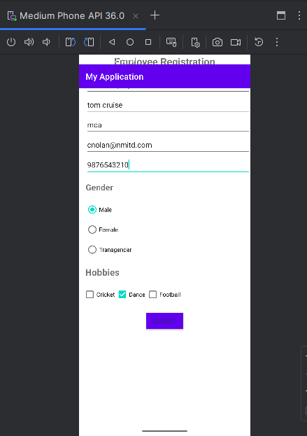

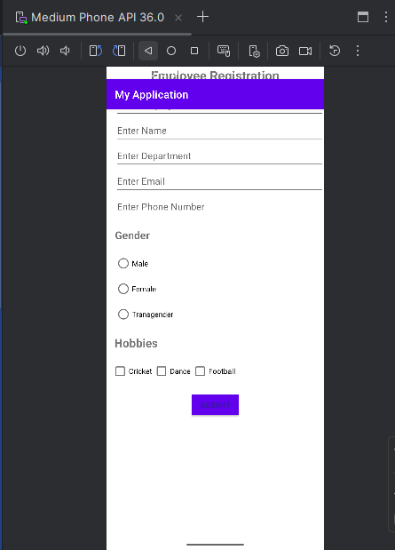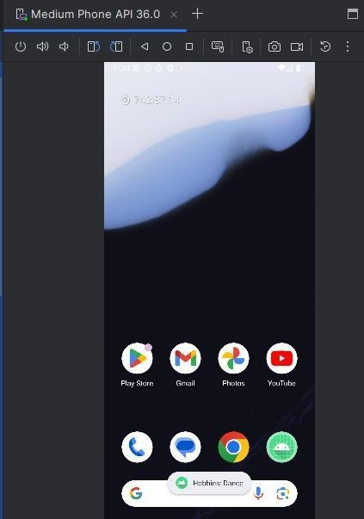

1. **Design a screen that displays the frame image and write a quote on that.**

Activity_main.xml:

<?xml version="1.0" encoding="utf-8"?>

<FrameLayout xmlns:android=["http://schemas.android.com/apk/res/android"](http://schemas.android.com/apk/res/android) xmlns:t[ools="http://schemas.android.com/tools"](http://schemas.android.com/tools)

android:id="@+id/main" android:layout_width="match_parent" android:layout_height="match_parent" android:background="#FFFFFF" tools:context=".MainActivity">

<!-- Frame image as background -->

<ImageView android:id="@+id/frameImage" android:layout_width="match_parent" android:layout_height="match_parent" android:scaleType="centerCrop" android:src="@drawable/lewis" />

<!-- Quote text displayed on top -->

<TextView android:id="@+id/quoteText" android:layout_width="wrap_content" android:layout_height="wrap_content" android:layout_gravity="center"

android:text="“The best way to predict the future is to create it.”"

android:textColor="#FFFFFF" android:textSize="22sp" android:padding="24dp" android:background="#80000000" android:gravity="center" android:textStyle="italic" android:fontFamily="sans-serif-medium" />

</FrameLayout> MainActivity.java:

package com.example.myapplication;

import android.os.Bundle;

import androidx.activity.EdgeToEdge;

import androidx.appcompat.app.AppCompatActivity; import androidx.core.graphics.Insets;

import androidx.core.view.ViewCompat;

import androidx.core.view.WindowInsetsCompat; import androidx.appcompat.app.AppCompatActivity; import android.os.Bundle;

import android.widget.ImageView; import android.widget.TextView;

public class MainActivity extends AppCompatActivity { @Override

protected void onCreate(Bundle savedInstanceState) { super.onCreate(savedInstanceState); setContentView(R.layout.activity_main);

// Reference views (optional, if you want to change them dynamically) ImageView frameImage = findViewById(R.id.frameImage); TextView quoteText = findViewById(R.id.quoteText);

// Optional: change text or image programmatically quoteText.setText("7x world champion!");

// frameImage.setImageResource(R.drawable.another_frame); // Example if you want to swap the image

}

}

**Output:**

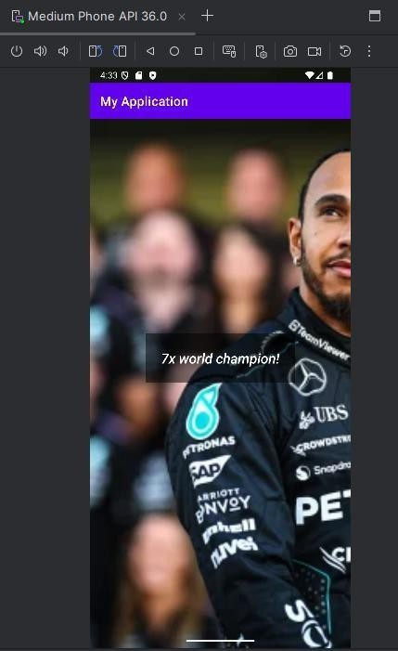

1. **Create an android application that displays an image using frame layout and when the user clicks on that image another image should be displayed on the screen.**

Activity_main.xml:

plugins { alias(libs.plugins.android.application)

}

android {

namespace = "com.example.myapplication" compileSdk = 36 // ⬛ updated from 35 → 36

defaultConfig {

applicationId = "com.example.myapplication" minSdk = 24

targetSdk = 36 // ⬛ updated from 35 → 36 versionCode = 1

versionName = "1.0"

testInstrumentationRunner = "androidx.test.runner.AndroidJUnitRunner"

}

buildTypes { release {

isMinifyEnabled = false proguardFiles(

getDefaultProguardFile("proguard-android-optimize.txt"), "proguard-rules.pro"

)

}

}

compileOptions {

// ⬛ Use Java 17 (recommended for new Android Gradle Plugin versions) sourceCompatibility = JavaVersion.VERSION_17

targetCompatibility = JavaVersion.VERSION_17

}

}

dependencies { implementation(libs.appcompat) implementation(libs.material) implementation(libs.activity) implementation(libs.constraintlayout)

testImplementation(libs.junit) androidTestImplementation(libs.ext.junit) androidTestImplementation(libs.espresso.core)

}

MainActivity.java:

package com.example.myapplication; import android.os.Bundle;

import androidx.activity.EdgeToEdge;

import androidx.appcompat.app.AppCompatActivity; import androidx.core.graphics.Insets;

import androidx.core.view.ViewCompat;

import androidx.core.view.WindowInsetsCompat; import androidx.appcompat.app.AppCompatActivity;

import android.os.Bundle; import android.view.View;

import android.widget.ImageView;

public class MainActivity extends AppCompatActivity { ImageView image1, image2;

@Override

protected void onCreate(Bundle savedInstanceState) { super.onCreate(savedInstanceState); setContentView(R.layout.activity_main);

image1 = findViewById(R.id.imageView1); image2 = findViewById(R.id.imageView2);

//Set OnClickListener using anonymous class: image1.setOnClickListener(new View.OnClickListener() {

@Override

public void onClick(View view) { image1.setVisibility(View.GONE); image2.setVisibility(View.VISIBLE);

}

});

//Set OnClickListener using anonymous class: image2.setOnClickListener(new View.OnClickListener() {

@Override

public void onClick(View view) { image1.setVisibility(View.VISIBLE); image2.setVisibility(View.GONE);

}

});

}

}

**output:**

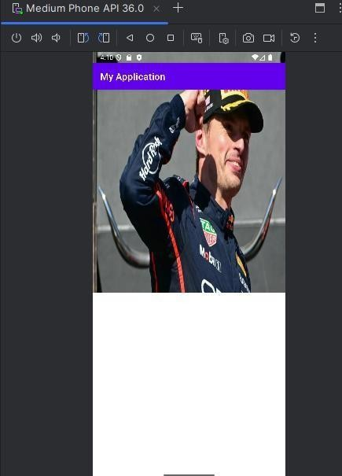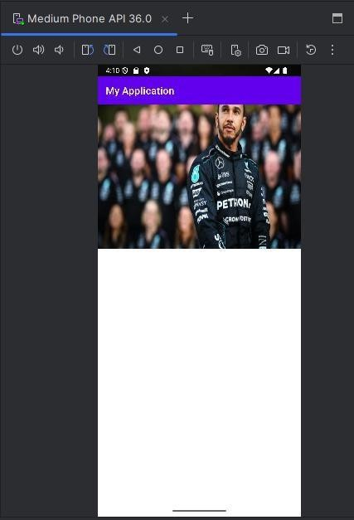

1. **Create an android application to add two numbers and display result in Toast Message and AlertDialog.**

Activity_main.xml:

<?xml version="1.0" encoding="utf-8"?>

<LinearLayout xmlns:andr[oid="http://schemas.android.com/apk/res/android"](http://schemas.android.com/apk/res/android) xmlns:app=["http://schemas.android.com/apk/res-auto"](http://schemas.android.com/apk/res-auto) xmlns:t[ools="http://schemas.android.com/tools"](http://schemas.android.com/tools) android:layout_width="match_parent" android:layout_height="match_parent" android:orientation="vertical" tools:context=".MainActivity">

<EditText android:id="@+id/Num1"

android:layout_width="match_parent" android:layout_height="wrap_content" android:ems="10" android:hint="Enter number 1" android:layout_marginTop="100dp" android:inputType="number" />

<EditText android:id="@+id/Num2"

android:layout_width="match_parent" android:layout_height="wrap_content" android:ems="10" android:hint="Enter number 2" android:inputType="number" />

<Button

android:id="@+id/button" android:layout_width="wrap_content" android:layout_height="wrap_content" android:layout_gravity="center" android:padding="50dp" android:text="Add" />

</LinearLayout> MainActivity.java:

package com.example.myapplication; import android.os.Bundle;

import androidx.activity.EdgeToEdge;

import androidx.appcompat.app.AppCompatActivity; import androidx.core.graphics.Insets;

import androidx.core.view.ViewCompat;

import androidx.core.view.WindowInsetsCompat;

import androidx.appcompat.app.AppCompatActivity; import android.os.Bundle;

import android.view.View; import android.widget.Button; import android.widget.EditText; import android.widget.Toast;

import androidx.appcompat.app.AppCompatActivity; import android.os.Bundle;

import android.view.View; import android.widget.Button; import android.widget.EditText; import android.widget.Toast;

public class MainActivity extends AppCompatActivity {

// UI elements

private EditText number1; private EditText number2; private Button addButton;

@Override

protected void onCreate(Bundle savedInstanceState) { super.onCreate(savedInstanceState); setContentView(R.layout.activity_main);

// Initialize views

number1 = findViewById(R.id.Num1); number2 = findViewById(R.id.Num2); addButton = findViewById(R.id.button);

// Set click listener

addButton.setOnClickListener(new View.OnClickListener() { @Override

public void onClick(View v) {

double num1 = Double.parseDouble(number1.getText().toString()); double num2 = Double.parseDouble(number2.getText().toString()); double sum = num1 + num2;

Toast.makeText( getApplicationContext(), "Addition: " + sum, Toast.LENGTH_LONG

).show();

}

});

}

}

**output:**

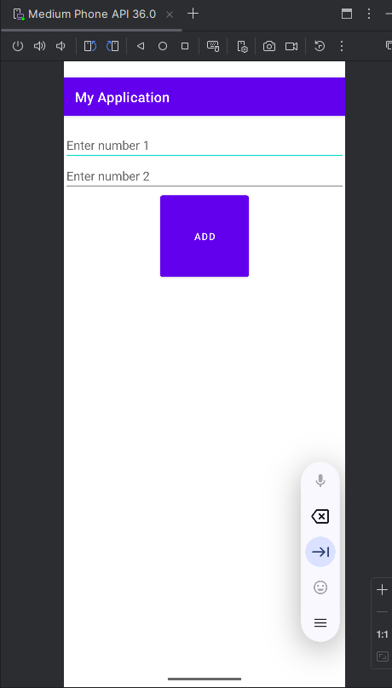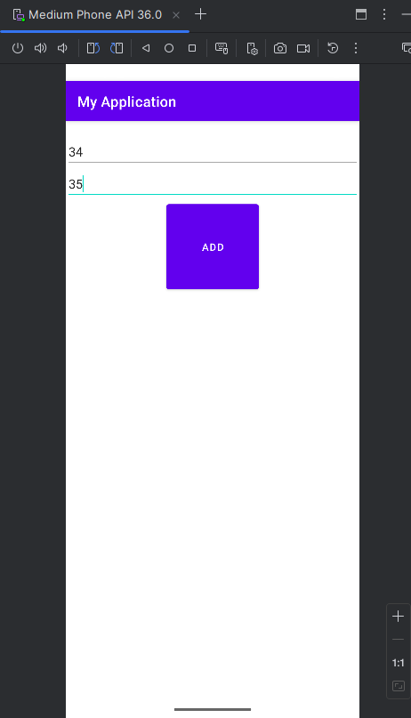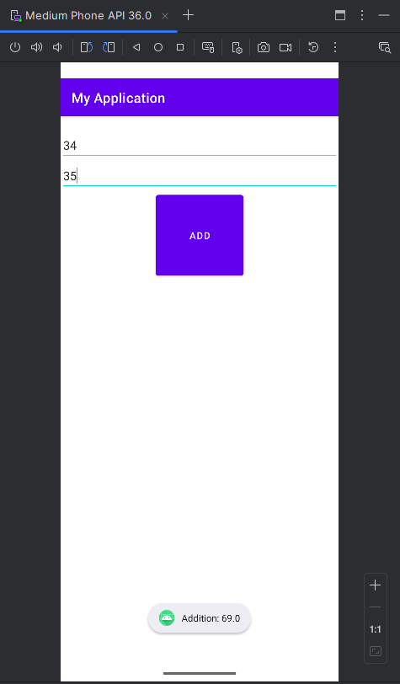

1. **Create an Android application for the student registration form using the relative layout. Display the entered details on the second page using explicit intent.**

MODULE 1 : PRACTICAL 6

activity_main.xml:

<?xml version="1.0" encoding="utf-8"?>

<RelativeLayout xmlns:andr[oid="http://schemas.android.com/apk/res/android"](http://schemas.android.com/apk/res/android) android:id="@+id/main" android:layout_width="match_parent" android:layout_height="match_parent" android:padding="16dp">

<TextView android:id="@+id/tvHeader" android:layout_width="wrap_content"

android:layout_height="wrap_content" android:text="Student Registration" android:textSize="24sp" android:textStyle="bold" android:layout_centerHorizontal="true" android:paddingBottom="24dp"/>

<EditText android:id="@+id/etName"

android:layout_width="match_parent" android:layout_height="wrap_content" android:hint="Enter Name" android:inputType="textPersonName" android:minHeight="48dp" android:layout_below="@id/tvHeader" android:layout_marginTop="16dp"/>

<EditText android:id="@+id/etRollNo"

android:layout_width="match_parent" android:layout_height="wrap_content" android:hint="Enter Roll Number" android:inputType="number" android:minHeight="48dp" android:layout_below="@id/etName" android:layout_marginTop="16dp"/>

<EditText android:id="@+id/etCourse"

android:layout_width="match_parent" android:layout_height="wrap_content" android:hint="Enter Course" android:inputType="text"

android:minHeight="48dp" android:layout_below="@id/etRollNo" android:layout_marginTop="16dp"/>

<Button

android:id="@+id/btnSubmit" android:layout_width="wrap_content" android:layout_height="wrap_content" android:text="Submit" android:layout_below="@id/etCourse" android:layout_centerHorizontal="true" android:layout_marginTop="24dp"/>

</RelativeLayout> activity_main2.xml:

<?xml version="1.0" encoding="utf-8"?>

<RelativeLayout xmlns:andr[oid="http://schemas.android.com/apk/res/android"](http://schemas.android.com/apk/res/android) android:id="@+id/displayLayout" android:layout_width="match_parent" android:layout_height="match_parent" android:padding="16dp">

<TextView android:id="@+id/tvDisplayHeader" android:layout_width="wrap_content" android:layout_height="wrap_content" android:text="Student Details" android:textSize="24sp" android:textStyle="bold" android:layout_centerHorizontal="true" android:paddingBottom="24dp"/>

<TextView android:id="@+id/tvName"

android:layout_width="wrap_content" android:layout_height="wrap_content" android:text="Name:" android:layout_below="@id/tvDisplayHeader" android:textSize="18sp"/>

<TextView android:id="@+id/tvRollNo" android:layout_width="wrap_content"

android:layout_height="wrap_content" android:text="Roll No:" android:layout_below="@id/tvName" android:layout_marginTop="16dp" android:textSize="18sp"/>

<TextView

android:id="@+id/tvCourse" android:layout_width="wrap_content" android:layout_height="wrap_content" android:text="Course:" android:layout_below="@id/tvRollNo" android:layout_marginTop="16dp" android:textSize="18sp"/>

</RelativeLayout> MainActivity.java:

package com.example.myapplication; import android.os.Bundle;

import androidx.activity.EdgeToEdge;

import androidx.appcompat.app.AppCompatActivity; import androidx.core.graphics.Insets;

import androidx.core.view.ViewCompat;

import androidx.core.view.WindowInsetsCompat; import androidx.appcompat.app.AppCompatActivity; import android.content.Intent;

import android.os.Bundle; import android.view.View; import android.widget.Button; import android.widget.EditText;

public class MainActivity extends AppCompatActivity { EditText etName, etRollNo, etCourse;

Button btnSubmit;

@Override

protected void onCreate(Bundle savedInstanceState) { super.onCreate(savedInstanceState); setContentView(R.layout.activity_main);

etName = findViewById(R.id.etName); etRollNo = findViewById(R.id.etRollNo); etCourse = findViewById(R.id.etCourse); btnSubmit = findViewById(R.id.btnSubmit);

btnSubmit.setOnClickListener(new View.OnClickListener() { @Override

public void onClick(View view) {

String name = etName.getText().toString(); String rollNo = etRollNo.getText().toString(); String course = etCourse.getText().toString();

Intent intent = new Intent(MainActivity.this, MainActivity2.class); intent.putExtra("name", name);

intent.putExtra("rollNo", rollNo);

intent.putExtra("course", course); startActivity(intent);

}

});

}

}

MainActivity2.java:

package com.example.myapplication; import android.os.Bundle;

import androidx.activity.EdgeToEdge;

import androidx.appcompat.app.AppCompatActivity; import androidx.core.graphics.Insets;

import androidx.core.view.ViewCompat;

import androidx.core.view.WindowInsetsCompat; import androidx.appcompat.app.AppCompatActivity; import android.os.Bundle;

import android.widget.TextView;

public class MainActivity2 extends AppCompatActivity { TextView tvName, tvRollNo, tvCourse;

@Override

protected void onCreate(Bundle savedInstanceState) { super.onCreate(savedInstanceState); setContentView(R.layout.activity_main2);

tvName = findViewById(R.id.tvName); tvRollNo = findViewById(R.id.tvRollNo); tvCourse = findViewById(R.id.tvCourse);

// Get data from intent

String name = getIntent().getStringExtra("name"); String rollNo = getIntent().getStringExtra("rollNo"); String course = getIntent().getStringExtra("course");

tvName.setText("Name: " + name); tvRollNo.setText("Roll No: " + rollNo); tvCourse.setText("Course: " + course);

}

}

**output:**

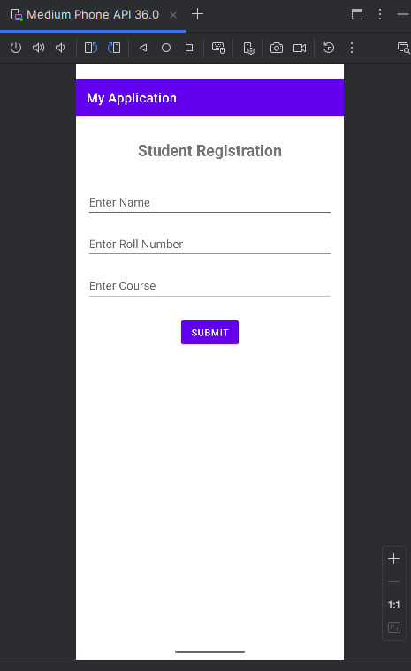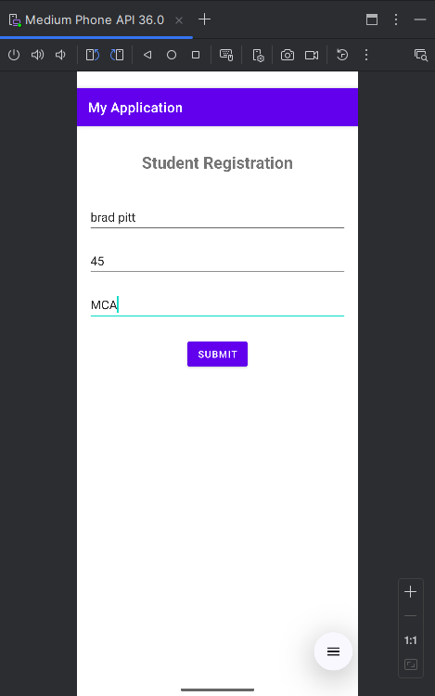

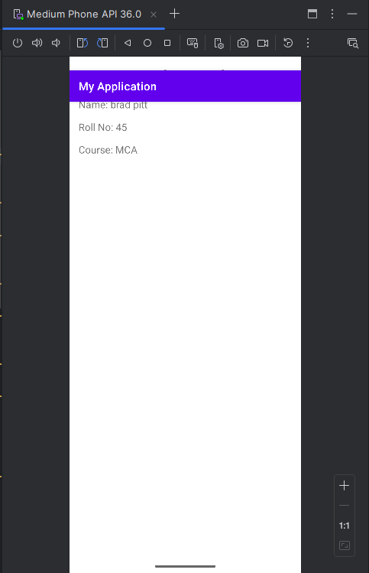

1. **Create an application to implement implicit intent with functionality to open camera, Gallery, Contact, Dial, Browser.**

package com.example.practical4;

import android.content.Intent; import android.net.Uri; import android.os.Bundle;

import android.provider.MediaStore; import android.view.View;

import android.widget.EditText;

import androidx.activity.EdgeToEdge;

import androidx.appcompat.app.AppCompatActivity; import androidx.core.graphics.Insets;

import androidx.core.view.ViewCompat;

import androidx.core.view.WindowInsetsCompat; public class MainActivity extends AppCompatActivity {

@Override

protected void onCreate(Bundle savedInstanceState) { super.onCreate(savedInstanceState);

setContentView(R.layout.activity_main); findViewById(R.id.button2).setOnClickListener(new View.OnClickListener() {

@Override

public void onClick(View v) {

Intent i=new Intent(MediaStore.ACTION_IMAGE_CAPTURE); startActivity(i);

}

});

findViewById(R.id.button6).setOnClickListener(new View.OnClickListener() { @Override

public void onClick(View v) {

Intent i=new Intent(Intent.ACTION_VIEW); i.setData(Uri.parse("content://media/external/images/media/")); startActivity(i);

}

});

findViewById(R.id.button5).setOnClickListener(new View.OnClickListener() { @Override

public void onClick(View v) {

Intent i=new Intent(Intent.ACTION_VIEW); i.setData(Uri.parse("content://contacts/people/")); startActivity(i);

}

});

EditText ed=findViewById(R.id.editTextText2); findViewById(R.id.button7).setOnClickListener(new View.OnClickListener() {

@Override

public void onClick(View v) {

Intent i=new Intent(Intent.ACTION_VIEW); i.setData(Uri.parse("tel:"+ed.getText())); startActivity(i);

}

});

findViewById(R.id.button8).setOnClickListener(new View.OnClickListener() { @Override

public void onClick(View v) {

Intent i=new Intent(Intent.ACTION_VIEW,Uri.parse("http://"+ed.getText()+"/"));

startActivity(i);

}

});

}

}

<?xml version="1.0" encoding="utf-8"?>

<GridLayout xmlns:andr[oid="http://schemas.android.com/apk/res/android"](http://schemas.android.com/apk/res/android) xmlns:app=["http://schemas.android.com/apk/res-auto"](http://schemas.android.com/apk/res-auto) xmlns:t[ools="http://schemas.android.com/tools"](http://schemas.android.com/tools)

android:id="@+id/main" android:layout_width="match_parent" android:layout_height="match_parent" tools:context=".MainActivity" android:columnCount="2" android:layout_margin="20dp" android:padding="10dp">

<EditText android:id="@+id/editTextText2" android:layout_width="wrap_content" android:layout_height="wrap_content" android:layout_row="0" android:layout_column="0" android:layout_marginTop="50dp" android:ems="10" android:hint="Phone number" android:inputType="text" />

<Button

android:id="@+id/button8"

android:layout_width="120dp" android:layout_height="wrap_content" android:layout_row="3" android:layout_column="1" android:text="Browser" />

<Button

android:id="@+id/button7" android:layout_width="120dp" android:layout_height="wrap_content" android:layout_row="2" android:layout_column="1" android:text="Dial" />

<Button

android:id="@+id/button6" android:layout_width="120dp" android:layout_height="wrap_content" android:layout_row="1" android:layout_column="1" android:text="Gallery" />

<Button

android:id="@+id/button2" android:layout_width="120dp" android:layout_height="wrap_content" android:layout_row="1" android:layout_column="0" android:text="Camera" />

<Button

android:id="@+id/button5" android:layout_width="120dp" android:layout_height="wrap_content" android:layout_row="2" android:layout_column="0" android:text="Contact" />

</GridLayout>

**Output:**

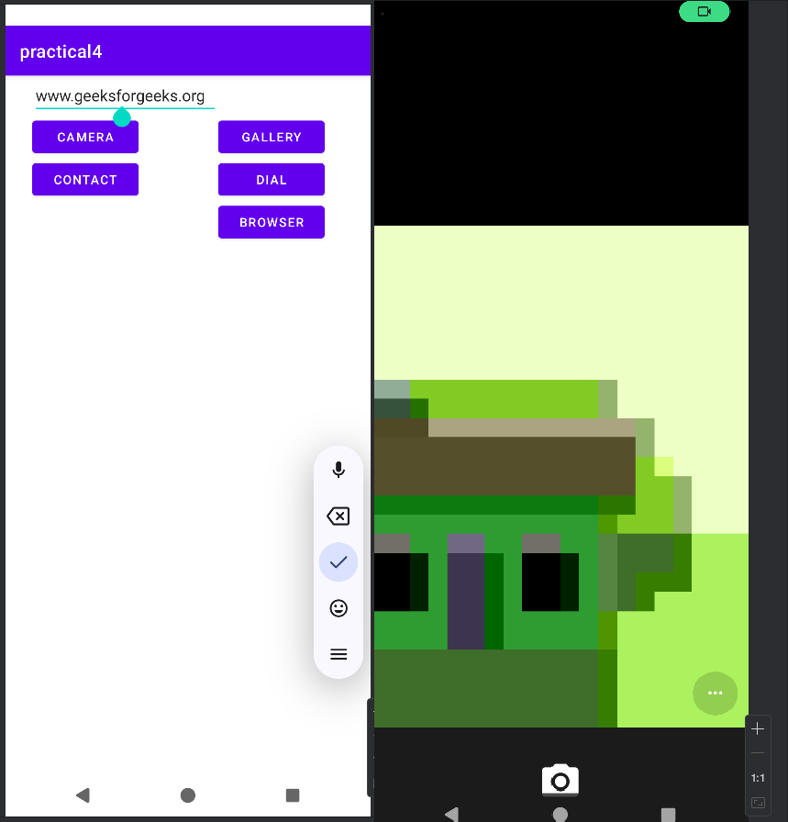

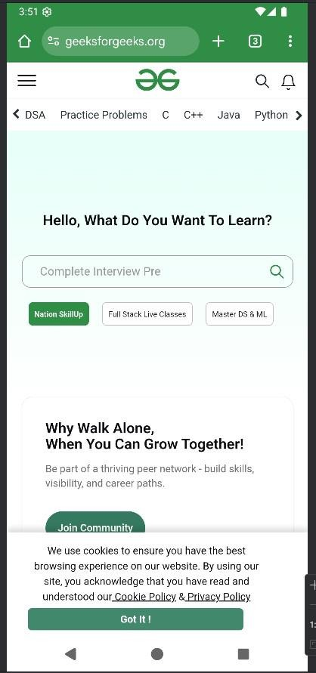

1. **Create an application which has two buttons. When the user clicks on the first button the first fragment will be displayed and when the user clicks on the second button the second fragment will be displayed.**

//Creating fragments

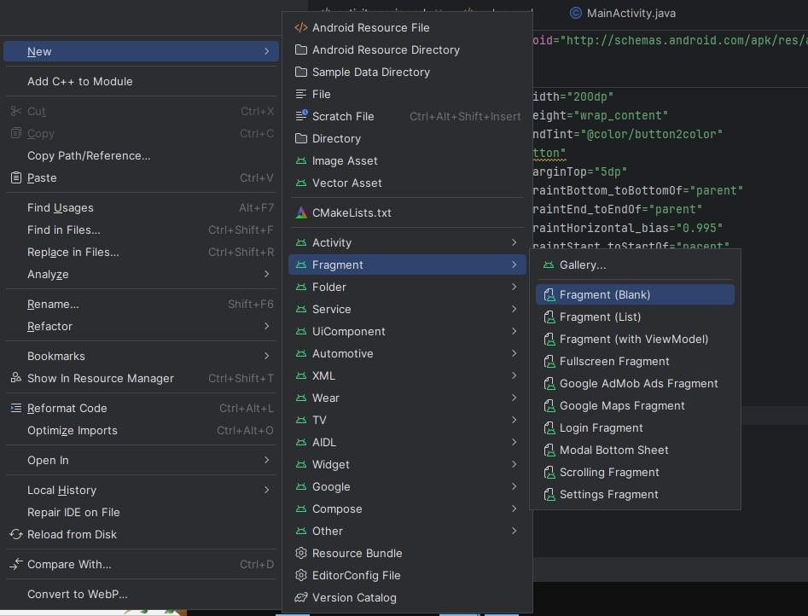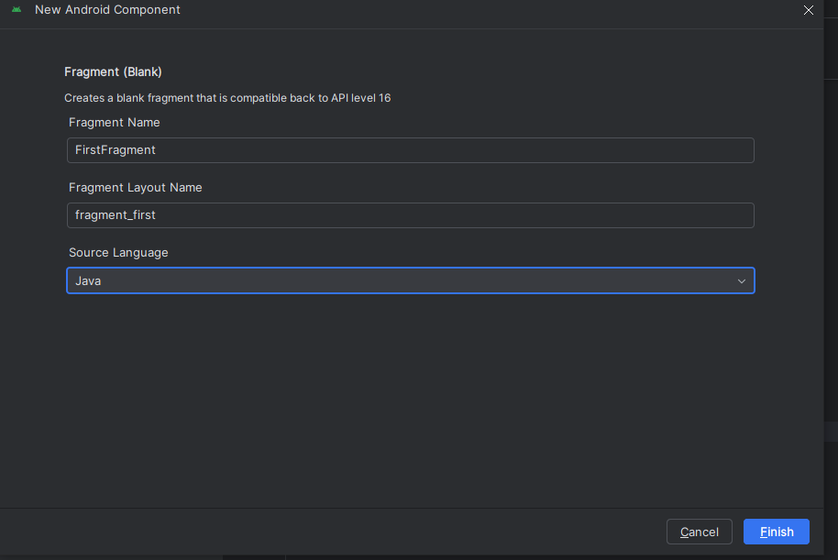

**Code:**

<?xml version="1.0" encoding="utf-8"?>

<LinearLayout xmlns:android=["http://schemas.android.com/apk/res/android"](http://schemas.android.com/apk/res/android) xmlns:app=["http://schemas.android.com/apk/res-auto"](http://schemas.android.com/apk/res-auto) xmlns:t[ools="http://schemas.android.com/tools"](http://schemas.android.com/tools)

android:id="@+id/main" android:layout_width="match_parent" android:orientation="horizontal" android:layout_height="match_parent" tools:context=".MainActivity">

<LinearLayout android:layout_width="match_parent" android:layout_height="wrap_content" android:orientation="horizontal" android:background="@color/fragmenttwocolor">

<Button

android:id="@+id/button2" android:layout_width="200dp" android:layout_height="wrap_content" android:layout_marginTop="5dp" android:text="Button" app:layout_constraintBottom_toBottomOf="parent" app:layout_constraintEnd_toEndOf="parent" app:layout_constraintHorizontal_bias="0.0" android:backgroundTint="@color/button1color" app:layout_constraintStart_toStartOf="parent" app:layout_constraintTop_toTopOf="parent" app:layout_constraintVertical_bias="0.023" />

<Button

android:id="@+id/button" android:layout_width="200dp" android:layout_height="wrap_content" android:backgroundTint="@color/button2color" android:text="Button" android:layout_marginTop="5dp" app:layout_constraintBottom_toBottomOf="parent" app:layout_constraintEnd_toEndOf="parent" app:layout_constraintHorizontal_bias="0.995" app:layout_constraintStart_toStartOf="parent" app:layout_constraintTop_toTopOf="parent" app:layout_constraintVertical_bias="0.023" />

</LinearLayout>

</LinearLayout>

<?xml version="1.0" encoding="utf-8"?>

<LinearLayout xmlns:android=["http://schemas.android.com/apk/res/android"](http://schemas.android.com/apk/res/android) xmlns:app=["http://schemas.android.com/apk/res-auto"](http://schemas.android.com/apk/res-auto) xmlns:t[ools="http://schemas.android.com/tools"](http://schemas.android.com/tools)

android:id="@+id/main" android:layout_width="match_parent" android:orientation="vertical" android:layout_height="match_parent" tools:context=".MainActivity">

<LinearLayout android:layout_width="match_parent" android:layout_height="wrap_content" android:orientation="horizontal" android:background="@color/fragmenttwocolor">

<Button

android:id="@+id/button2" android:layout_width="200dp" android:layout_height="wrap_content" android:layout_marginTop="5dp" android:text="Button" app:layout_constraintBottom_toBottomOf="parent" app:layout_constraintEnd_toEndOf="parent" app:layout_constraintHorizontal_bias="0.0" android:backgroundTint="@color/button1color" app:layout_constraintStart_toStartOf="parent" app:layout_constraintTop_toTopOf="parent" app:layout_constraintVertical_bias="0.023" />

<Button

android:id="@+id/button" android:layout_width="200dp" android:layout_height="wrap_content" android:backgroundTint="@color/button2color" android:text="Button" android:layout_marginTop="5dp" app:layout_constraintBottom_toBottomOf="parent" app:layout_constraintEnd_toEndOf="parent" app:layout_constraintHorizontal_bias="0.995" app:layout_constraintStart_toStartOf="parent" app:layout_constraintTop_toTopOf="parent" app:layout_constraintVertical_bias="0.023" />

</LinearLayout>

<FrameLayout android:id="@+id/Frame1" android:layout_width="match_parent" android:layout_height="match_parent">

</FrameLayout>

</LinearLayout>

package com.example.myapplication; import android.os.Bundle;

import android.view.View; import android.widget.Button;

import androidx.activity.EdgeToEdge;

import androidx.appcompat.app.AppCompatActivity; import androidx.core.graphics.Insets;

import androidx.core.view.ViewCompat;

import androidx.core.view.WindowInsetsCompat; import androidx.fragment.app.FragmentTransaction;

public class MainActivity extends AppCompatActivity { Button bt1,bt2;

@Override

protected void onCreate(Bundle savedInstanceState) {

super.onCreate(savedInstanceState); EdgeToEdge.enable(this); setContentView(R.layout.activity_main);

bt1=findViewById(R.id.button); bt2=findViewById(R.id.button2);

ViewCompat.setOnApplyWindowInsetsListener(findViewById(R.id.main), (v, insets) ->

{

Insets systemBars = insets.getInsets(WindowInsetsCompat.Type.systemBars()); v.setPadding(systemBars.left, systemBars.top, systemBars.right, systemBars.bottom); return insets;

});

bt1.setOnClickListener(new View.OnClickListener() { @Override

public void onClick(View v) {

FirstFragment firstFragment=new FirstFragment();

FragmentTransaction transaction=getSupportFragmentManager().beginTransaction();

transaction.replace(R.id.Frame1,firstFragment); transaction.commit();

}

});

bt2.setOnClickListener(new View.OnClickListener() { @Override

public void onClick(View v) {

FragmentTwo fragmentTwo=new FragmentTwo();

FragmentTransaction transaction=getSupportFragmentManager().beginTransaction();

transaction.replace(R.id.Frame1,fragmentTwo); transaction.commit();

}

});

}

}

<?xml version="1.0" encoding="utf-8"?>

<FrameLayout xmlns:android=["http://schemas.android.com/apk/res/android"](http://schemas.android.com/apk/res/android) xmlns:t[ools="http://schemas.android.com/tools"](http://schemas.android.com/tools) android:layout_width="match_parent" android:layout_height="match_parent"

tools:context=".FragmentTwo">

<ImageView android:layout_width="match_parent" android:layout_height="match_parent" android:scaleType="fitXY" android:src="@drawable/i5"/>

<TextView android:layout_width="match_parent" android:layout_height="match_parent" android:text="Nature" android:textSize="30dp" android:textColor="@color/white"/>

</FrameLayout>

<?xml version="1.0" encoding="utf-8"?>

<FrameLayout xmlns:android=["http://schemas.android.com/apk/res/android"](http://schemas.android.com/apk/res/android) xmlns:t[ools="http://schemas.android.com/tools"](http://schemas.android.com/tools) android:layout_width="match_parent" android:layout_height="match_parent"

tools:context=".FirstFragment">

<ImageView android:layout_width="match_parent" android:layout_height="match_parent" android:src="@drawable/i3" android:scaleType="fitXY"

/>

<TextView android:layout_width="match_parent" android:layout_height="match_parent" android:text="Plain field in front of mountain."

android:textSize="20dp" android:textColor="@color/black"

/>

</FrameLayout>

**Output:**

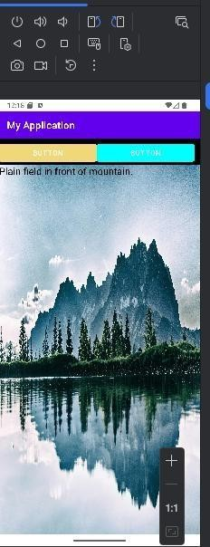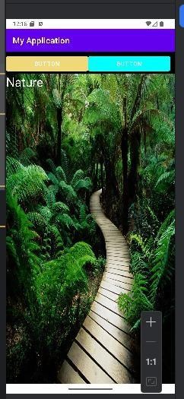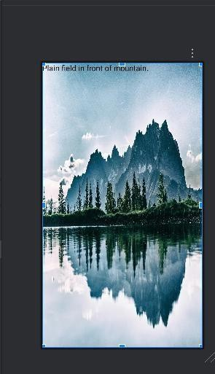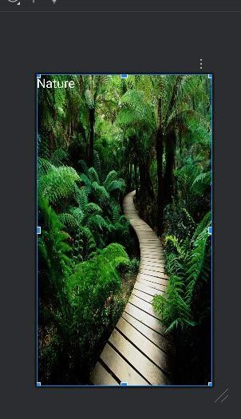

1. **Write an Android application with five check boxes to list the 5 subjects of your class and radio buttons to display gender. Display the selected subject name when you click any one of the checkboxes and gender in the alert dialog box.**

Activitymain.xml

<?xml version="1.0" encoding="utf-8"?>

<LinearLayout xmlns:android="[http://schemas.android.com/apk/res/android"](http://schemas.android.com/apk/res/android) android:layout_width="match_parent" android:layout_height="match_parent"

android:orientation="vertical" android:padding="20dp">

<TextView android:layout_width="wrap_content" android:layout_height="wrap_content" android:text="Select Your Subjects:" android:textSize="18sp" android:layout_marginTop="70dp" android:layout_marginBottom="10dp" />

<CheckBox android:id="@+id/cbMath"

android:layout_width="wrap_content" android:layout_height="wrap_content" android:text="Mathematics" />

<CheckBox android:id="@+id/cbScience" android:layout_width="wrap_content" android:layout_height="wrap_content" android:text="Science" />

<CheckBox android:id="@+id/cbEnglish" android:layout_width="wrap_content" android:layout_height="wrap_content" android:text="English" />

<CheckBox android:id="@+id/cbHistory" android:layout_width="wrap_content" android:layout_height="wrap_content" android:text="History" />

<CheckBox android:id="@+id/cbComputer" android:layout_width="wrap_content" android:layout_height="wrap_content" android:text="Computer Science" />

<View

android:layout_width="match_parent"

android:layout_height="1dp" android:background="#CCCCCC" android:layout_marginVertical="15dp" />

<TextView android:layout_width="wrap_content" android:layout_height="wrap_content" android:text="Select Gender:" android:textSize="18sp" android:layout_marginBottom="10dp" />

<RadioGroup android:id="@+id/radioGroupGender" android:layout_width="wrap_content" android:layout_height="wrap_content" android:orientation="horizontal">

<RadioButton android:id="@+id/rbMale" android:layout_width="wrap_content" android:layout_height="wrap_content" android:text="Male" />

<RadioButton android:id="@+id/rbFemale" android:layout_width="wrap_content" android:layout_height="wrap_content" android:text="Female" android:layout_marginStart="20dp" />

</RadioGroup>

</LinearLayout>

MainActivity.java

package com.example.myapplication; import androidx.appcompat.app.AlertDialog;

import androidx.appcompat.app.AppCompatActivity;

import android.os.Bundle;

import android.widget.CheckBox; import android.widget.RadioButton; import android.widget.RadioGroup; import android.widget.Toast;

public class MainActivity extends AppCompatActivity {

CheckBox cbMath, cbScience, cbEnglish, cbHistory, cbComputer; RadioGroup radioGroupGender;

@Override

protected void onCreate(Bundle savedInstanceState) { super.onCreate(savedInstanceState);

setContentView(R.layout.*activity_main*);

cbMath = findViewById(R.id.*cbMath*); cbScience = findViewById(R.id.*cbScience*); cbEnglish = findViewById(R.id.*cbEnglish*); cbHistory = findViewById(R.id.*cbHistory*); cbComputer = findViewById(R.id.*cbComputer*);

radioGroupGender = findViewById(R.id.*radioGroupGender*);

// --- Checkbox listeners --- cbMath.setOnClickListener(v -> showSubject(cbMath));

cbScience.setOnClickListener(v -> showSubject(cbScience)); cbEnglish.setOnClickListener(v -> showSubject(cbEnglish)); cbHistory.setOnClickListener(v -> showSubject(cbHistory)); cbComputer.setOnClickListener(v -> showSubject(cbComputer));

// --- RadioGroup listener --- radioGroupGender.setOnCheckedChangeListener((group, checkedId) -> {

RadioButton selected = findViewById(checkedId); if (selected != null) {

showGenderDialog(selected.getText().toString());

}

});

}

private void showSubject(CheckBox cb) { if (cb.isChecked()) {

Toast.*makeText*(this, "Selected: " + cb.getText(), Toast.*LENGTH_SHORT*).show();

}

}

private void showGenderDialog(String gender) { new AlertDialog.Builder(this)

.setTitle("Gender Selected")

.setMessage("You selected: " + gender)

.setPositiveButton("OK", null)

.show();

}

}

**Output:**

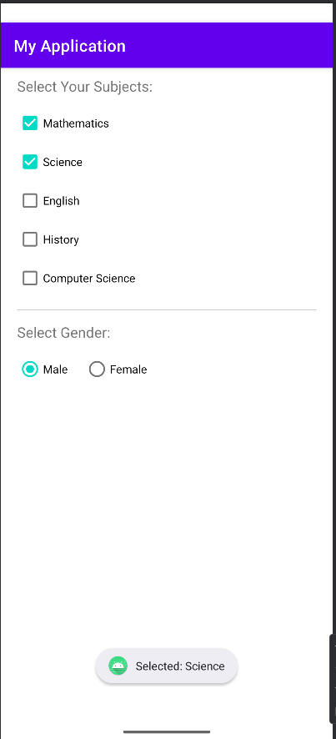

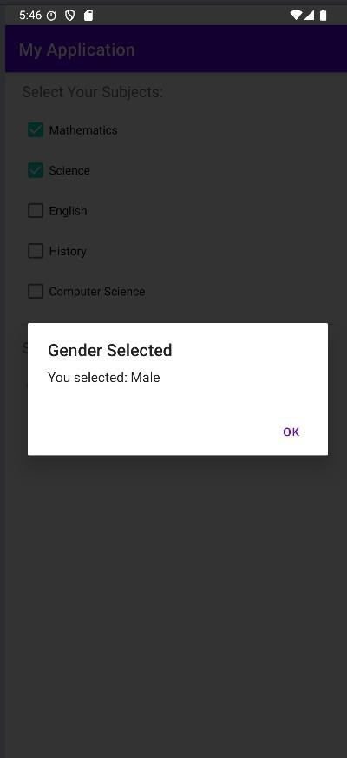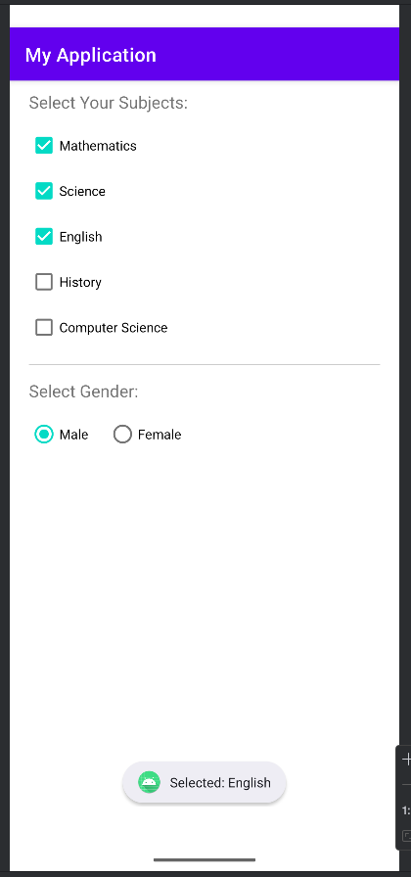

1. **Create a basic calculator to perform arithmetic operations with divide-by-zero validation. (using Alert box).**

<?xml version="1.0" encoding="utf-8"?>

<LinearLayout xmlns:andr[oid="http://schemas.android.com/apk/res/android"](http://schemas.android.com/apk/res/android) android:orientation="vertical"

android:padding="20dp" android:gravity="center" android:layout_width="match_parent" android:layout_height="match_parent">

<EditText android:id="@+id/num1"

android:layout_width="match_parent" android:layout_height="wrap_content" android:hint="Enter first number" android:inputType="numberDecimal" />

<EditText android:id="@+id/num2"

android:layout_width="match_parent" android:layout_height="wrap_content" android:hint="Enter second number" android:inputType="numberDecimal" android:layout_marginTop="10dp" />

<TextView android:id="@+id/result"

android:layout_width="match_parent" android:layout_height="wrap_content" android:text="Result: " android:textSize="18sp" android:layout_marginTop="20dp" />

<LinearLayout android:layout_width="match_parent" android:layout_height="wrap_content" android:orientation="horizontal" android:gravity="center" android:layout_marginTop="20dp">

<Button

android:id="@+id/btnAdd" android:layout_width="wrap_content" android:layout_height="wrap_content" android:text="+" />

<Button

android:id="@+id/btnSub" android:layout_width="wrap_content"

android:layout_height="wrap_content" android:text="-" android:layout_marginStart="10dp" />

<Button

android:id="@+id/btnMul" android:layout_width="wrap_content" android:layout_height="wrap_content" android:text="×" android:layout_marginStart="10dp" />

<Button

android:id="@+id/btnDiv" android:layout_width="wrap_content" android:layout_height="wrap_content" android:text="÷" android:layout_marginStart="10dp" />

</LinearLayout>

</LinearLayout>

MainActivity.java

package com.example.myapplication;

import androidx.appcompat.app.AlertDialog;

import androidx.appcompat.app.AppCompatActivity;

import android.os.Bundle; import android.view.View; import android.widget.Button; import android.widget.EditText; import android.widget.TextView;

public class MainActivity extends AppCompatActivity { EditText num1, num2;

TextView result;

Button btnAdd, btnSub, btnMul, btnDiv;

@Override

protected void onCreate(Bundle savedInstanceState) { super.onCreate(savedInstanceState); setContentView(R.layout.activity_main);

num1 = findViewById(R.id.num1); num2 = findViewById(R.id.num2); result = findViewById(R.id.result);

btnAdd = findViewById(R.id.btnAdd); btnSub = findViewById(R.id.btnSub); btnMul = findViewById(R.id.btnMul); btnDiv = findViewById(R.id.btnDiv);

btnAdd.setOnClickListener(v -> calculate('+')); btnSub.setOnClickListener(v -> calculate('-')); btnMul.setOnClickListener(v -> calculate('*')); btnDiv.setOnClickListener(v -> calculate('/'));

}

private void calculate(char operator) { String n1 = num1.getText().toString(); String n2 = num2.getText().toString();

if (n1.isEmpty() || n2.isEmpty()) { showAlert("Please enter both numbers."); return;

}

double a = Double.parseDouble(n1); double b = Double.parseDouble(n2); double res = 0;

switch (operator) { case '+':

res = a + b; break;

case '-':

res = a - b; break;

case '*':

res = a * b; break;

case '/':

if (b == 0) {

showAlert("Division by zero is not allowed!"); return;

} else {

res = a / b;

}

break;

}

result.setText("Result: " + res);

}

private void showAlert(String message) {

AlertDialog.Builder builder = new AlertDialog.Builder(this); builder.setTitle("Error");

builder.setMessage(message);

builder.setPositiveButton("OK", null); builder.show();

}

}

**Output:**

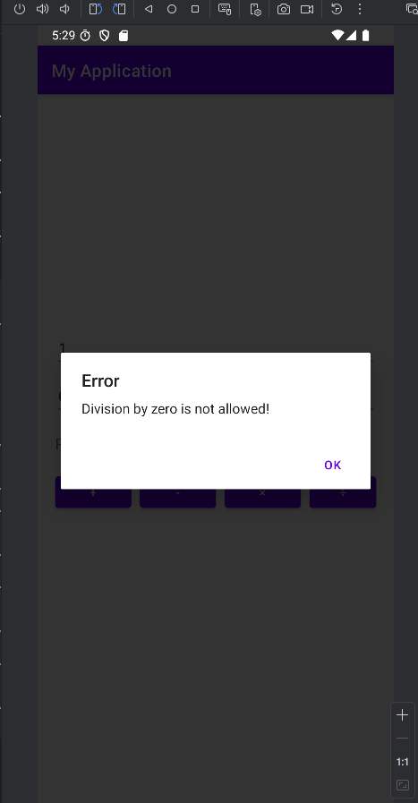

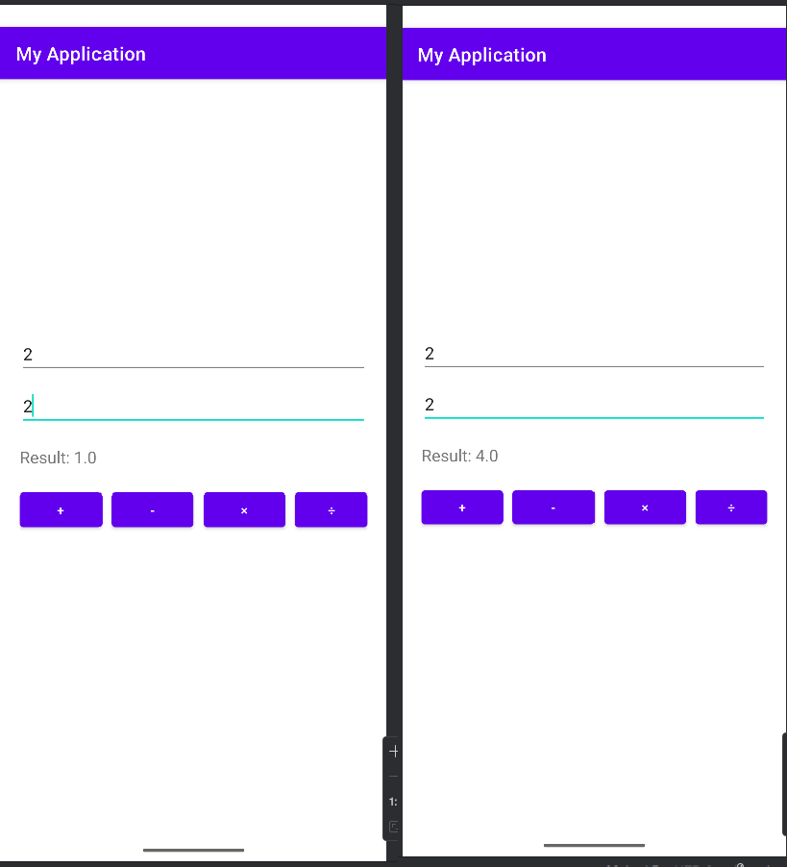

1. **Create an Android application to demonstrate List View using an array adapter.**

Code:

Activity_main.xml

<?xml version="1.0" encoding="utf-8"?>

<LinearLayout xmlns:android=["http://schemas.android.com/apk/res/android"](http://schemas.android.com/apk/res/android) xmlns:app=["http://schemas.android.com/apk/res-auto"](http://schemas.android.com/apk/res-auto) xmlns:t[ools="http://schemas.android.com/tools"](http://schemas.android.com/tools) android:layout_width="match_parent" android:layout_height="match_parent"

tools:context=".MainActivity" android:orientation="vertical" android:padding="16dp">

<ListView android:id="@+id/listView"

android:layout_width="match_parent" android:layout_height="wrap_content" />

</LinearLayout>

MainActivity.java

package com.example.myapplication; import android.os.Bundle;

import androidx.activity.EdgeToEdge;

import androidx.appcompat.app.AppCompatActivity; import androidx.core.graphics.Insets;

import androidx.core.view.ViewCompat;

import androidx.core.view.WindowInsetsCompat; import androidx.appcompat.app.AppCompatActivity;

import android.os.Bundle;

import android.widget.ArrayAdapter; import android.widget.ListView;

public class MainActivity extends AppCompatActivity { @Override

protected void onCreate(Bundle savedInstanceState) { super.onCreate(savedInstanceState); setContentView(R.layout.activity_main);

ListView listView = findViewById(R.id.listView);

String[] sub = {"Mobile computing", "Big data", "STQA", "CSDF", "MIS"}; ArrayAdapter<String> adapter = new ArrayAdapter<>(this,

android.R.layout.simple_list_item_1, sub);

listView.setAdapter(adapter);

}

}

**Output:**

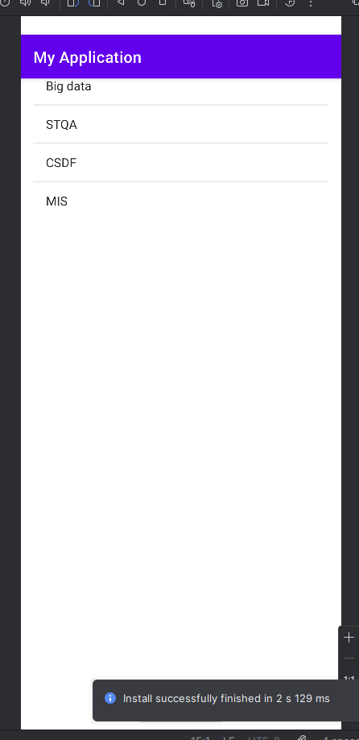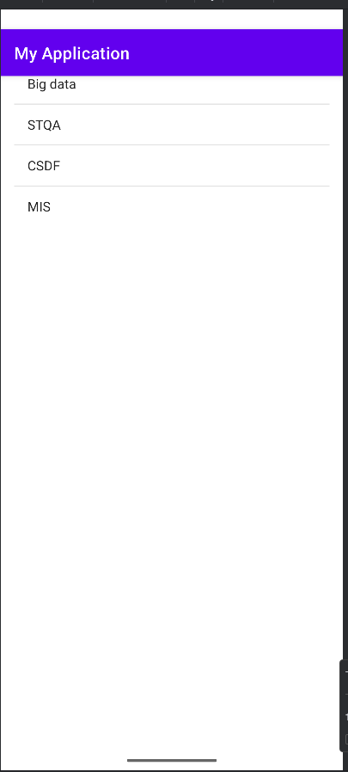

1. **Create a mobile application for a currency converter. Use a spinner for selecting the currency.**

package com.example.myapplication; import android.os.Bundle;

import android.view.View;

import android.widget.ArrayAdapter; import android.widget.Button; import android.widget.EditText; import android.widget.ImageButton; import android.widget.Spinner; import android.widget.TextView;

import androidx.activity.EdgeToEdge;

import androidx.appcompat.app.AppCompatActivity; import androidx.core.graphics.Insets;

import androidx.core.view.ViewCompat;

import androidx.core.view.WindowInsetsCompat;

public class MainActivity extends AppCompatActivity { Spinner sp;

TextView tx; ImageButton ib; EditText et; Spinner sp1; @Override

protected void onCreate(Bundle savedInstanceState) { super.onCreate(savedInstanceState); setContentView(R.layout.activity_main); ib=findViewById(R.id.imageButton); sp=findViewById(R.id.spinner); sp1=findViewById(R.id.spinner2); tx=findViewById(R.id.textView); et=findViewById(R.id.editTextText);

// ArrayAdapter<CharSequence>

adapter=ArrayAdapter.createFromResource(this,R.array.currencies, android.R.layout.simple_spinner_item);

// adapter.setDropDownViewResource(android.R.layout.simple_spinner_dropdown_item);

// sp.setAdapter(adapter);

// sp1.setAdapter(adapter);

ib.setOnClickListener(new View.OnClickListener() { @Override

public void onClick(View v) {

String fromcurr=sp.getSelectedItem().toString(); String tocurr=sp1.getSelectedItem().toString();

double amount=Double.parseDouble(et.getText().toString());

}

});

}

double conversionrate=getConversionRate(fromcurr,tocurr); double result=amount*conversionrate; tx.setText(String.valueOf(result));

private double getConversionRate(String fromcurr,String tocurr){ if(fromcurr.equals("USD")&&tocurr.equals("EUR")){

return 0.86;

} else if (fromcurr.equals("EUR")&&tocurr.equals("USB")) { return 1.16;

}

else if (fromcurr.equals("USD")&&tocurr.equals("INR")) { return 87.67;

}

else if (fromcurr.equals("INR")&&tocurr.equals("USD")) { return 0.011;

}

else if (fromcurr.equals("EUR")&&tocurr.equals("INR")) { return 101.79;

}

else if (fromcurr.equals("INR")&&tocurr.equals("EUR")) { return 0.0098;

}

else if (fromcurr.equals("GBP")&&tocurr.equals("INR")) { return 117.99;

}

else if (fromcurr.equals("INR")&&tocurr.equals("GBP")) { return 0.0085 ;

}

else if (fromcurr.equals("JPY")&&tocurr.equals("INR")) { return 0.59 ;

}

else if (fromcurr.equals("JPY")&&tocurr.equals("GBP")) { return 0.0050;

}else if (fromcurr.equals("JPY")&&tocurr.equals("USD")) { return 0.0067 ;

}

else if (fromcurr.equals("USD")&&tocurr.equals("JPY")) { return 148.40 ;

}

else if (fromcurr.equals("INR")&&tocurr.equals("JPY")) { return 1.69 ;

}

else if (fromcurr.equals("GBP")&&tocurr.equals("JPY")) { return 199.74 ;

}

return 0.0;

}

}

**Xml file:**

<?xml version="1.0" encoding="utf-8"?>

<androidx.constraintlayout.widget.ConstraintLayout xmlns:andr[oid="http://schemas.android.com/apk/res/android"](http://schemas.android.com/apk/res/android) xmlns:app=["http://schemas.android.com/apk/res-auto"](http://schemas.android.com/apk/res-auto) xmlns:t[ools="http://schemas.android.com/tools"](http://schemas.android.com/tools) android:id="@+id/main" android:layout_width="match_parent" android:layout_height="match_parent" tools:context=".MainActivity">

<Spinner android:id="@+id/spinner2" android:layout_width="354dp" android:layout_height="48dp"

android:entries="@array/currencies" android:minHeight="48dp" app:layout_constraintBottom_toBottomOf="parent" app:layout_constraintEnd_toEndOf="parent" app:layout_constraintHorizontal_bias="0.491" app:layout_constraintStart_toStartOf="parent" app:layout_constraintTop_toTopOf="parent" app:layout_constraintVertical_bias="0.213" />

<Spinner android:id="@+id/spinner" android:layout_width="354dp" android:layout_height="48dp"

android:entries="@array/currencies" app:layout_constraintBottom_toBottomOf="parent" app:layout_constraintEnd_toEndOf="parent" app:layout_constraintHorizontal_bias="0.491" app:layout_constraintStart_toStartOf="parent" app:layout_constraintTop_toTopOf="parent" app:layout_constraintVertical_bias="0.098" />

<EditText android:id="@+id/editTextText" android:layout_width="wrap_content"

android:layout_height="wrap_content" android:ems="10" android:hint="Enter Amount" android:inputType="number" android:minHeight="48dp"

app:layout_constraintBottom_toBottomOf="parent" app:layout_constraintEnd_toEndOf="parent" app:layout_constraintHorizontal_bias="0.452" app:layout_constraintStart_toStartOf="parent" app:layout_constraintTop_toTopOf="parent" app:layout_constraintVertical_bias="0.325" />

<ImageButton android:id="@+id/imageButton" android:layout_width="100dp" android:layout_height="wrap_content"

app:layout_constraintBottom_toBottomOf="parent" app:layout_constraintEnd_toEndOf="parent" app:layout_constraintHorizontal_bias="0.463" app:layout_constraintStart_toStartOf="parent" app:layout_constraintTop_toTopOf="parent" app:layout_constraintVertical_bias="0.414" app:srcCompat="@drawable/outline_add_card_24" tools:ignore="SpeakableTextPresentCheck,TouchTargetSizeCheck" />

<TextView android:id="@+id/textView" android:layout_width="400dp"

android:layout_height="wrap_content" android:text="Result" app:layout_constraintBottom_toBottomOf="parent" app:layout_constraintEnd_toEndOf="parent" app:layout_constraintHorizontal_bias="0.097" app:layout_constraintStart_toStartOf="parent" app:layout_constraintTop_toTopOf="parent" app:layout_constraintVertical_bias="0.542" />

</androidx.constraintlayout.widget.ConstraintLayout>

**Output:**

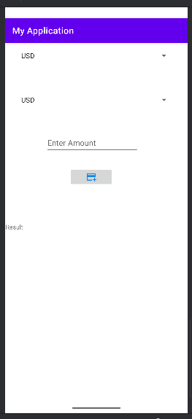 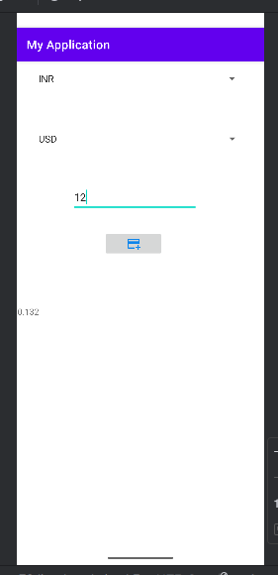

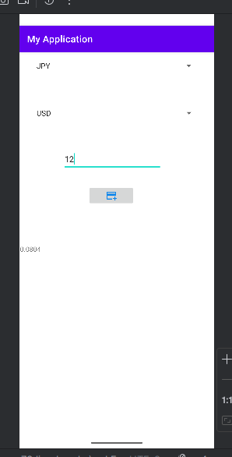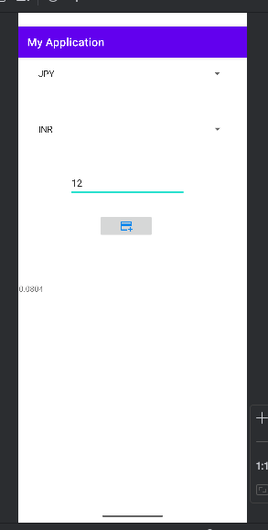

1. **Write an application to increase font size using seekbar.**

<?xml version="1.0" encoding="utf-8"?>

<androidx.constraintlayout.widget.ConstraintLayout xmlns:andr[oid="http://schemas.android.com/apk/res/android"](http://schemas.android.com/apk/res/android)

xmlns:app=["http://schemas.android.com/apk/res-auto"](http://schemas.android.com/apk/res-auto) xmlns:t[ools="http://schemas.android.com/tools"](http://schemas.android.com/tools) android:id="@+id/main" android:layout_width="match_parent" android:layout_height="match_parent" tools:context=".MainActivity">

<TextView android:id="@+id/editTextText" android:layout_width="wrap_content" android:layout_height="wrap_content" android:ems="10" android:inputType="text" android:text="Name"

app:layout_constraintBottom_toBottomOf="parent" app:layout_constraintEnd_toEndOf="parent" app:layout_constraintStart_toStartOf="parent" app:layout_constraintTop_toTopOf="parent" app:layout_constraintVertical_bias="0.023" app:layout_editor_absoluteX="123dp" app:layout_editor_absoluteY="111dp"/>

<SeekBar android:id="@+id/seekBar3"

android:layout_width="match_parent" android:layout_height="wrap_content" android:max="100"

android:min="0" app:layout_constraintBottom_toBottomOf="parent" app:layout_constraintEnd_toEndOf="parent" app:layout_constraintStart_toStartOf="parent" app:layout_constraintTop_toTopOf="parent" app:layout_constraintVertical_bias="0.155" />

</androidx.constraintlayout.widget.ConstraintLayout>

**.JAVA File:**

package com.example.myapplication; import android.os.Bundle;

import android.widget.SeekBar; import android.widget.TextView;

import androidx.activity.EdgeToEdge;

import androidx.appcompat.app.AppCompatActivity; import androidx.core.graphics.Insets;

import androidx.core.view.ViewCompat;

import androidx.core.view.WindowInsetsCompat;

public class MainActivity extends AppCompatActivity { TextView tv;

SeekBar sb; @Override

protected void onCreate(Bundle savedInstanceState) { super.onCreate(savedInstanceState);

setContentView(R.layout.activity_main); tv=findViewById(R.id.editTextText); sb=findViewById(R.id.seekBar3);

sb.setOnSeekBarChangeListener(new SeekBar.OnSeekBarChangeListener() { @Override

public void onProgressChanged(SeekBar seekBar, int progress, boolean fromUser) { tv.setTextSize(progress);

}

@Override

public void onStartTrackingTouch(SeekBar seekBar) {

}

@Override

public void onStopTrackingTouch(SeekBar seekBar) {

}

});

}

}

**Output:**

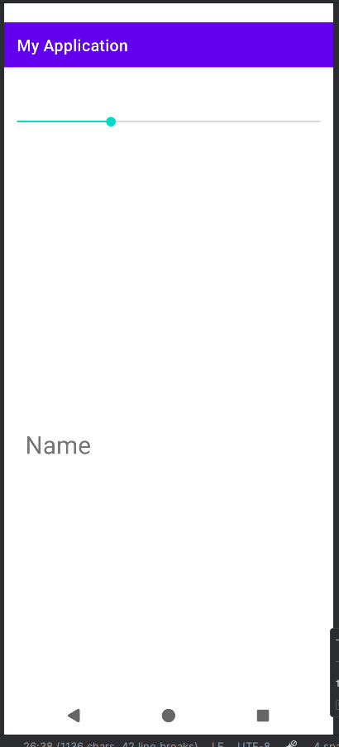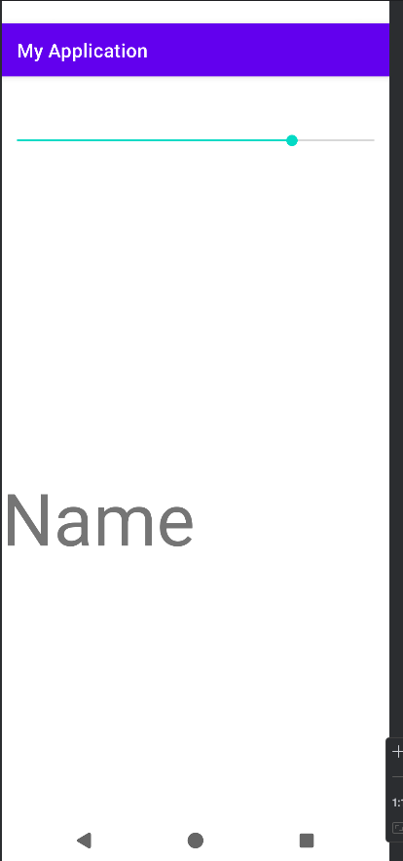

1. **Create an Android application to demonstrate progressbar.**

MainActivity.java

package com.example.myapplication;

import androidx.appcompat.app.AppCompatActivity; import android.os.Bundle;

import android.os.Handler; import android.view.View; import android.widget.Button;

import android.widget.ProgressBar;

public class MainActivity extends AppCompatActivity { ProgressBar progressBar;

Button btnStart;

Handler handler = new Handler(); int progressStatus = 0;

@Override

protected void onCreate(Bundle savedInstanceState) { super.onCreate(savedInstanceState); setContentView(R.layout.activity_main);

progressBar = findViewById(R.id.progressBar); btnStart = findViewById(R.id.btnStart);

btnStart.setOnClickListener(v -> { progressBar.setVisibility(View.VISIBLE); progressStatus = 0;

new Thread(() -> {

while (progressStatus < 100) { progressStatus += 10;

handler.post(() -> progressBar.setProgress(progressStatus)); try {

Thread.sleep(500); // delay for effect

} catch (InterruptedException e) { e.printStackTrace();

}

}

}).start();

});

}

}

<?xml version="1.0" encoding="utf-8"?>

<LinearLayout xmlns:android="[http://schemas.android.com/apk/res/android"](http://schemas.android.com/apk/res/android) android:layout_width="match_parent" android:layout_height="match_parent"

android:orientation="vertical"

android:gravity="center" android:padding="20dp">

<ProgressBar android:id="@+id/progressBar"

style="?android:attr/progressBarStyleHorizontal" android:layout_width="match_parent" android:layout_height="wrap_content" android:max="100"

android:progress="0" android:visibility="gone"/>

<Button

android:id="@+id/btnStart" android:layout_width="wrap_content" android:layout_height="wrap_content" android:text="Start Progress" android:layout_marginTop="20dp"/>

</LinearLayout>

# Output:

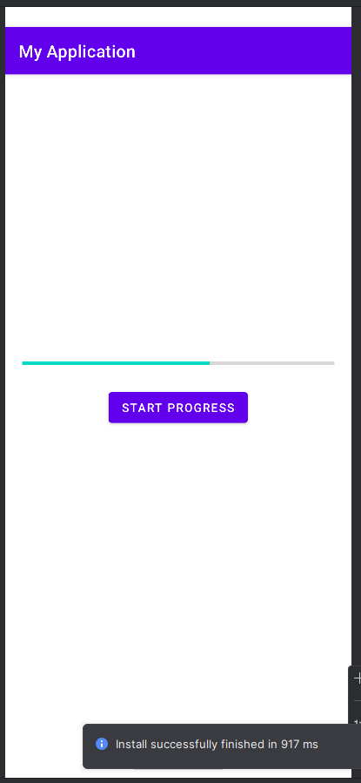

**Module 2 Database Connectivity:**

**Practical 1: Create an Android application to read and write content in internal storage.**

<?xml version="1.0" encoding="utf-8"?>

<LinearLayout xmlns:andr[oid="http://schemas.android.com/apk/res/android"](http://schemas.android.com/apk/res/android) android:orientation="vertical" android:layout_width="match_parent" android:layout_height="match_parent" android:padding="20dp" android:gravity="center_horizontal">

<EditText android:id="@+id/editText"

android:layout_width="match_parent" android:layout_height="wrap_content" android:hint="Enter text here" android:minHeight="80dp" android:gravity="top"

android:background="@android:drawable/edit_text" />

<Button

android:id="@+id/btnSave" android:layout_width="wrap_content" android:layout_height="wrap_content" android:text="Save to Internal Storage" android:layout_marginTop="20dp"/>

<Button

android:id="@+id/btnRead" android:layout_width="wrap_content" android:layout_height="wrap_content" android:text="Read from Internal Storage" android:layout_marginTop="10dp"/>

<TextView android:id="@+id/textView" android:layout_width="match_parent"

android:layout_height="wrap_content" android:text="File content will appear here" android:textSize="16sp" android:layout_marginTop="20dp" android:gravity="center"/>

</LinearLayout>

package com.example.ksr;

import androidx.appcompat.app.AppCompatActivity; import android.os.Bundle;

import android.view.View; import android.widget.*; import java.io.*;

public class MainActivity2 extends AppCompatActivity {

EditText editText; Button btnSave, btnRead;

TextView textView;

String fileName = "myFile.txt";

@Override

protected void onCreate(Bundle savedInstanceState) { super.onCreate(savedInstanceState); setContentView(R.layout.activity_main);

editText = findViewById(R.id.editText); btnSave = findViewById(R.id.btnSave); btnRead = findViewById(R.id.btnRead); textView = findViewById(R.id.textView);

// SAVE BUTTON

btnSave.setOnClickListener(new View.OnClickListener() { @Override

public void onClick(View v) {

String data = editText.getText().toString(); if (data.isEmpty()) {

Toast.makeText(MainActivity2.this, "Please enter text", Toast.LENGTH_SHORT).show();

} else {

writeToFile(data);

}

}

});

// READ BUTTON

btnRead.setOnClickListener(new View.OnClickListener() { @Override

public void onClick(View v) { readFromFile();

}

});

}

// Function to Write Data

private void writeToFile(String data) { try {

FileOutputStream fos = openFileOutput(fileName, MODE_PRIVATE); fos.write(data.getBytes());

fos.close();

Toast.makeText(this, "Data saved successfully!", Toast.LENGTH_SHORT).show(); editText.setText("");

} catch (IOException e) { e.printStackTrace();

Toast.makeText(this, "Error saving file!", Toast.LENGTH_SHORT).show();

}

}

// Function to Read Data private void readFromFile() {

try {

FileInputStream fis = openFileInput(fileName);

BufferedReader reader = new BufferedReader(new InputStreamReader(fis)); StringBuilder stringBuilder = new StringBuilder();

String line;

while ((line = reader.readLine()) != null) { stringBuilder.append(line).append("\n");

}

reader.close(); fis.close();

textView.setText(stringBuilder.toString());

} catch (IOException e) { e.printStackTrace();

Toast.makeText(this, "Error reading file!", Toast.LENGTH_SHORT).show();

}

}

}

**Output:**

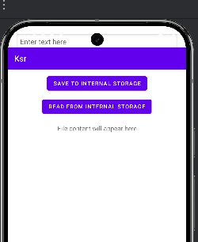

**Practical 2: Create an Android application to read and write content in external storage.**

package com.example.myapplication;

import androidx.appcompat.app.AppCompatActivity; import android.os.Bundle;

import android.os.Environment; import android.view.View; import android.widget.Button; import android.widget.EditText; import android.widget.TextView; import android.widget.Toast; import java.io.BufferedReader; import java.io.File;

import java.io.FileInputStream; import java.io.FileOutputStream; import java.io.IOException; import java.io.InputStreamReader;

public class MainActivity extends AppCompatActivity { private EditText inputText;

private Button btnWrite, btnLoad; private TextView dir;

private String filename = "hello.txt"; private String filepath = "MyFileStorage"; private File extFile;

private String data = "";

@Override

protected void onCreate(Bundle savedInstanceState) { super.onCreate(savedInstanceState); setContentView(R.layout.activity_main);

inputText = findViewById(R.id.input_text); btnWrite = findViewById(R.id.btn_write); btnLoad = findViewById(R.id.btn_load); dir=findViewById(R.id.dir);

if (!isExternalStorageAvailable() || isExternalStorageReadOnly()) { btnWrite.setEnabled(false);

}

else {

extFile = new File(getExternalFilesDir(filepath), filename);

}

getDir();

btnWrite.setOnClickListener(new View.OnClickListener() { @Override

public void onClick(View view) {

data = inputText.getText().toString(); try {

FileOutputStream fos = new FileOutputStream(extFile); fos.write(data.getBytes());

// fos.write("Hello".getBytes()); inputText.getText().clear();

Toast.makeText(getApplicationContext(), filename + " saved to external storage...", Toast.LENGTH_SHORT).show();

fos.close();

}

catch (IOException ex) { ex.printStackTrace();

}

}

});

btnLoad.setOnClickListener(new View.OnClickListener() { @Override

public void onClick(View view) { try {

FileInputStream fis = new FileInputStream(extFile); InputStreamReader isr = new InputStreamReader(fis); BufferedReader br = new BufferedReader(isr); StringBuilder data = new StringBuilder();

String line;

while ((line = br.readLine()) != null) { data.append("\n").append(line);

}

inputText.setText(data);

Toast.makeText(getApplicationContext(), "Data Retrieved from External File Successfully...", Toast.LENGTH_SHORT).show();

fis.close();

}

catch (IOException ex) { ex.printStackTrace();

}

}

});

}

private static boolean isExternalStorageAvailable() {

String extStorageState = Environment.getExternalStorageState(); return Environment.MEDIA_MOUNTED.equals(extStorageState);

}

private static boolean isExternalStorageReadOnly() {

String extStorageState = Environment.getExternalStorageState();

return Environment.MEDIA_MOUNTED_READ_ONLY.equals(extStorageState);

}

private void getDir()

{

StringBuilder builder=new StringBuilder();

builder.append("External File Directories: ").append(getExternalFilesDir(filepath).getAbsolutePath()).append("\n");

dir.setText(builder.toString());

}

}

AndroidManifest.xml

package com.example.myapplication;

import androidx.appcompat.app.AppCompatActivity; import android.os.Bundle;

import android.os.Environment; import android.view.View; import android.widget.Button; import android.widget.EditText; import android.widget.TextView; import android.widget.Toast; import java.io.BufferedReader; import java.io.File;

import java.io.FileInputStream; import java.io.FileOutputStream; import java.io.IOException; import java.io.InputStreamReader;

public class MainActivity extends AppCompatActivity { private EditText inputText;

private Button btnWrite, btnLoad; private TextView dir;

private String filename = "hello.txt"; private String filepath = "MyFileStorage"; private File extFile;

private String data = "";

@Override

protected void onCreate(Bundle savedInstanceState) { super.onCreate(savedInstanceState); setContentView(R.layout.activity_main);

inputText = findViewById(R.id.input_text); btnWrite = findViewById(R.id.btn_write); btnLoad = findViewById(R.id.btn_load); dir=findViewById(R.id.dir);

if (!isExternalStorageAvailable() || isExternalStorageReadOnly()) { btnWrite.setEnabled(false);

}

else {

extFile = new File(getExternalFilesDir(filepath), filename);

}

getDir();

btnWrite.setOnClickListener(new View.OnClickListener() { @Override

public void onClick(View view) {

data = inputText.getText().toString(); try {

FileOutputStream fos = new FileOutputStream(extFile); fos.write(data.getBytes());

// fos.write("Hello".getBytes()); inputText.getText().clear();

Toast.makeText(getApplicationContext(), filename + " saved to external storage...", Toast.LENGTH_SHORT).show();

fos.close();

}

catch (IOException ex) { ex.printStackTrace();

}

}

});

btnLoad.setOnClickListener(new View.OnClickListener() { @Override

public void onClick(View view) { try {

FileInputStream fis = new FileInputStream(extFile); InputStreamReader isr = new InputStreamReader(fis); BufferedReader br = new BufferedReader(isr); StringBuilder data = new StringBuilder();

String line;

while ((line = br.readLine()) != null) { data.append("\n").append(line);

}

inputText.setText(data);

Toast.makeText(getApplicationContext(), "Data Retrieved from External File Successfully...", Toast.LENGTH_SHORT).show();

fis.close();

}

catch (IOException ex) { ex.printStackTrace();

}

}

});

}

private static boolean isExternalStorageAvailable() {

String extStorageState = Environment.getExternalStorageState(); return Environment.MEDIA_MOUNTED.equals(extStorageState);

}

private static boolean isExternalStorageReadOnly() {

String extStorageState = Environment.getExternalStorageState();

return Environment.MEDIA_MOUNTED_READ_ONLY.equals(extStorageState);

}

private void getDir()

{

StringBuilder builder=new StringBuilder();

builder.append("External File Directories: ").append(getExternalFilesDir(filepath).getAbsolutePath()).append("\n"); dir.setText(builder.toString());

}

}

activity_main.xml

package com.example.myapplication;

import androidx.appcompat.app.AppCompatActivity; import android.os.Bundle;

import android.os.Environment; import android.view.View; import android.widget.Button; import android.widget.EditText; import android.widget.TextView; import android.widget.Toast; import java.io.BufferedReader; import java.io.File;

import java.io.FileInputStream; import java.io.FileOutputStream; import java.io.IOException; import java.io.InputStreamReader;

public class MainActivity extends AppCompatActivity { private EditText inputText;

private Button btnWrite, btnLoad; private TextView dir;

private String filename = "hello.txt"; private String filepath = "MyFileStorage"; private File extFile;

private String data = "";

@Override

protected void onCreate(Bundle savedInstanceState) { super.onCreate(savedInstanceState); setContentView(R.layout.activity_main);

inputText = findViewById(R.id.input_text); btnWrite = findViewById(R.id.btn_write); btnLoad = findViewById(R.id.btn_load); dir=findViewById(R.id.dir);

if (!isExternalStorageAvailable() || isExternalStorageReadOnly()) { btnWrite.setEnabled(false);

}

else {

extFile = new File(getExternalFilesDir(filepath), filename);

}

getDir();

btnWrite.setOnClickListener(new View.OnClickListener() {

@Override

public void onClick(View view) {

data = inputText.getText().toString(); try {

FileOutputStream fos = new FileOutputStream(extFile); fos.write(data.getBytes());

// fos.write("Hello".getBytes()); inputText.getText().clear();

Toast.makeText(getApplicationContext(), filename + " saved to external storage...", Toast.LENGTH_SHORT).show();

fos.close();

}

catch (IOException ex) { ex.printStackTrace();

}

}

});

btnLoad.setOnClickListener(new View.OnClickListener() { @Override

public void onClick(View view) { try {

FileInputStream fis = new FileInputStream(extFile); InputStreamReader isr = new InputStreamReader(fis); BufferedReader br = new BufferedReader(isr); StringBuilder data = new StringBuilder();

String line;

while ((line = br.readLine()) != null) { data.append("\n").append(line);

}

inputText.setText(data);

Toast.makeText(getApplicationContext(), "Data Retrieved from External File Successfully...", Toast.LENGTH_SHORT).show();

fis.close();

}

catch (IOException ex) { ex.printStackTrace();

}

}

});

}

private static boolean isExternalStorageAvailable() {

String extStorageState = Environment.getExternalStorageState(); return Environment.MEDIA_MOUNTED.equals(extStorageState);

}

private static boolean isExternalStorageReadOnly() {

String extStorageState = Environment.getExternalStorageState();

return Environment.MEDIA_MOUNTED_READ_ONLY.equals(extStorageState);

}

private void getDir()

{

StringBuilder builder=new StringBuilder();

builder.append("External File Directories: ").append(getExternalFilesDir(filepath).getAbsolutePath()).append("\n"); dir.setText(builder.toString());

}

}

**Output:**

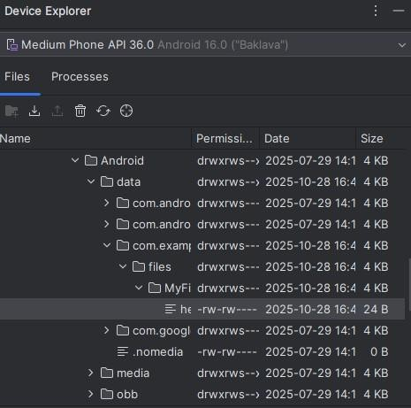

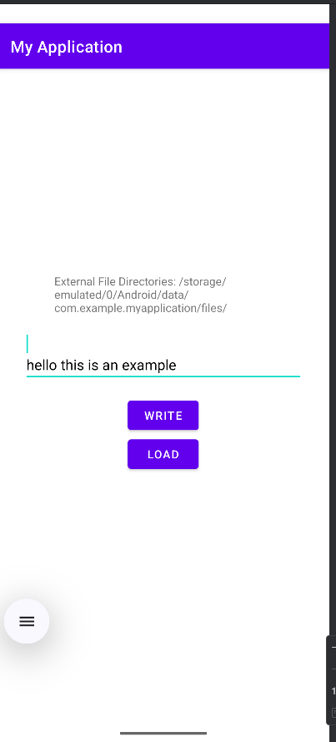

**Practical 3: Write an android program for shared preference to store value in name-value pairs.**

<?xml version="1.0" encoding="utf-8"?>

<LinearLayout xmlns:andr[oid="http://schemas.android.com/apk/res/android"](http://schemas.android.com/apk/res/android) android:orientation="vertical" android:layout_width="match_parent" android:layout_height="match_parent"

android:padding="20dp" android:gravity="center_horizontal">

<EditText android:id="@+id/etName"

android:layout_width="match_parent" android:layout_height="wrap_content" android:hint="Enter your name" android:minHeight="80dp" android:gravity="center"/>

<Button

android:id="@+id/btnSave" android:layout_width="wrap_content" android:layout_height="wrap_content" android:text="Save Name" android:layout_marginTop="20dp"/>

<Button

android:id="@+id/btnShow" android:layout_width="wrap_content" android:layout_height="wrap_content" android:text="Show Saved Name" android:layout_marginTop="10dp"/>

<TextView android:id="@+id/tvDisplay" android:layout_width="match_parent" android:layout_height="wrap_content"

android:text="Your saved name will appear here" android:textSize="18sp"

android:gravity="center" android:layout_marginTop="20dp"/>

</LinearLayout>

package com.example.sharedpreferenceexample;

import androidx.appcompat.app.AppCompatActivity; import android.os.Bundle;

import android.view.View; import android.widget.*;

import android.content.SharedPreferences;

public class MainActivity extends AppCompatActivity { EditText etName;

Button btnSave, btnShow; TextView tvDisplay;

SharedPreferences sharedPreferences;

public static final String MY_PREFS = "MyPrefs"; public static final String KEY_NAME = "userName";

@Override

protected void onCreate(Bundle savedInstanceState) { super.onCreate(savedInstanceState); setContentView(R.layout.activity_main);

etName = findViewById(R.id.etName); btnSave = findViewById(R.id.btnSave); btnShow = findViewById(R.id.btnShow); tvDisplay = findViewById(R.id.tvDisplay);

// Initialize SharedPreferences

sharedPreferences = getSharedPreferences(MY_PREFS, MODE_PRIVATE);

// SAVE button click

btnSave.setOnClickListener(new View.OnClickListener() { @Override

public void onClick(View v) {

String name = etName.getText().toString(); if (name.isEmpty()) {

Toast.makeText(MainActivity.this, "Please enter your name", Toast.LENGTH_SHORT).show();

} else {

SharedPreferences.Editor editor = sharedPreferences.edit(); editor.putString(KEY_NAME, name);

editor.apply(); // or commit()

Toast.makeText(MainActivity.this, "Name saved successfully!", Toast.LENGTH_SHORT).show();

etName.setText("");

}

}

});

// SHOW button click

btnShow.setOnClickListener(new View.OnClickListener() { @Override

public void onClick(View v) {

String savedName = sharedPreferences.getString(KEY_NAME, "No name found"); tvDisplay.setText("Saved Name: " + savedName);

}

});

}

}

**Output:**

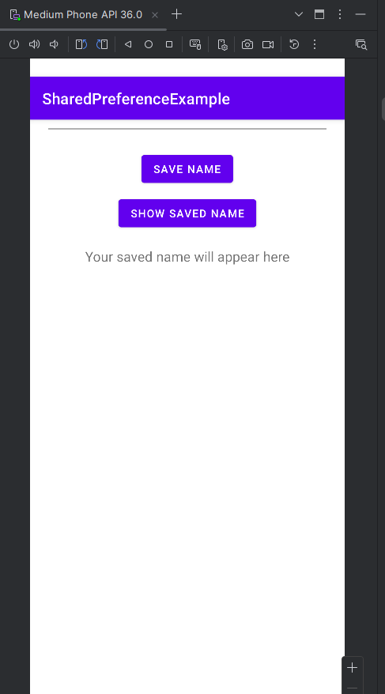

**Practical 4: Create a login form with a remember me checkbox. Save the username and password if the checkbox is checked using shared preference and show the welcome page when the login button is clicked.**

<?xml version="1.0" encoding="utf-8"?>

<LinearLayout xmlns:andr[oid="http://schemas.android.com/apk/res/android"](http://schemas.android.com/apk/res/android) android:orientation="vertical"

android:gravity="center" android:padding="20dp" android:layout_width="match_parent" android:layout_height="match_parent">

<TextView android:text="Login Form" android:textSize="24sp" android:textStyle="bold"

android:layout_marginBottom="30dp" android:layout_width="wrap_content" android:layout_height="wrap_content"/>

<EditText android:id="@+id/etUsername" android:hint="Username" android:layout_width="match_parent" android:layout_height="wrap_content"

android:inputType="textPersonName"/>

<EditText android:id="@+id/etPassword" android:hint="Password" android:layout_width="match_parent" android:layout_height="wrap_content" android:inputType="textPassword" android:layout_marginTop="10dp"/>

<CheckBox android:id="@+id/chkRemember" android:text="Remember Me" android:layout_marginTop="10dp" android:layout_width="wrap_content" android:layout_height="wrap_content"/>

<Button

android:id="@+id/btnLogin" android:text="Login" android:layout_marginTop="20dp" android:layout_width="wrap_content" android:layout_height="wrap_content"/>

</LinearLayout>

package com.example.loginsharedprefapp;

import androidx.appcompat.app.AppCompatActivity; import android.content.Intent;

import android.content.SharedPreferences; import android.os.Bundle;

import android.view.View; import android.widget.*;

public class MainActivity extends AppCompatActivity { EditText etUsername, etPassword;

CheckBox chkRemember;

Button btnLogin;

SharedPreferences sharedPreferences;

public static final String PREFS_NAME = "LoginPrefs"; public static final String KEY_USER = "username"; public static final String KEY_PASS = "password";

public static final String KEY_REMEMBER = "remember";

@Override

protected void onCreate(Bundle savedInstanceState) { super.onCreate(savedInstanceState); setContentView(R.layout.activity_main);

etUsername = findViewById(R.id.etUsername); etPassword = findViewById(R.id.etPassword); chkRemember = findViewById(R.id.chkRemember); btnLogin = findViewById(R.id.btnLogin);

sharedPreferences = getSharedPreferences(PREFS_NAME, MODE_PRIVATE);

// Load saved data if Remember Me was checked

boolean isRemembered = sharedPreferences.getBoolean(KEY_REMEMBER, false); if (isRemembered) {

String savedUser = sharedPreferences.getString(KEY_USER, ""); String savedPass = sharedPreferences.getString(KEY_PASS, ""); etUsername.setText(savedUser);

etPassword.setText(savedPass); chkRemember.setChecked(true);

}

btnLogin.setOnClickListener(new View.OnClickListener() { @Override

public void onClick(View v) {

String username = etUsername.getText().toString(); String password = etPassword.getText().toString();

if (username.isEmpty() || password.isEmpty()) {

Toast.makeText(MainActivity.this, "Enter username and password", Toast.LENGTH_SHORT).show();

} else {

SharedPreferences.Editor editor = sharedPreferences.edit();

if (chkRemember.isChecked()) { editor.putString(KEY_USER, username); editor.putString(KEY_PASS, password); editor.putBoolean(KEY_REMEMBER, true);

} else {

editor.clear(); // Remove saved data if unchecked

}

editor.apply();

}

});

}

}

// Navigate to WelcomeActivity

Intent intent = new Intent(MainActivity.this, MainActivity2.class); intent.putExtra("username", username);

startActivity(intent);

}

<?xml version="1.0" encoding="utf-8"?>

<androidx.constraintlayout.widget.ConstraintLayout xmlns:andr[oid="http://schemas.android.com/apk/res/android"](http://schemas.android.com/apk/res/android) xmlns:app=["http://schemas.android.com/apk/res-auto"](http://schemas.android.com/apk/res-auto) xmlns:t[ools="http://schemas.android.com/tools"](http://schemas.android.com/tools) android:id="@+id/main" android:layout_width="match_parent" android:layout_height="match_parent" tools:context=".MainActivity2">

<TextView android:id="@+id/tvWelcome" android:layout_width="wrap_content" android:layout_height="wrap_content" android:text="TextView" tools:layout_editor_absoluteX="66dp"

tools:layout_editor_absoluteY="48dp" />

</androidx.constraintlayout.widget.ConstraintLayout>

package com.example.loginsharedprefapp; import android.os.Bundle;

import android.widget.TextView;

import androidx.activity.EdgeToEdge;

import androidx.appcompat.app.AppCompatActivity; import androidx.core.graphics.Insets;

import androidx.core.view.ViewCompat;

import androidx.core.view.WindowInsetsCompat;

public class MainActivity2 extends AppCompatActivity { TextView tvWelcome;

@Override

protected void onCreate(Bundle savedInstanceState) { super.onCreate(savedInstanceState); setContentView(R.layout.activity_welcome);

tvWelcome = findViewById(R.id.tvWelcome);

String username = getIntent().getStringExtra("username"); tvWelcome.setText("Welcome, " + username + "!");

}

}

**Output:**

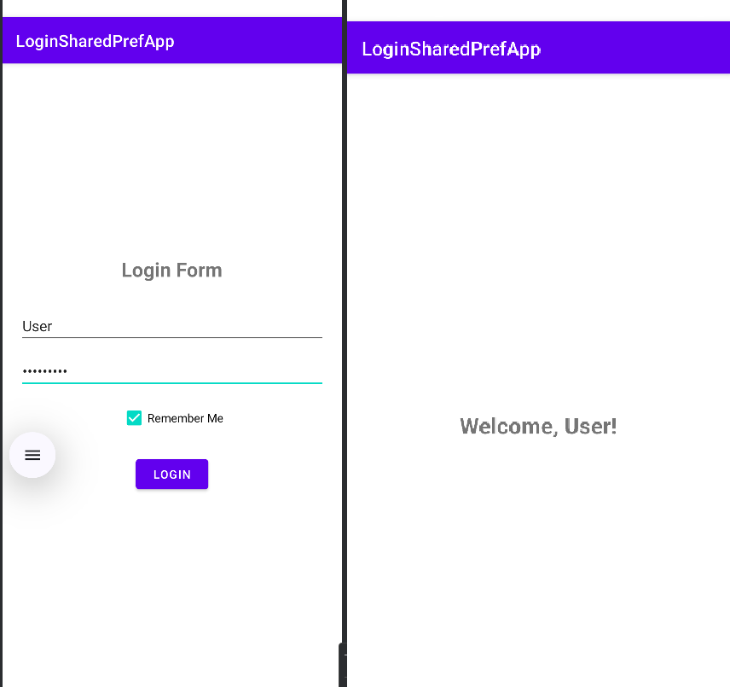

**Practical 5: Create an Android application to insert, update, select, and delete records from the student table using SQLite Database.**

<?xml version="1.0" encoding="utf-8"?>

<ScrollView xmlns:andr[oid="http://schemas.android.com/apk/res/android"](http://schemas.android.com/apk/res/android) android:layout_width="match_parent" android:layout_height="match_parent">

<LinearLayout android:orientation="vertical" android:layout_width="match_parent" android:layout_height="wrap_content" android:padding="20dp" android:gravity="center_horizontal">

<TextView

android:text="Student Database App" android:textSize="24sp" android:textStyle="bold" android:layout_marginBottom="20dp" android:layout_width="wrap_content" android:layout_height="wrap_content"/>

<EditText android:id="@+id/etId" android:hint="Student ID" android:inputType="number"

android:layout_width="match_parent" android:layout_height="wrap_content"/>

<EditText android:id="@+id/etName" android:hint="Student Name"

android:layout_width="match_parent" android:layout_height="wrap_content" android:layout_marginTop="10dp"/>

<EditText android:id="@+id/etCourse" android:hint="Course"

android:layout_width="match_parent" android:layout_height="wrap_content" android:layout_marginTop="10dp"/>

<EditText android:id="@+id/etMarks" android:hint="Marks" android:inputType="number"

android:layout_width="match_parent" android:layout_height="wrap_content"

android:layout_marginTop="10dp"/>

<LinearLayout android:orientation="horizontal" android:gravity="center" android:layout_marginTop="20dp" android:layout_width="match_parent" android:layout_height="wrap_content">

<Button

android:id="@+id/btnInsert" android:text="Insert" android:layout_width="wrap_content" android:layout_height="wrap_content"/>

<Button

android:id="@+id/btnUpdate" android:text="Update" android:layout_width="wrap_content" android:layout_height="wrap_content" android:layout_marginStart="10dp"/>

<Button

android:id="@+id/btnDelete" android:text="Delete" android:layout_width="wrap_content" android:layout_height="wrap_content" android:layout_marginStart="10dp"/>

</LinearLayout>

<Button

android:id="@+id/btnView" android:text="View All Records" android:layout_width="wrap_content" android:layout_height="wrap_content" android:layout_marginTop="20dp"/>

</LinearLayout>

</ScrollView>

package com.example.sqlitestudentapp;

import androidx.appcompat.app.AppCompatActivity; import android.database.Cursor;

import android.os.Bundle; import android.view.View; import android.widget.*;

public class MainActivity extends AppCompatActivity { EditText etId, etName, etCourse, etMarks;

Button btnInsert, btnUpdate, btnDelete, btnView; DatabaseHelper myDB;

@Override

protected void onCreate(Bundle savedInstanceState) { super.onCreate(savedInstanceState); setContentView(R.layout.activity_main);

myDB = new DatabaseHelper(this);

etId = findViewById(R.id.etId); etName = findViewById(R.id.etName);

etCourse = findViewById(R.id.etCourse); etMarks = findViewById(R.id.etMarks); btnInsert = findViewById(R.id.btnInsert); btnUpdate = findViewById(R.id.btnUpdate); btnDelete = findViewById(R.id.btnDelete); btnView = findViewById(R.id.btnView);

addData(); updateData(); deleteData(); viewAll();

}

public void addData() {

btnInsert.setOnClickListener(new View.OnClickListener() { @Override

public void onClick(View v) {

boolean isInserted = myDB.insertData( etName.getText().toString(), etCourse.getText().toString(), etMarks.getText().toString()

}

});

}

);

Toast.makeText(MainActivity.this,

isInserted ? "Data Inserted" : "Insert Failed", Toast.LENGTH_SHORT).show();

public void updateData() {

btnUpdate.setOnClickListener(new View.OnClickListener() { @Override

public void onClick(View v) {

boolean isUpdated = myDB.updateData( etId.getText().toString(), etName.getText().toString(), etCourse.getText().toString(), etMarks.getText().toString()

);

}

});

}

Toast.makeText(MainActivity.this,

isUpdated ? "Data Updated" : "Update Failed", Toast.LENGTH_SHORT).show();

public void deleteData() {

btnDelete.setOnClickListener(new View.OnClickListener() { @Override

public void onClick(View v) {

int deletedRows = myDB.deleteData(etId.getText().toString()); Toast.makeText(MainActivity.this,

deletedRows > 0 ? "Data Deleted" : "Delete Failed", Toast.LENGTH_SHORT).show();

}

});

}

public void viewAll() {

btnView.setOnClickListener(new View.OnClickListener() { @Override

public void onClick(View v) { Cursor res = myDB.getAllData(); if (res.getCount() == 0) {

showMessage("Error", "No Data Found"); return;

}

StringBuilder buffer = new StringBuilder(); while (res.moveToNext()) {

buffer.append("ID: ").append(res.getString(0)).append("\n"); buffer.append("Name: ").append(res.getString(1)).append("\n"); buffer.append("Course: ").append(res.getString(2)).append("\n"); buffer.append("Marks: ").append(res.getString(3)).append("\n\n");

}

showMessage("Student Records", buffer.toString());

}

});

}

public void showMessage(String title, String message) { android.app.AlertDialog.Builder builder = new android.app.AlertDialog.Builder(this); builder.setCancelable(true);

builder.setTitle(title); builder.setMessage(message); builder.show();

}

}

package com.example.sqlitestudentapp;

import android.content.ContentValues; import android.content.Context; import android.database.Cursor;

import android.database.sqlite.SQLiteDatabase; import android.database.sqlite.SQLiteOpenHelper;

public class DatabaseHelper extends SQLiteOpenHelper {

public static final String DATABASE_NAME = "StudentDB"; public static final String TABLE_NAME = "student_table"; public static final String COL_1 = "ID";

public static final String COL_2 = "NAME"; public static final String COL_3 = "COURSE"; public static final String COL_4 = "MARKS";

public DatabaseHelper(Context context) { super(context, DATABASE_NAME, null, 1);

}

@Override

public void onCreate(SQLiteDatabase db) { db.execSQL("CREATE TABLE " + TABLE_NAME +

" (ID INTEGER PRIMARY KEY AUTOINCREMENT, NAME TEXT, COURSE TEXT, MARKS INTEGER)");

}

@Override

public void onUpgrade(SQLiteDatabase db, int oldVersion, int newVersion) { db.execSQL("DROP TABLE IF EXISTS " + TABLE_NAME);

onCreate(db);

}

// INSERT

public boolean insertData(String name, String course, String marks) { SQLiteDatabase db = this.getWritableDatabase();

ContentValues contentValues = new ContentValues(); contentValues.put(COL_2, name); contentValues.put(COL_3, course); contentValues.put(COL_4, marks);

long result = db.insert(TABLE_NAME, null, contentValues); return result != -1; // return true if inserted

}

// UPDATE

public boolean updateData(String id, String name, String course, String marks) { SQLiteDatabase db = this.getWritableDatabase();

ContentValues contentValues = new ContentValues(); contentValues.put(COL_2, name); contentValues.put(COL_3, course);

contentValues.put(COL_4, marks);

int result = db.update(TABLE_NAME, contentValues, "ID = ?", new String[]{id}); return result > 0;

}

// DELETE

public int deleteData(String id) {

SQLiteDatabase db = this.getWritableDatabase();

return db.delete(TABLE_NAME, "ID = ?", new String[]{id});

}

// SELECT ALL

public Cursor getAllData() {

SQLiteDatabase db = this.getWritableDatabase();

return db.rawQuery("SELECT * FROM " + TABLE_NAME, null);

}

}

**Output:**

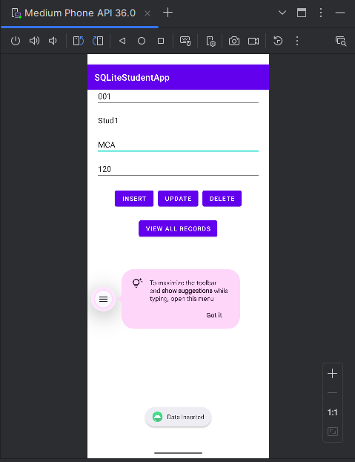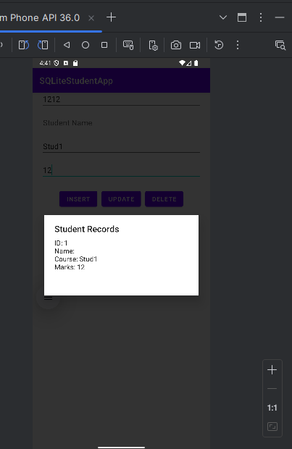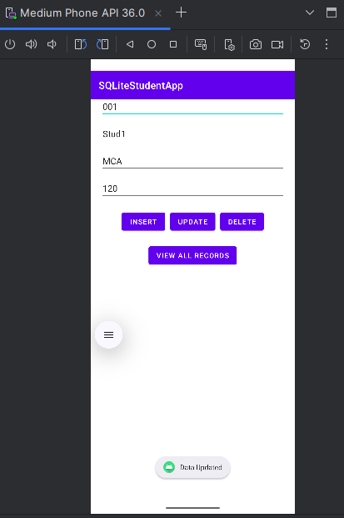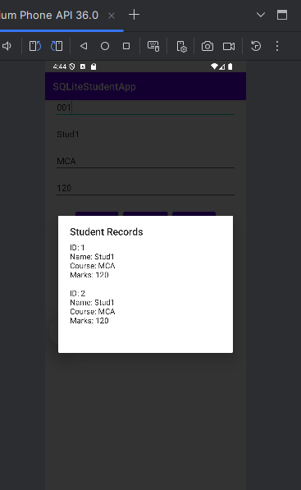

**Practical 6: Write a program to create a user registration form, after registration data will be inserted in the SQLite database, and design an activity that displays that information.**

<?xml version="1.0" encoding="utf-8"?>

<LinearLayout xmlns:android=["http://schemas.android.com/apk/res/android"](http://schemas.android.com/apk/res/android) android:layout_width="match_parent" android:layout_height="match_parent"

android:gravity="center" android:orientation="vertical" android:padding="20dp">

<EditText android:id="@+id/etName" android:hint="Enter Name"

android:layout_width="match_parent" android:layout_height="wrap_content" />

<EditText android:id="@+id/etEmail" android:hint="Enter Email"

android:layout_width="match_parent" android:layout_height="wrap_content" android:inputType="textEmailAddress"/>

<EditText android:id="@+id/etPhone" android:hint="Enter Phone"

android:layout_width="match_parent" android:layout_height="wrap_content" android:inputType="phone"/>

<Button

android:id="@+id/btnRegister" android:text="Register" android:layout_width="match_parent" android:layout_height="wrap_content" />

<Button

android:id="@+id/btnViewUsers" android:text="View Users" android:layout_width="match_parent" android:layout_height="wrap_content" android:layout_marginTop="10dp"/>

</LinearLayout>

package com.example.userregistrationapp;

import androidx.appcompat.app.AppCompatActivity;

import android.content.Intent; import android.database.Cursor; import android.os.Bundle; import android.view.View; import android.widget.Button; import android.widget.EditText; import android.widget.Toast;

public class MainActivity extends AppCompatActivity { DatabaseHelper db;

EditText etName, etEmail, etPhone; Button btnRegister, btnViewUsers;

@Override

protected void onCreate(Bundle savedInstanceState) { super.onCreate(savedInstanceState); setContentView(R.layout.activity_main);

db = new DatabaseHelper(this); etName = findViewById(R.id.etName); etEmail = findViewById(R.id.etEmail);

etPhone = findViewById(R.id.etPhone); btnRegister = findViewById(R.id.btnRegister); btnViewUsers = findViewById(R.id.btnViewUsers);

btnRegister.setOnClickListener(v -> {

String name = etName.getText().toString(); String email = etEmail.getText().toString(); String phone = etPhone.getText().toString();

if (name.isEmpty() || email.isEmpty() || phone.isEmpty()) {

Toast.makeText(this, "Please fill all fields", Toast.LENGTH_SHORT).show();

} else {

boolean inserted = db.insertUser(name, email, phone); if (inserted) {

Toast.makeText(this, "User Registered Successfully!", Toast.LENGTH_SHORT).show();

etName.setText(""); etEmail.setText(""); etPhone.setText("");

} else {

Toast.makeText(this, "Registration Failed!", Toast.LENGTH_SHORT).show();

}

}

});

btnViewUsers.setOnClickListener(v -> {

Intent intent = new Intent(MainActivity.this, activity_view_users.class); startActivity(intent);

});

}

}

package com.example.userregistrationapp;

import android.content.ContentValues; import android.content.Context; import android.database.Cursor;

import android.database.sqlite.SQLiteDatabase; import android.database.sqlite.SQLiteOpenHelper;

public class DatabaseHelper extends SQLiteOpenHelper {

public static final String DATABASE_NAME = "UserDB"; public static final String TABLE_NAME = "users";

public static final String COL_ID = "id";

public static final String COL_NAME = "name"; public static final String COL_EMAIL = "email"; public static final String COL_PHONE = "phone";

public DatabaseHelper(Context context) { super(context, DATABASE_NAME, null, 1);

}

@Override

public void onCreate(SQLiteDatabase db) { db.execSQL("CREATE TABLE " + TABLE_NAME +

" (" + COL_ID + " INTEGER PRIMARY KEY AUTOINCREMENT, " + COL_NAME + " TEXT, " +

COL_EMAIL + " TEXT, " + COL_PHONE + " TEXT)");

}

@Override

public void onUpgrade(SQLiteDatabase db, int oldVersion, int newVersion) { db.execSQL("DROP TABLE IF EXISTS " + TABLE_NAME);

onCreate(db);

}

// Insert User Data

public boolean insertUser(String name, String email, String phone) { SQLiteDatabase db = this.getWritableDatabase();

ContentValues values = new ContentValues(); values.put(COL_NAME, name); values.put(COL_EMAIL, email); values.put(COL_PHONE, phone);

long result = db.insert(TABLE_NAME, null, values); return result != -1;

}

// Get All Users

public Cursor getAllUsers() {

SQLiteDatabase db = this.getReadableDatabase();

return db.rawQuery("SELECT * FROM " + TABLE_NAME, null);

}

}

**Output:**

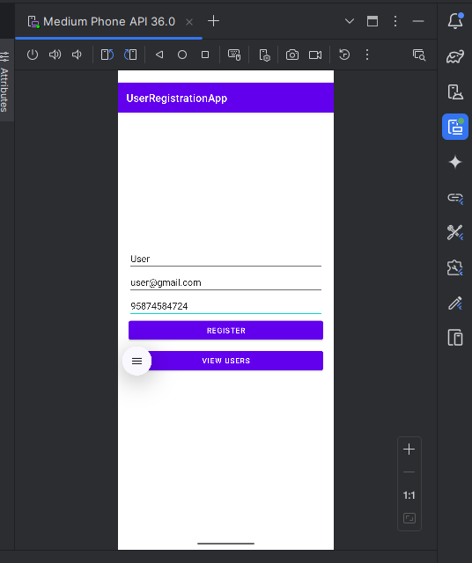

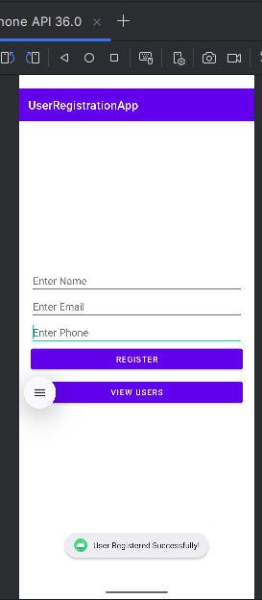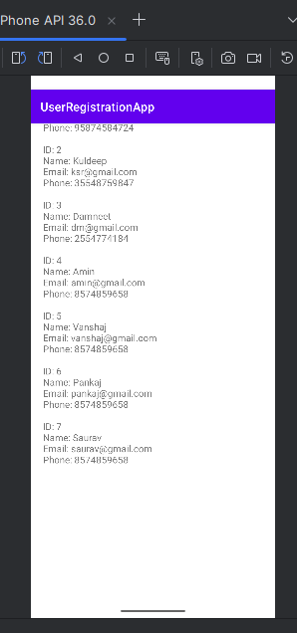

**Practical 7: Android Program to perform CRUD operation using real time database Firebase.**

MainActivity.java

package com.example.myapplication;

import androidx.appcompat.app.AppCompatActivity; import android.os.Bundle;

import android.os.Environment; import android.view.View; import android.widget.Button; import android.widget.EditText; import android.widget.TextView; import android.widget.Toast; import java.io.BufferedReader; import java.io.File;

import java.io.FileInputStream; import java.io.FileOutputStream; import java.io.IOException; import java.io.InputStreamReader;

public class MainActivity extends AppCompatActivity { private EditText inputText;

private Button btnWrite, btnLoad; private TextView dir;

private String filename = "hello.txt"; private String filepath = "MyFileStorage"; private File extFile;

private String data = "";

@Override

protected void onCreate(Bundle savedInstanceState) { super.onCreate(savedInstanceState); setContentView(R.layout.activity_main);

inputText = findViewById(R.id.input_text); btnWrite = findViewById(R.id.btn_write); btnLoad = findViewById(R.id.btn_load); dir=findViewById(R.id.dir);

if (!isExternalStorageAvailable() || isExternalStorageReadOnly()) { btnWrite.setEnabled(false);

}

else {

extFile = new File(getExternalFilesDir(filepath), filename);

}

getDir();

btnWrite.setOnClickListener(new View.OnClickListener() { @Override

public void onClick(View view) {

data = inputText.getText().toString(); try {

FileOutputStream fos = new FileOutputStream(extFile); fos.write(data.getBytes());

// fos.write("Hello".getBytes()); inputText.getText().clear();

Toast.makeText(getApplicationContext(), filename + " saved to external storage...",

Toast.LENGTH_SHORT).show(); fos.close();

}

catch (IOException ex) { ex.printStackTrace();

}

}

});

btnLoad.setOnClickListener(new View.OnClickListener() { @Override

public void onClick(View view) { try {

FileInputStream fis = new FileInputStream(extFile); InputStreamReader isr = new InputStreamReader(fis); BufferedReader br = new BufferedReader(isr); StringBuilder data = new StringBuilder();

String line;

while ((line = br.readLine()) != null) { data.append("\n").append(line);

}

inputText.setText(data);

Toast.makeText(getApplicationContext(), "Data Retrieved from External File Successfully...", Toast.LENGTH_SHORT).show();

fis.close();

}

catch (IOException ex) { ex.printStackTrace();

}

}

});

}

private static boolean isExternalStorageAvailable() {

String extStorageState = Environment.getExternalStorageState(); return Environment.MEDIA_MOUNTED.equals(extStorageState);

}

private static boolean isExternalStorageReadOnly() {

String extStorageState = Environment.getExternalStorageState();

return Environment.MEDIA_MOUNTED_READ_ONLY.equals(extStorageState);

}

private void getDir()

{

StringBuilder builder=new StringBuilder();

builder.append("External File Directories: ").append(getExternalFilesDir(filepath).getAbsolutePath()).append("\n");

dir.setText(builder.toString());

}

}

POJO.java

package com.example.myapplication;

import androidx.appcompat.app.AppCompatActivity; import android.os.Bundle;

import android.os.Environment;

import android.view.View; import android.widget.Button; import android.widget.EditText; import android.widget.TextView; import android.widget.Toast; import java.io.BufferedReader; import java.io.File;

import java.io.FileInputStream; import java.io.FileOutputStream; import java.io.IOException; import java.io.InputStreamReader;

public class MainActivity extends AppCompatActivity { private EditText inputText;

private Button btnWrite, btnLoad;

private TextView dir;

private String filename = "hello.txt"; private String filepath = "MyFileStorage"; private File extFile;

private String data = "";

@Override

protected void onCreate(Bundle savedInstanceState) { super.onCreate(savedInstanceState); setContentView(R.layout.activity_main);

inputText = findViewById(R.id.input_text); btnWrite = findViewById(R.id.btn_write); btnLoad = findViewById(R.id.btn_load); dir=findViewById(R.id.dir);

if (!isExternalStorageAvailable() || isExternalStorageReadOnly()) { btnWrite.setEnabled(false);

}

else {

extFile = new File(getExternalFilesDir(filepath), filename);

}

getDir();

btnWrite.setOnClickListener(new View.OnClickListener() { @Override

public void onClick(View view) {

data = inputText.getText().toString(); try {

FileOutputStream fos = new FileOutputStream(extFile); fos.write(data.getBytes());

// fos.write("Hello".getBytes()); inputText.getText().clear();

Toast.makeText(getApplicationContext(), filename + " saved to external storage...", Toast.LENGTH_SHORT).show();

fos.close();

}

catch (IOException ex) { ex.printStackTrace();

}

}

});

btnLoad.setOnClickListener(new View.OnClickListener() {

@Override

public void onClick(View view) { try {

FileInputStream fis = new FileInputStream(extFile); InputStreamReader isr = new InputStreamReader(fis); BufferedReader br = new BufferedReader(isr); StringBuilder data = new StringBuilder();

String line;

while ((line = br.readLine()) != null) { data.append("\n").append(line);

}

inputText.setText(data);

Toast.makeText(getApplicationContext(), "Data Retrieved from External File Successfully...", Toast.LENGTH_SHORT).show();

fis.close();

}

catch (IOException ex) { ex.printStackTrace();

}

}

});

}

private static boolean isExternalStorageAvailable() {

String extStorageState = Environment.getExternalStorageState(); return Environment.MEDIA_MOUNTED.equals(extStorageState);

}

private static boolean isExternalStorageReadOnly() {

String extStorageState = Environment.getExternalStorageState();

return Environment.MEDIA_MOUNTED_READ_ONLY.equals(extStorageState);

}

private void getDir()

{

StringBuilder builder=new StringBuilder();

builder.append("External File Directories: ").append(getExternalFilesDir(filepath).getAbsolutePath()).append("\n");

dir.setText(builder.toString());

}

}

XML File

package com.example.myapplication;

import androidx.appcompat.app.AppCompatActivity; import android.os.Bundle;

import android.os.Environment; import android.view.View; import android.widget.Button; import android.widget.EditText; import android.widget.TextView; import android.widget.Toast; import java.io.BufferedReader;

import java.io.File;

import java.io.FileInputStream; import java.io.FileOutputStream; import java.io.IOException; import java.io.InputStreamReader;

public class MainActivity extends AppCompatActivity { private EditText inputText;

private Button btnWrite, btnLoad;

private TextView dir;

private String filename = "hello.txt"; private String filepath = "MyFileStorage"; private File extFile;

private String data = "";

@Override

protected void onCreate(Bundle savedInstanceState) { super.onCreate(savedInstanceState); setContentView(R.layout.activity_main);

inputText = findViewById(R.id.input_text); btnWrite = findViewById(R.id.btn_write); btnLoad = findViewById(R.id.btn_load); dir=findViewById(R.id.dir);

if (!isExternalStorageAvailable() || isExternalStorageReadOnly()) { btnWrite.setEnabled(false);

}

else {

extFile = new File(getExternalFilesDir(filepath), filename);

}

getDir();

btnWrite.setOnClickListener(new View.OnClickListener() { @Override

public void onClick(View view) {

data = inputText.getText().toString(); try {

FileOutputStream fos = new FileOutputStream(extFile); fos.write(data.getBytes());

// fos.write("Hello".getBytes()); inputText.getText().clear();

Toast.makeText(getApplicationContext(), filename + " saved to external storage...", Toast.LENGTH_SHORT).show();

fos.close();

}

catch (IOException ex) { ex.printStackTrace();

}

}

});

btnLoad.setOnClickListener(new View.OnClickListener() { @Override

public void onClick(View view) { try {

FileInputStream fis = new FileInputStream(extFile); InputStreamReader isr = new InputStreamReader(fis); BufferedReader br = new BufferedReader(isr);

StringBuilder data = new StringBuilder(); String line;

while ((line = br.readLine()) != null) { data.append("\n").append(line);

}

inputText.setText(data);

Toast.makeText(getApplicationContext(), "Data Retrieved from External File Successfully...", Toast.LENGTH_SHORT).show();

fis.close();

}

catch (IOException ex) { ex.printStackTrace();

}

}

});

}

private static boolean isExternalStorageAvailable() {

String extStorageState = Environment.getExternalStorageState(); return Environment.MEDIA_MOUNTED.equals(extStorageState);

}

private static boolean isExternalStorageReadOnly() {

String extStorageState = Environment.getExternalStorageState();

return Environment.MEDIA_MOUNTED_READ_ONLY.equals(extStorageState);

}

private void getDir()

{

StringBuilder builder=new StringBuilder();

builder.append("External File Directories: ").append(getExternalFilesDir(filepath).getAbsolutePath()).append("\n");

dir.setText(builder.toString());

}

}

# Output:

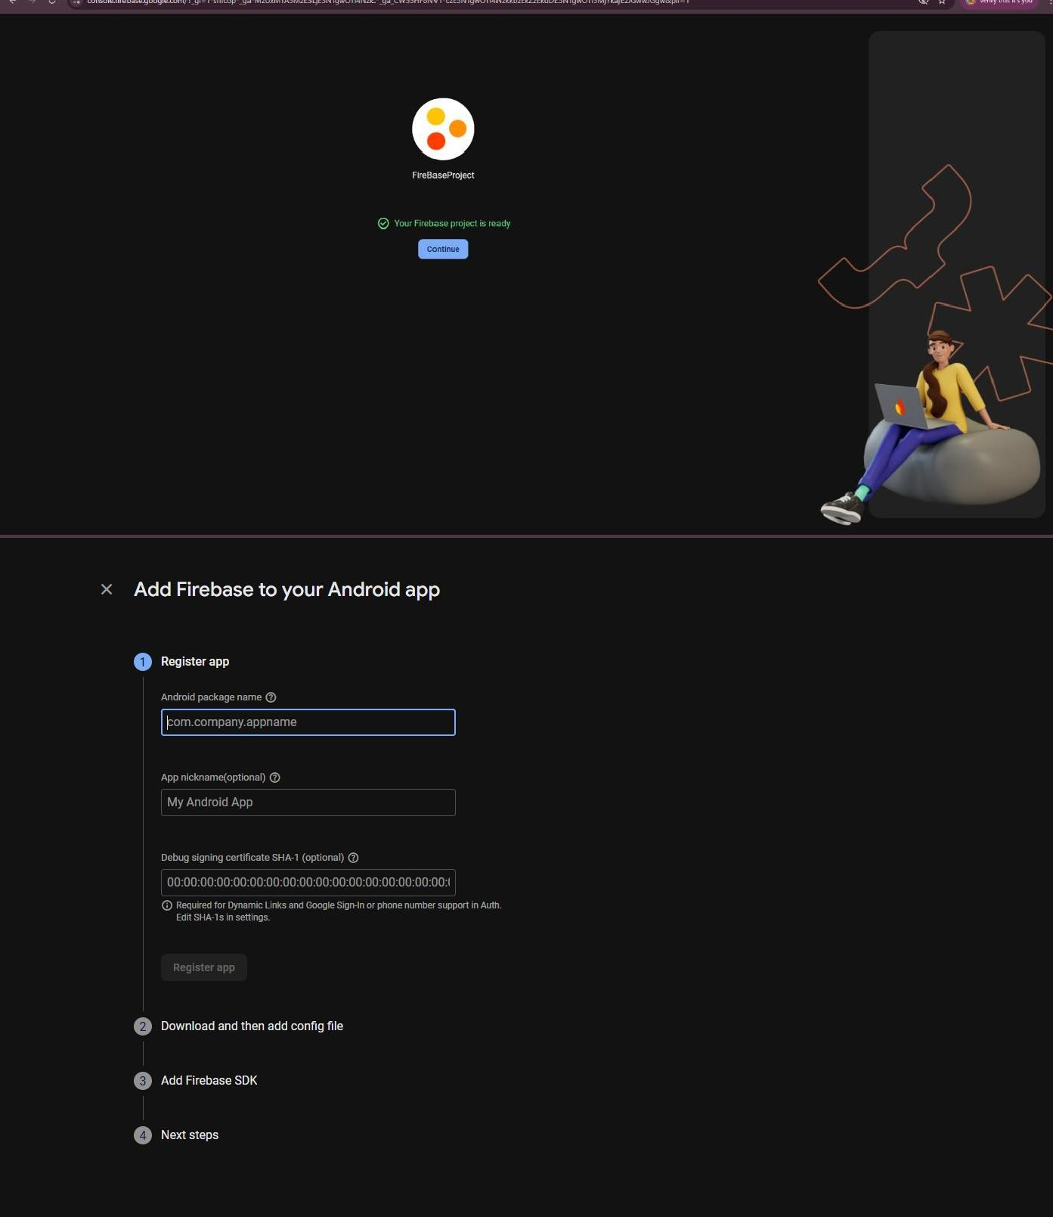

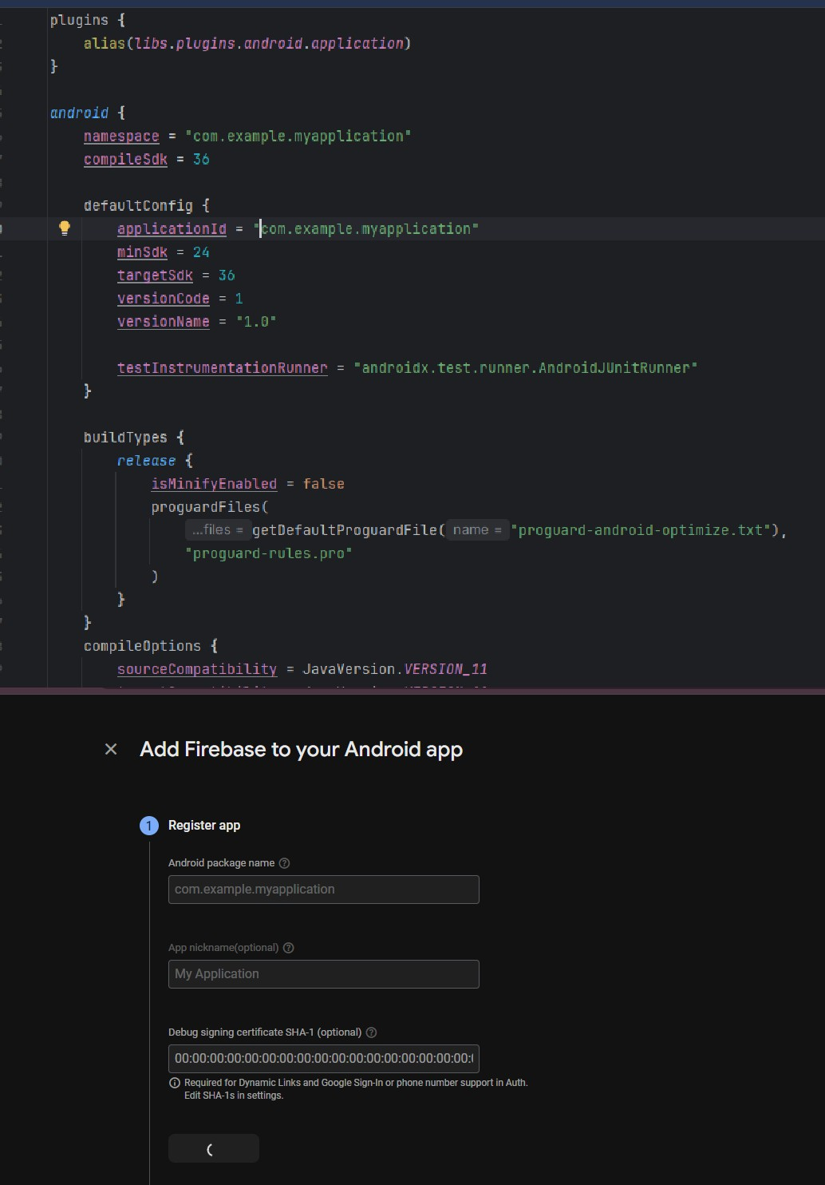

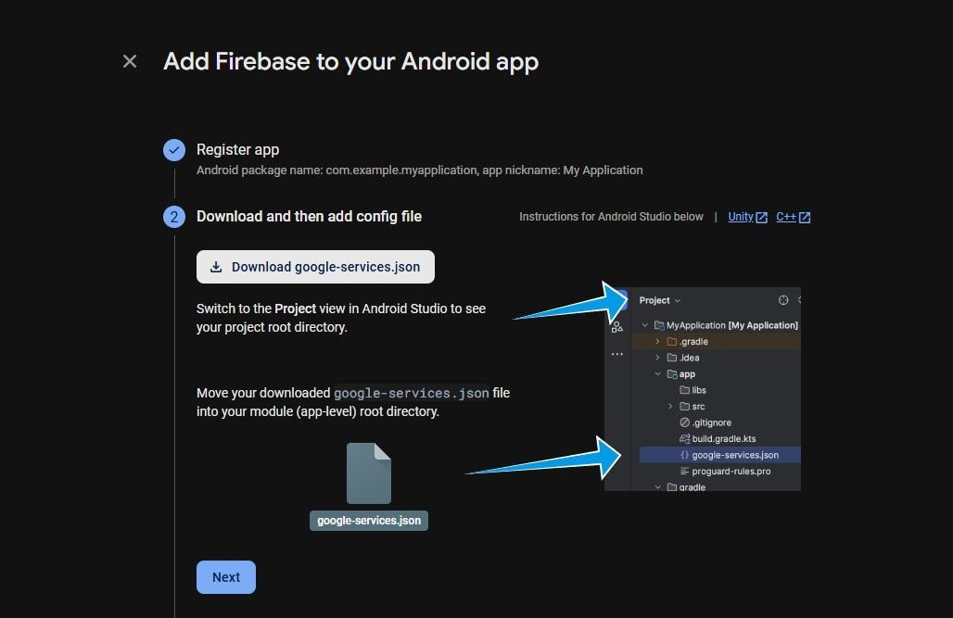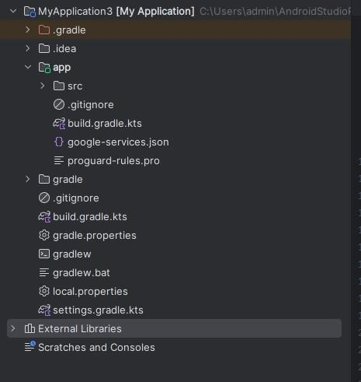

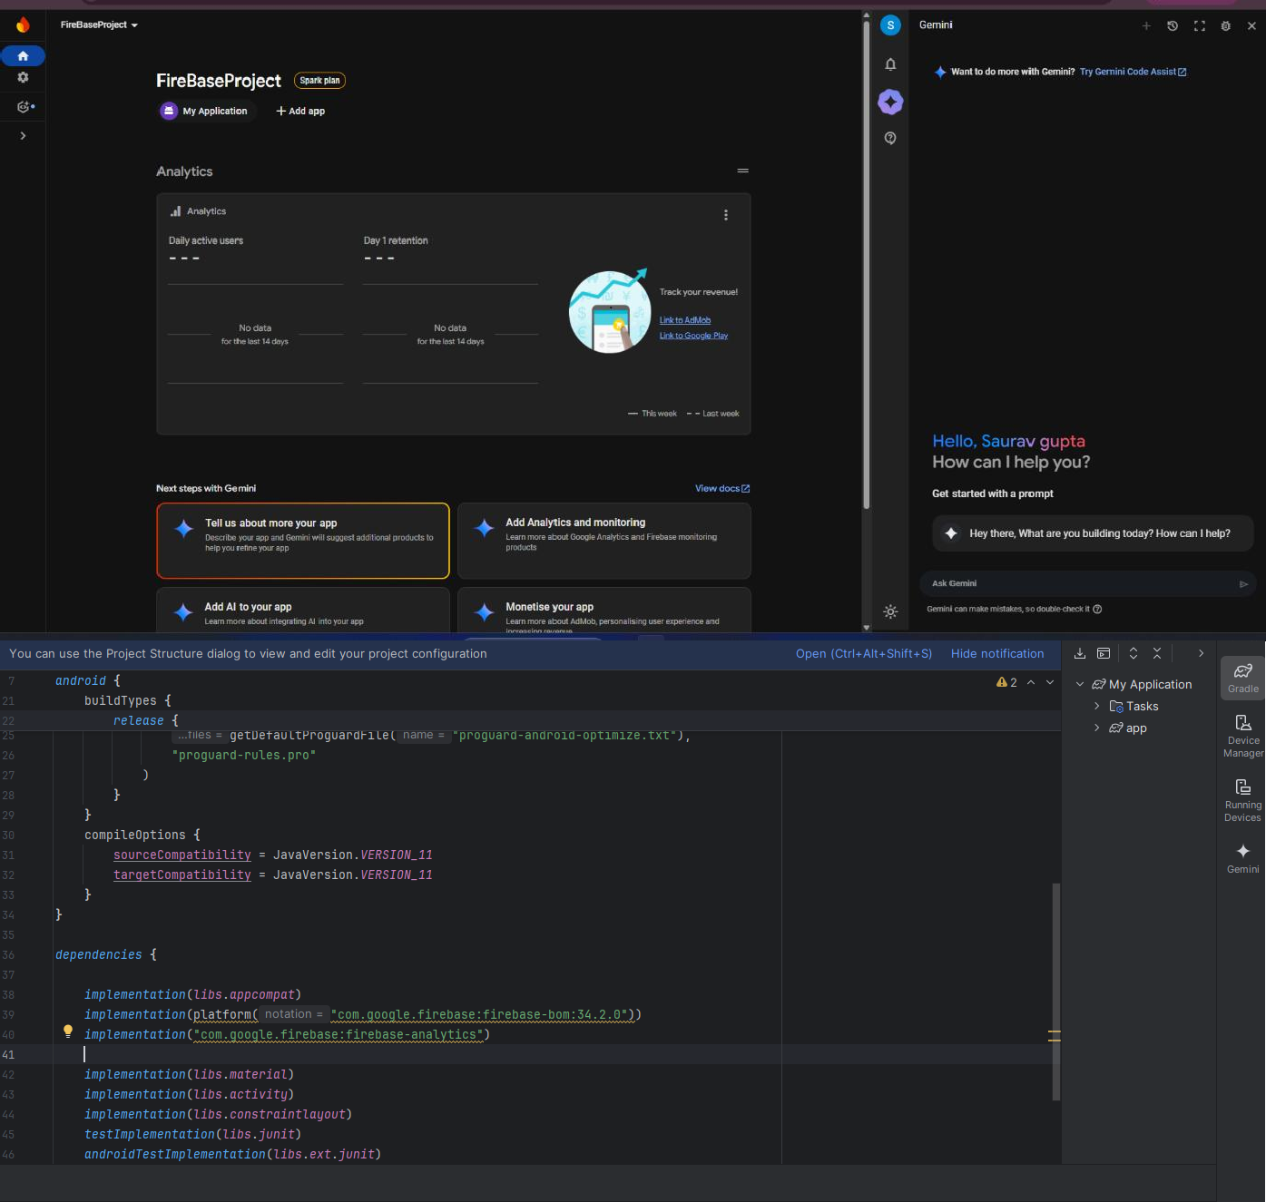

Follow steps and do sync now

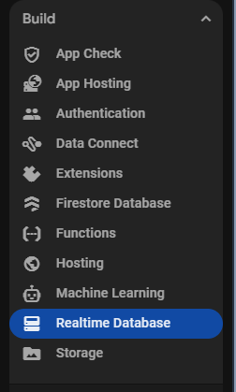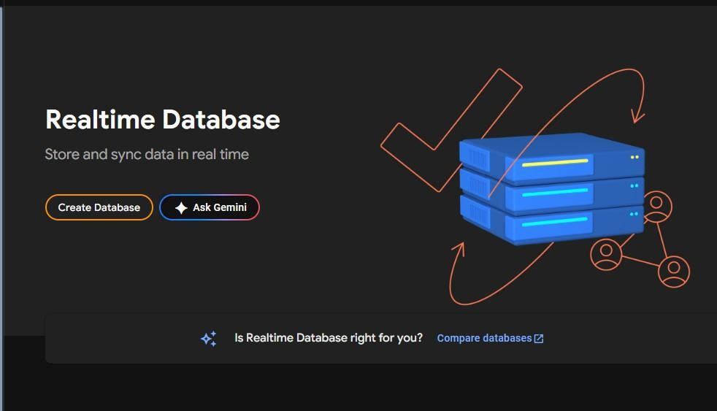

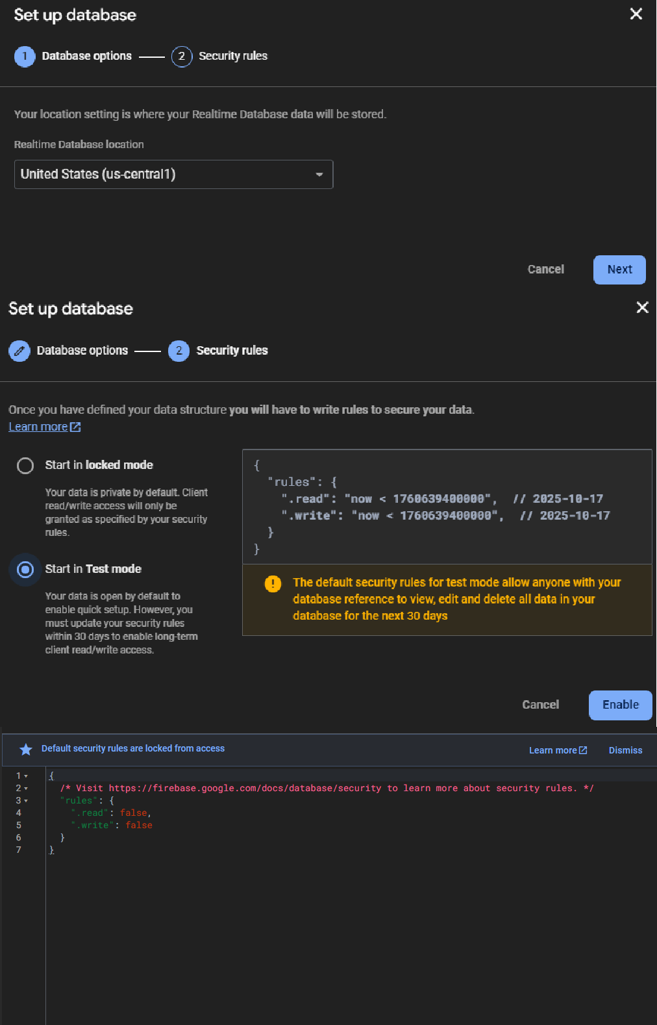

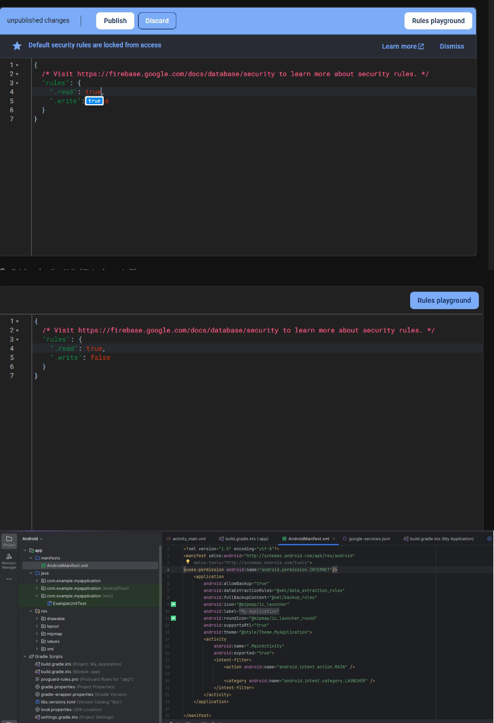

Add this a well in App level bluild.gradle.kts



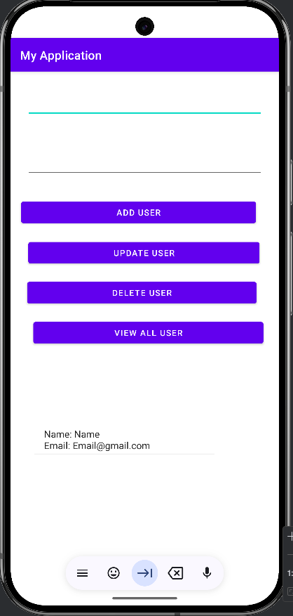

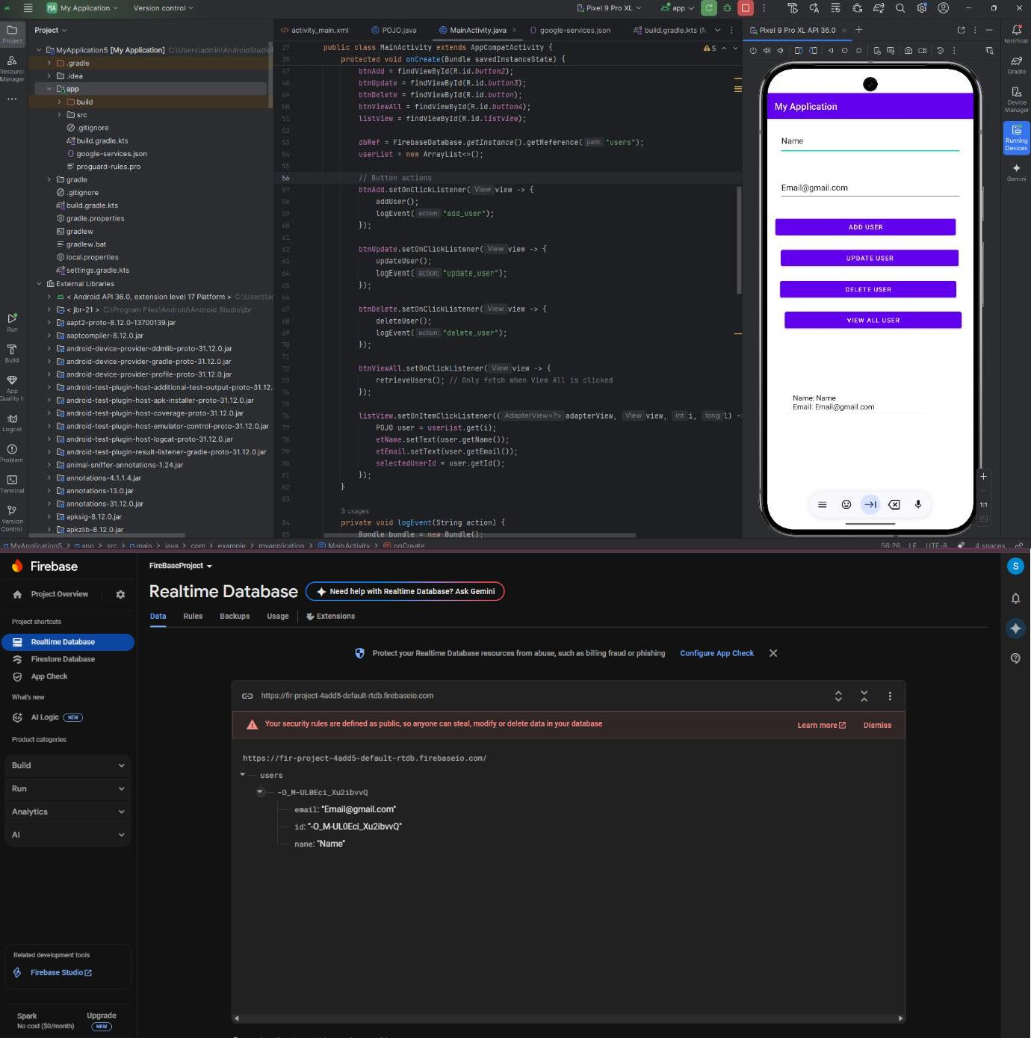

**Module 3 Animation, Multimedia and Location Based Services:**

1. **Write an Android application to play, pause, and stop an audio file.**

## activity_main.xml

<?xml version="1.0" encoding="utf-8"?>

<LinearLayout xmlns:android=["http://schemas.android.com/apk/res/android"](http://schemas.android.com/apk/res/android) xmlns:app=["http://schemas.android.com/apk/res-auto"](http://schemas.android.com/apk/res-auto) xmlns:t[ools="http://schemas.android.com/tools"](http://schemas.android.com/tools) android:layout_width="match_parent" android:layout_height="match_parent" android:gravity="bottom|center_horizontal" android:orientation="horizontal"

android:background="@drawable/music" tools:context=".MainActivity">

<Button

android:id="@+id/btnPlay" android:layout_width="wrap_content" android:layout_height="wrap_content" android:layout_margin="10dp" android:backgroundTint="#C6A8A8" android:text="Play" android:textColor="#01579B" />

<Button

android:id="@+id/btnPause" android:layout_width="wrap_content" android:layout_height="wrap_content" android:layout_margin="10dp" android:backgroundTint="#C6A8A8" android:text="Pause" android:textColor="#01579B" />

<Button

android:id="@+id/btnStop" android:layout_width="wrap_content" android:layout_height="wrap_content" android:layout_margin="10dp" android:backgroundTint="#C6A8A8" android:text="Stop" android:textColor="#01579B" />

</LinearLayout>

## MainActivity.java

package com.example.myapplication;

import androidx.appcompat.app.AppCompatActivity; import android.media.MediaPlayer;

import android.os.Bundle; import android.view.View; import android.widget.Button;

public class MainActivity extends AppCompatActivity { Button play,pause,stop;

MediaPlayer mp; @Override

protected void onCreate(Bundle savedInstanceState) { super.onCreate(savedInstanceState); setContentView(R.layout.activity_main); play=findViewById(R.id.btnPlay); pause=findViewById(R.id.btnPause); stop=findViewById(R.id.btnStop); play.setOnClickListener(new View.OnClickListener() {

@Override

public void onClick(View v) { if(mp==null)

{

mp=MediaPlayer.create(getApplicationContext(),R.raw.song);

} mp.start();

}

});

pause.setOnClickListener(new View.OnClickListener() { @Override

public void onClick(View v) { if(mp!=null)

{

mp.pause();

}

}

});

stop.setOnClickListener(new View.OnClickListener() { @Override

public void onClick(View v) { if(mp!=null)

{

}

});

}

}

mp.release(); mp=null;

}

**Ouput :**

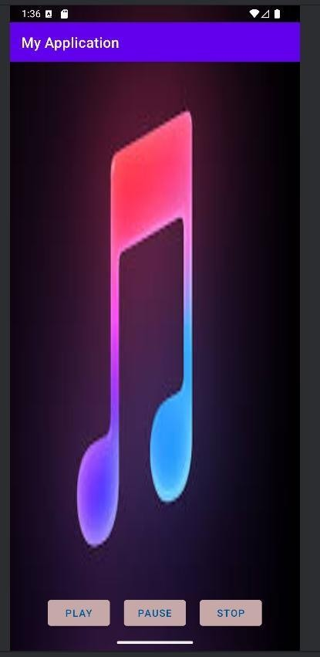

1. **Write an Android application to play a video with Media controller.**

## activity_main.xml

<?xml version="1.0" encoding="utf-8"?>

<FrameLayout xmlns:android=["http://schemas.android.com/apk/res/android"](http://schemas.android.com/apk/res/android) xmlns:app=["http://schemas.android.com/apk/res-auto"](http://schemas.android.com/apk/res-auto) xmlns:t[ools="http://schemas.android.com/tools"](http://schemas.android.com/tools) android:layout_width="match_parent" android:layout_height="match_parent"

tools:context=".MainActivity">

<VideoView android:id="@+id/video_view" android:layout_width="match_parent" android:layout_marginTop="80dp" android:layout_height="match_parent" />

</FrameLayout>

## MainActivity.java

package com.example.myapplication;

import androidx.appcompat.app.AppCompatActivity; import android.net.Uri;

import android.os.Bundle;

import android.widget.MediaController; import android.widget.VideoView;

public class MainActivity extends AppCompatActivity { @Override

protected void onCreate(Bundle savedInstanceState) { super.onCreate(savedInstanceState); setContentView(R.layout.activity_main);

VideoView videoView = findViewById(R.id.video_view);

//Storing video resource in string variable

String videoPath = "android.resource://" + getPackageName() + "/" + R.raw.video; Uri uri = Uri.parse(videoPath);

videoView.setVideoURI(uri);

MediaController mediaController = new MediaController(this); videoView.setMediaController(mediaController); mediaController.setAnchorView(videoView);

}

}

**Output :**

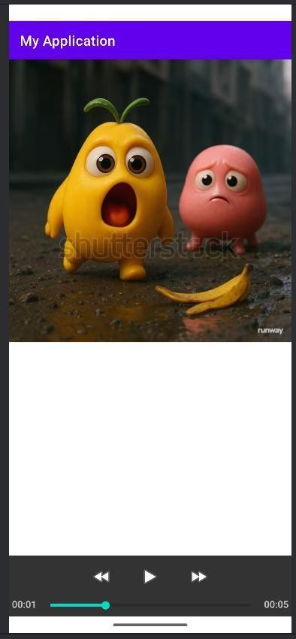

1. **Create an android application that applies different animations on**

**an image.**

## activity_main.xml

<?xml version="1.0" encoding="utf-8"?>

<GridLayout xmlns:andr[oid="http://schemas.android.com/apk/res/android"](http://schemas.android.com/apk/res/android) xmlns:app=["http://schemas.android.com/apk/res-auto"](http://schemas.android.com/apk/res-auto) xmlns:t[ools="http://schemas.android.com/tools"](http://schemas.android.com/tools) android:layout_width="wrap_content" android:layout_height="wrap_content"

android:columnCount="4" android:layout_gravity="center" tools:context=".MainActivity">

<!-- this layout holds image which won't overflow out of this frame during animations -->

<FrameLayout android:padding="5dp" android:layout_gravity="center" android:layout_columnSpan="4">

<ImageView android:layout_width="180dp" android:layout_height="180dp" android:id="@+id/bird" android:src="@drawable/bird" />

</FrameLayout>

<TextView style="@style/animation_title_props" android:text="Rotate Animations" />

<Button

style="@style/btn_medium_props" android:text="Clockwise" android:onClick="clockwise"/>

<Button

style="@style/btn_medium_props" android:text="Anti Clockwise" android:onClick="antiClockwise" android:layout_width="170dp"/>

<TextView style="@style/animation_title_props" android:text="Scale Animations" />

<Button

style="@style/btn_medium_props" android:text="Expand" android:onClick="expand"/>

<Button

style="@style/btn_medium_props" android:text="Shrink" android:onClick="shrink"/>

<TextView style="@style/animation_title_props" android:text="Translate Animations" />

<Button

style="@style/btn_min_props" android:text="L2R" android:onClick="slideL2R"/>

<Button

style="@style/btn_min_props" android:text="T2B" android:onClick="slideT2B"/>

<Button

style="@style/btn_min_props" android:text="R2L" android:onClick="slideR2L"/>

<Button

style="@style/btn_min_props" android:text="B2T" android:onClick="slideB2T"/>

<TextView style="@style/animation_title_props" android:text="Alpha Animations" />

<Button

style="@style/btn_medium_props" android:text="Fade In" android:onClick="fadeIn"/>

<Button

style="@style/btn_medium_props" android:text="Fade Out" android:onClick="fadeOut"/>

<TextView style="@style/animation_title_props" android:text="Mix Animations" />

<Button

style="@style/btn_medium_props" android:text="Expand with Rotation" android:onClick="expandWithRotation"/>

<Button

style="@style/btn_medium_props" android:text="Slide with Fade In" android:onClick="slideWithFadeIn"/>

<TextView style="@style/animation_title_props" android:text="Clear Animation" />

<Button

style="@style/btn_max_props" android:text="Clear Animation" android:onClick="clearAnimation"/>

</GridLayout>

## MainActivity.java

package com.example.myapplication;

import androidx.appcompat.app.AppCompatActivity; import android.os.Bundle;

import android.view.View;

import android.view.animation.Animation; import android.view.animation.AnimationUtils; import android.widget.ImageView;

import android.widget.Toast;

public class MainActivity extends AppCompatActivity { ImageView bird;

Animation animation; @Override

protected void onCreate(Bundle savedInstanceState) { super.onCreate(savedInstanceState); setContentView(R.layout.activity_main); bird=findViewById(R.id.bird);

}

public void expand(View view) {

animation = AnimationUtils.loadAnimation(MainActivity.this, R.anim.expand); bird.startAnimation(animation);

Toast.makeText(this, "Expanding...", Toast.LENGTH_SHORT).show();

}

public void shrink(View view) {

animation = AnimationUtils.loadAnimation(MainActivity.this, R.anim.shrink); bird.startAnimation(animation);

Toast.makeText(this, "Shrinking Scaling...", Toast.LENGTH_SHORT).show();

}

public void fadeIn(View view) {

animation = AnimationUtils.loadAnimation(MainActivity.this, R.anim.fade_in); bird.startAnimation(animation);

Toast.makeText(this, "Fading In...", Toast.LENGTH_SHORT).show();

}

public void fadeOut(View view) {

animation = AnimationUtils.loadAnimation(MainActivity.this, R.anim.fade_out); bird.startAnimation(animation);

Toast.makeText(this, "Fading Out...", Toast.LENGTH_SHORT).show();

}

public void expandWithRotation(View view) {

animation = AnimationUtils.loadAnimation(MainActivity.this, R.anim.expand_with_rotation); bird.startAnimation(animation);

Toast.makeText(this, "Expanding with Rotation...", Toast.LENGTH_SHORT).show();

}

public void clearAnimation(View view) { bird.clearAnimation();

Toast.makeText(this, "Animation Cleared...", Toast.LENGTH_SHORT).show();

}

}

## Themes.xml

<style name="animation_title_props">

<item name="android:layout_columnSpan">4</item>

<item name="android:textColor">@color/black</item>

<item name="android:textSize">20sp</item>

<item name="android:paddingTop">10dp</item>

</style>

<!-- small button properties -->

<style name="btn_min_props">

<item name="android:layout_columnSpan">1</item>

<item name="android:layout_width">80dp</item>

<item name="android:layout_margin">1dp</item>

</style>

<!-- medium button properties -->

<style name="btn_medium_props">

<item name="android:layout_columnSpan">2</item>

<item name="android:layout_width">165dp</item>

<item name="android:layout_margin">1dp</item>

</style>

<!-- large button properties -->

<style name="btn_max_props">

<item name="android:layout_columnSpan">4</item>

<item name="android:layout_width">wrap_content</item>

<item name="android:layout_gravity">center</item>

</style>

## Expand.xml

<?xml version="1.0" encoding="utf-8"?>

<set xmlns:android[="http://schemas.android.com/apk/res/android](http://schemas.android.com/apk/res/android)">

<scale

android:fromXScale="0" android:toXScale="2" android:fromYScale="0" android:toYScale="2" android:pivotX="70%" android:pivotY="70%" android:repeatCount="infinite" android:duration="2000" />

</set>

## Shrink.xml

<?xml version="1.0" encoding="utf-8"?>

<set xmlns:android[="http://schemas.android.com/apk/res/android](http://schemas.android.com/apk/res/android)">

<scale

android:fromXScale="1" android:toXScale="0" android:fromYScale="1" android:toYScale="0" android:pivotX="50%" android:pivotY="50%" android:duration="2000" />

</set>

## fadeIn.xml

<?xml version="1.0" encoding="utf-8"?>

<set xmlns:android[="http://schemas.android.com/apk/res/android](http://schemas.android.com/apk/res/android)">

<alpha

android:fromAlpha="0" android:toAlpha="1" android:duration="2000" />

</set>

## fadeout.xml

<?xml version="1.0" encoding="utf-8"?>

<set xmlns:android[="http://schemas.android.com/apk/res/android](http://schemas.android.com/apk/res/android)">

<alpha

android:fromAlpha="1" android:toAlpha="0" android:duration="2000" />

</set>

**Output :**

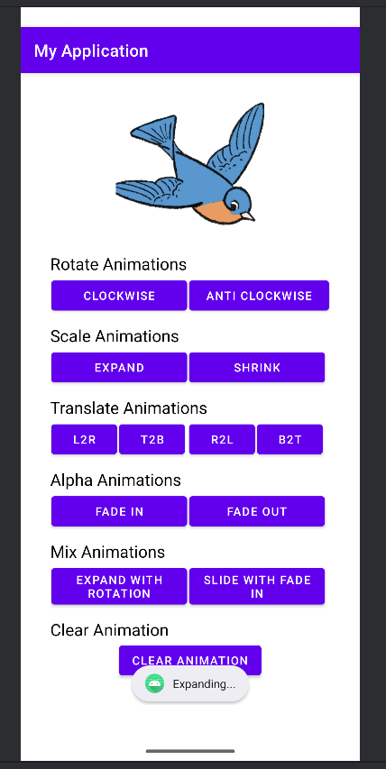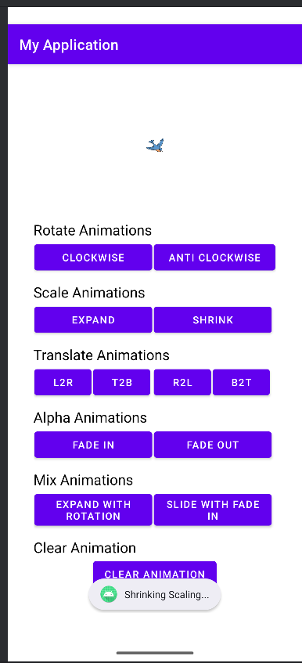

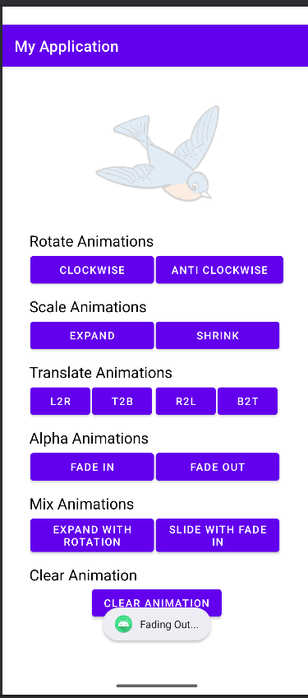

1. **Create an Android application to implement frame animation.**

## Running.xml

<?xml version="1.0" encoding="utf-8"?>

<animation-list xmlns:android[="http://schemas.android.com/apk/res/android](http://schemas.android.com/apk/res/android)">

<item android:drawable="@drawable/one" android:duration="100" />

<item android:drawable="@drawable/two" android:duration="100" />

<item android:drawable="@drawable/three" android:duration="100" />

<item android:drawable="@drawable/four" android:duration="100" />

</animation-list>

## activity_main.xml

<?xml version="1.0" encoding="utf-8"?>

<LinearLayout xmlns:android[="http://schemas.android.com/apk/res/android](http://schemas.android.com/apk/res/android)" xmlns:app="[http://schemas.android.com/apk/res-auto"](http://schemas.android.com/apk/res-auto) xmlns:tools="[http://schemas.android.com/tools"](http://schemas.android.com/tools) android:layout_width="match_parent" android:layout_height="match_parent"

android:orientation="vertical" android:gravity="center" tools:context=".MainActivity">

<!-- image view to hold animation frame images -->

<ImageView android:id="@+id/img"

android:layout_width="match_parent" android:layout_height="wrap_content" android:src="@drawable/running" />

<!-- button to start or pause animation -->

<Button android:id="@+id/btn_start_stop" android:layout_width="wrap_content" android:layout_height="wrap_content" android:text="Start" />

</LinearLayout>

## MainActivity.java

import androidx.appcompat.app.AppCompatActivity; import android.graphics.drawable.AnimationDrawable; import android.os.Bundle;

import android.widget.Button; import android.widget.ImageView;

public class MainActivity extends AppCompatActivity { ImageView img;

Button btnStartStop; AnimationDrawable animation; @Override

protected void onCreate(Bundle savedInstanceState) { super.onCreate(savedInstanceState); setContentView(R.layout.activity_main);

img = findViewById(R.id.img);

btnStartStop = findViewById(R.id.btn_start_stop);

// fetching animation drawable from image view animation = (AnimationDrawable) img.getDrawable();

// starting and stopping animation on button click btnStartStop.setOnClickListener(view -> {

// if running then stop

if (animation.isRunning()) { animation.stop(); btnStartStop.setText("Start"); return;

});

}

}

}

// else start animation animation.start(); btnStartStop.setText("Stop");

**Output :**

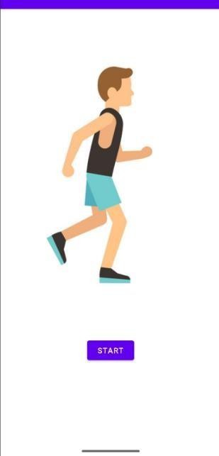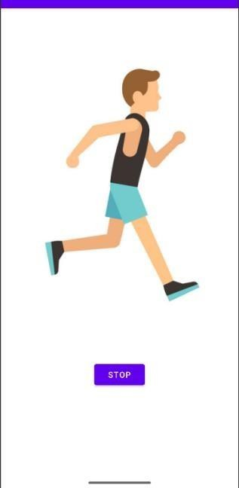

1. **Create an Android application to display the current location of your device (display longitude and latitude values).**

## AndroidManifest.xml:

<uses-permission android:name="android.permission.ACCESS_FINE_LOCATION" />

<uses-permission android:name="android.permission.ACCESS_COARSE_LOCATION" />

<uses-permission android:name="android.permission.INTERNET" />

## activity_main.xml

<?xml version="1.0" encoding="utf-8"?>

<LinearLayout xmlns:android[="http://schemas.android.com/apk/res/android](http://schemas.android.com/apk/res/android)" android:layout_width="match_parent" android:layout_height="match_parent" android:orientation="vertical" android:padding="16dp">

<TextView android:id="@+id/latitude" android:layout_width="wrap_content" android:layout_height="wrap_content" android:layout_marginTop="20dp" android:text="Latitude:" android:textSize="24sp"/>

<TextView android:id="@+id/longitude" android:layout_width="wrap_content" android:layout_height="wrap_content" android:layout_marginTop="20dp" android:text="Longitude:" android:textSize="24sp"/>

<Button android:id="@+id/fetch_location_button" android:layout_width="wrap_content" android:layout_height="wrap_content" android:layout_marginTop="20dp" android:text="Fetch Coordinates" />

</LinearLayout>

## MainActivity.java

package com.example.myapplication;

import android.Manifest;

import android.content.pm.PackageManager; import android.os.Bundle;

import android.widget.Button;

import android.widget.TextView;

import androidx.activity.EdgeToEdge;

import androidx.appcompat.app.AppCompatActivity; import androidx.core.app.ActivityCompat;

import androidx.core.graphics.Insets; import androidx.core.view.ViewCompat;

import androidx.core.view.WindowInsetsCompat;

import com.google.android.gms.location.FusedLocationProviderClient; import com.google.android.gms.location.LocationServices;

public class MainActivity extends AppCompatActivity {

TextView latitudeText, longitudeText; FusedLocationProviderClient fusedLocationClient;

@Override

protected void onCreate(Bundle savedInstanceState) { super.onCreate(savedInstanceState); setContentView(R.layout.activity_main);

latitudeText = findViewById(R.id.latitude); longitudeText = findViewById(R.id.longitude);

fusedLocationClient = LocationServices.getFusedLocationProviderClient(this);

Button fetchButton = findViewById(R.id.fetch_location_button); fetchButton.setOnClickListener(v -> fetchCoordinates());

}

private void fetchCoordinates() {

if (ActivityCompat.checkSelfPermission(this, Manifest.permission.ACCESS_FINE_LOCATION) != PackageManager.PERMISSION_GRANTED) {

ActivityCompat.requestPermissions(this, new String[]{Manifest.permission.ACCESS_FINE_LOCATION}, 1);

return;

}

fusedLocationClient.getLastLocation()

.addOnSuccessListener(this, location -> { if (location != null) {

latitudeText.setText("Latitude: " + location.getLatitude()); longitudeText.setText("Longitude: " + location.getLongitude());

}

});

}

}

**Output:**

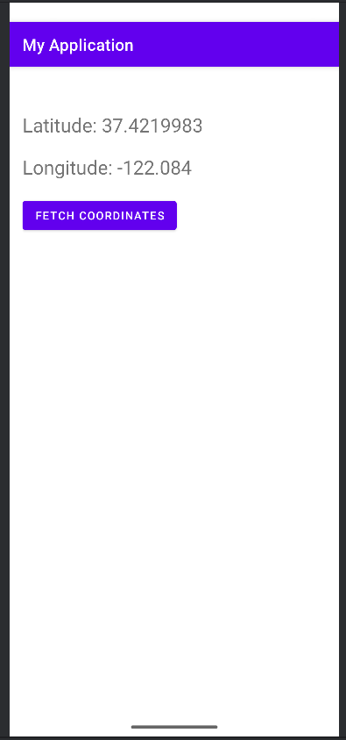

1. **Create an Android application that displays the current location of your device from longitude and latitude values (Reverse Geocoding).**

## Main activity.java

package com.example.myapplication;

import android.Manifest;

import android.content.pm.PackageManager; import android.location.Address;

import android.location.Geocoder; import android.os.Bundle;

import android.widget.Button; import android.widget.TextView;

import androidx.activity.EdgeToEdge;

import androidx.appcompat.app.AppCompatActivity; import androidx.core.app.ActivityCompat;

import androidx.core.graphics.Insets; import androidx.core.view.ViewCompat;

import androidx.core.view.WindowInsetsCompat;

import com.google.android.gms.location.FusedLocationProviderClient; import com.google.android.gms.location.LocationServices;

import java.io.IOException; import java.util.List;

import java.util.Locale;

public class MainActivity extends AppCompatActivity { TextView addressText;

FusedLocationProviderClient fusedLocationClient;

@Override

protected void onCreate(Bundle savedInstanceState) { super.onCreate(savedInstanceState); setContentView(R.layout.activity_main);

addressText = findViewById(R.id.address);

fusedLocationClient = LocationServices.getFusedLocationProviderClient(this);

Button fetchButton = findViewById(R.id.fetch_address_button); fetchButton.setOnClickListener(v -> fetchAddress());

}

private void fetchAddress() {

if (ActivityCompat.checkSelfPermission(this, Manifest.permission.ACCESS_FINE_LOCATION) != PackageManager.PERMISSION_GRANTED) {

ActivityCompat.requestPermissions(this, new String[]{Manifest.permission.ACCESS_FINE_LOCATION}, 1);

return;

}

fusedLocationClient.getLastLocation()

.addOnSuccessListener(this, location -> { if (location != null) {

Geocoder geocoder = new Geocoder(this, Locale.getDefault()); try {

List<Address> addresses = geocoder.getFromLocation(location.getLatitude(), location.getLongitude(), 1);

if (addresses != null && !addresses.isEmpty()) { String address = addresses.get(0).getAddressLine(0); addressText.setText("Address: " + address);

} else {

addressText.setText("No address found.");

}

} catch (IOException e) { e.printStackTrace();

addressText.setText("Error: " + e.getMessage());

}

}

});

}

}

## Activity main.xml

<?xml version="1.0" encoding="utf-8"?>

<LinearLayout xmlns:android=["http://schemas.android.com/apk/res/android"](http://schemas.android.com/apk/res/android) android:layout_width="match_parent" android:layout_height="match_parent" android:orientation="vertical" android:padding="16dp">

<TextView android:id="@+id/address" android:layout_width="wrap_content" android:layout_height="wrap_content" android:layout_marginTop="50dp" android:text="Address will appear here" android:textSize="18sp"/>

<Button

android:id="@+id/fetch_address_button" android:layout_width="wrap_content" android:layout_height="wrap_content" android:layout_marginTop="24sp" android:text="Fetch Address" />

</LinearLayout>

**Output :**

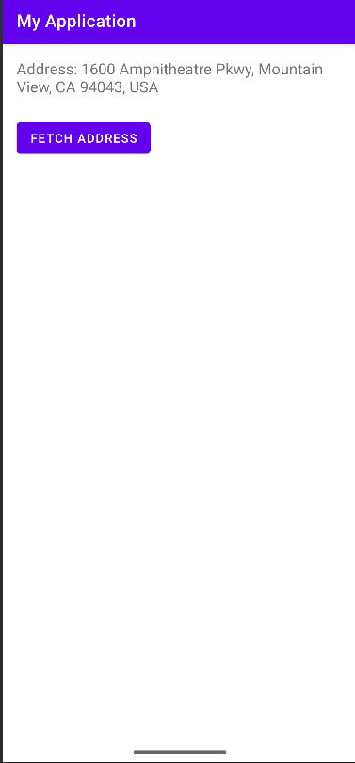

**Module 4 REST API integration:**

1. **Create an Android application to demonstrate JSON data parsing using OkHttp (you can use https://api.github.com/users JSON data).**

## activity_main.xml

<?xml version="1.0" encoding="utf-8"?>

<ScrollView xmlns:andr[oid="http://schemas.android.com/apk/res/android"](http://schemas.android.com/apk/res/android) xmlns:t[ools="http://schemas.android.com/tools"](http://schemas.android.com/tools) android:layout_width="match_parent" android:layout_height="match_parent" tools:context=".MainActivity">

<LinearLayout android:layout_width="match_parent" android:layout_height="wrap_content" android:layout_marginTop="80dp" android:orientation="vertical">

<Button

android:id="@+id/btnFetch" android:layout_width="wrap_content" android:layout_height="wrap_content" android:layout_marginTop="30dp" android:layout_gravity="center_horizontal" android:text="Fetch data"/>

<TextView android:id="@+id/result_view" android:layout_width="match_parent" android:layout_height="wrap_content" android:paddingHorizontal="16dp" />

</LinearLayout>

</ScrollView>

## MainActivity.java

package com.example.myapplication; import androidx.annotation.NonNull;

import androidx.appcompat.app.AppCompatActivity;

import android.os.Bundle; import android.widget.Button; import android.widget.TextView; import android.widget.Toast;

import com.google.gson.Gson;

import java.io.IOException;

import okhttp3.Call; import okhttp3.Callback;

import okhttp3.OkHttpClient; import okhttp3.Request; import okhttp3.Response;

public class MainActivity extends AppCompatActivity { TextView resultView;

Button fetch; OkHttpClient client;

@Override

protected void onCreate(Bundle savedInstanceState) { super.onCreate(savedInstanceState); setContentView(R.layout.activity_main);

resultView = findViewById(R.id.result_view); fetch = findViewById(R.id.btnFetch);

client = new OkHttpClient();

fetch.setOnClickListener(view -> { getWebService();

});

}

private void getWebService() {

String url = "https://reqres.in/api/users/1";

Request request = new Request.Builder().url(url).build(); client.newCall(request).enqueue(new Callback() {

@Override

public void onResponse(@NonNull Call call, @NonNull Response response) throws IOException {

if (response.isSuccessful()) {

String jsonResponse = response.body().string();

// Parse JSON using Gson Gson gson = new Gson();

UserResponse userResponse = gson.fromJson(jsonResponse, UserResponse.class);

+ "\n"

String display = "ID: " + userResponse.data.id + "\n"

+ "Name: " + userResponse.data.first_name + " " + userResponse.data.last_name

+ "Email: " + userResponse.data.email + "\n"

+ "Avatar: " + userResponse.data.avatar;

runOnUiThread(() -> resultView.setText(display));

} else {

runOnUiThread(() -> Toast.makeText(MainActivity.this, "API Error", Toast.LENGTH_SHORT).show());

}

}

@Override

public void onFailure(@NonNull Call call, @NonNull IOException e) { runOnUiThread(() -> Toast.makeText(MainActivity.this, "Failed: " + e.getMessage(),

Toast.LENGTH_SHORT).show());

}

});

}

// Model classes to map the JSON structure public class UserResponse {

public Data data;

}

public class Data { public int id;

public String email; public String first_name; public String last_name; public String avatar;

}

}

**Output :**

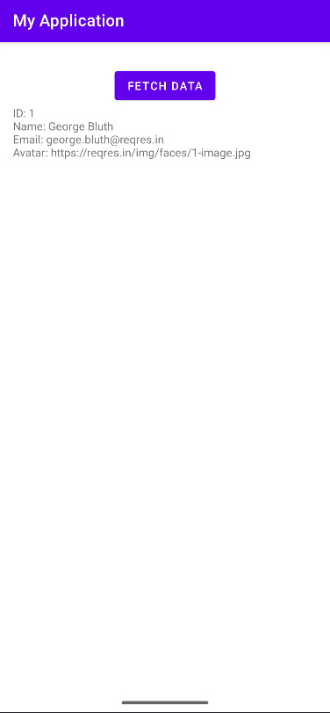

1. **Create an Android application to demonstrate JSON data parsing using Volley (you can use https://api.github.com/users JSON data).**

## activity_main.xml

<?xml version="1.0" encoding="utf-8"?>

<LinearLayout xmlns:android[="http://schemas.android.com/apk/res/android](http://schemas.android.com/apk/res/android)" android:orientation="vertical"

android:padding="16dp" android:layout_width="match_parent" android:layout_height="match_parent">

<ListView android:id="@+id/listView"

android:layout_width="match_parent" android:layout_height="match_parent" android:textStyle="bold"

android:layout_marginTop="90dp"/>

</LinearLayout>

## MainActivity.java

package com.example.myapplication; import android.os.Bundle;

import android.widget.ArrayAdapter;

import android.widget.ListView; import android.widget.Toast;

import androidx.appcompat.app.AppCompatActivity; import com.android.volley.Request;

import com.android.volley.RequestQueue;

import com.android.volley.toolbox.JsonArrayRequest; import com.android.volley.toolbox.Volley;

import org.json.JSONArray; import org.json.JSONException; import org.json.JSONObject;

import java.util.ArrayList;

public class MainActivity extends AppCompatActivity {

private ListView listView;

private ArrayList<String> usernames; private ArrayAdapter<String> adapter;

private static final String URL = "https://api.github.com/users"; @Override

protected void onCreate(Bundle savedInstanceState) {

super.onCreate(savedInstanceState); setContentView(R.layout.activity_main);

listView = findViewById(R.id.listView); usernames = new ArrayList<>();

adapter = new ArrayAdapter<>(this, android.R.layout.simple_list_item_1, usernames); listView.setAdapter(adapter);

fetchGitHubUsers();

}

private void fetchGitHubUsers() {

RequestQueue queue = Volley.newRequestQueue(this);

JsonArrayRequest jsonArrayRequest = new JsonArrayRequest(Request.Method.GET, URL, null, response -> {

try {

for (int i = 0; i < response.length(); i++) {

JSONObject userObject = response.getJSONObject(i); String login = userObject.getString("login"); usernames.add(login);

}

adapter.notifyDataSetChanged();

} catch (JSONException e) {

Toast.makeText(this, "Parsing error!", Toast.LENGTH_SHORT).show();

}

},

error -> Toast.makeText(this, "Volley error!", Toast.LENGTH_SHORT).show()

);

queue.add(jsonArrayRequest);

}

}

**Output :**

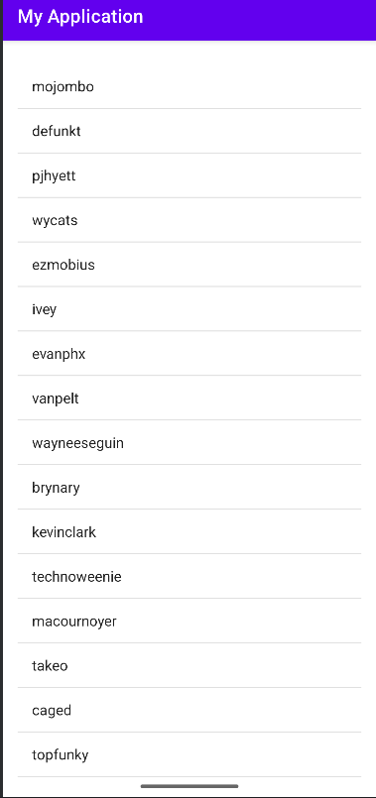

1. **Create an Android application to demonstrate JSON data parsing using Retrofit (you can use https://api.github.com/users JSON data).**

## activity_main.xml

<?xml version="1.0" encoding="utf-8"?>

<LinearLayout xmlns:android=["http://schemas.android.com/apk/res/android"](http://schemas.android.com/apk/res/android) android:orientation="vertical"

android:layout_width="match_parent" android:layout_height="match_parent" android:padding="16dp">

<TextView android:layout_width="wrap_content" android:layout_height="wrap_content" android:text="Using Retrofit" android:layout_gravity="center_horizontal" android:textSize="16sp" android:layout_marginTop="90dp"

android:textColor="@color/black"

/>

<ListView android:id="@+id/listView"

android:layout_width="match_parent" android:layout_height="match_parent" android:layout_marginTop="30dp"/>

</LinearLayout>

## MainActivity.java

package com.example.myapplication;

import android.os.Bundle;

import android.widget.ArrayAdapter; import android.widget.ListView; import android.widget.Toast;

import androidx.appcompat.app.AppCompatActivity; import java.util.List;

import java.util.ArrayList;

import retrofit2.Retrofit;

import retrofit2.converter.gson.GsonConverterFactory; import retrofit2.Call;

import retrofit2.Callback; import retrofit2.Response;

import retrofit2.http.GET;

public class MainActivity extends AppCompatActivity { private ListView listView;

private ArrayAdapter<String> adapter;

private ArrayList<String> usernames = new ArrayList<>();

// --- Step 1: Model class --- public class GitHubUser {

private String login;

public String getLogin() { return login;

}

}

// --- Step 2: API interface --- public interface GitHubApi {

@GET("users") Call<List<GitHubUser>> getUsers();

}

// --- Step 3: onCreate --- @Override

protected void onCreate(Bundle savedInstanceState) { super.onCreate(savedInstanceState); setContentView(R.layout.activity_main);

listView = findViewById(R.id.listView);

adapter = new ArrayAdapter<>(this, android.R.layout.simple_list_item_1, usernames); listView.setAdapter(adapter);

fetchGitHubUsers();

}

// --- Step 4: Retrofit Call --- private void fetchGitHubUsers() {

Retrofit retrofit = new Retrofit.Builder()

.baseUrl("https://api.github.com/") // NOTE: ends with /

.addConverterFactory(GsonConverterFactory.create())

.build();

GitHubApi api = retrofit.create(GitHubApi.class);

Call<List<GitHubUser>> call = api.getUsers(); call.enqueue(new Callback<List<GitHubUser>>() {

@Override

public void onResponse(Call<List<GitHubUser>> call, Response<List<GitHubUser>> response) {

if (!response.isSuccessful()) {

Toast.makeText(MainActivity.this, "Error: " + response.code(), Toast.LENGTH_SHORT).show();

return;

}

List<GitHubUser> users = response.body(); for (GitHubUser user : users) {

usernames.add(user.getLogin());

}

adapter.notifyDataSetChanged();

}

@Override

public void onFailure(Call<List<GitHubUser>> call, Throwable t) { Toast.makeText(MainActivity.this, "Failure: " + t.getMessage(),

Toast.LENGTH_SHORT).show();

}

});

}

}

**Output :**

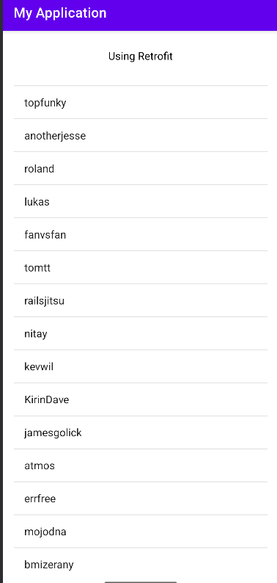

**Module 5 Introduction to Dart and Flutter:**

1. **Write a Flutter program to demonstrate Text widget and its properties.**

Code:

import 'package:flutter/material.dart';

void main() => runApp(const MyApp());

class MyApp extends StatelessWidget { const MyApp({super.key});

@override

Widget build(BuildContext context) { return MaterialApp(

home: Scaffold(

appBar: AppBar(title: const Text('Text Widget Demo')), body: const Center(

child: Text(

'Hello Flutter!\nThis is styled text.', textAlign: TextAlign.center, maxLines: 2,

overflow: TextOverflow.ellipsis, style: TextStyle(

color: Colors.blue, fontSize: 24,

fontWeight: FontWeight.bold, fontStyle: FontStyle.italic, letterSpacing: 2,

),

),

),

),

);

}

}

**Output:**

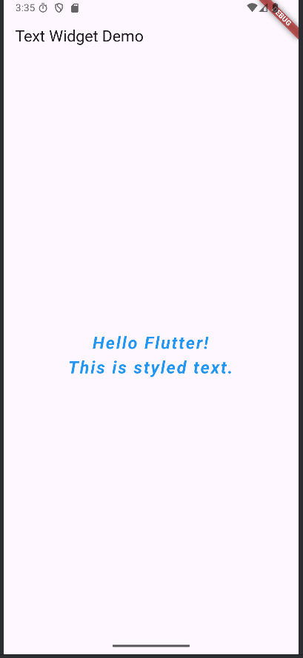

1. **Write a Flutter program to display dog names (demonstrate stateless widget and column widgets).**

Code:

import 'package:flutter/material.dart';

void main() { runApp(DogApp());

}

class DogApp extends StatelessWidget { @override

Widget build(BuildContext context) { return MaterialApp(

title: 'My Dog App',

home: Scaffold(backgroundColor: Colors.white, appBar: AppBar(backgroundColor: Colors.cyan, title: Text('Yellow lab'),

),

body: Center( child: Column(

mainAxisAlignment: MainAxisAlignment.center, children: [

DogName('Dobberman'), SizedBox(height: 12.0), DogName('Lybrador'), SizedBox(height: 10.0), DogName('Rotwiller'),

],

),

),

),

);

}

}

class DogName extends StatelessWidget { final String name;

const DogName(this.name); @override

Widget build(BuildContext context) {

return DecoratedBox(decoration: BoxDecoration(color: Colors.lightBlueAccent), child: Padding(

padding: const EdgeInsets.all(10.0), child: Text(name),

),

);

}

}

**Output:**

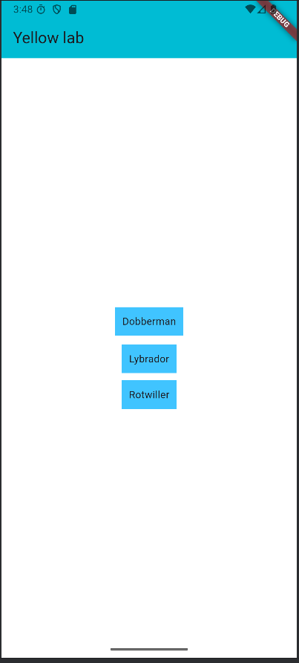

1. **Write a Flutter program that allows the user to enter a city in a text field and displays city name (demonstrate stateful widget).**

Code:

import 'package:flutter/material.dart';

void main() { runApp(FavouriteCity());

/*runApp( MaterialApp(

title: 'Stateful Application Example', home: FavouriteCity(),

)

);

*/

}

class FavouriteCity extends StatefulWidget { @override

State<StatefulWidget> createState() { return _FavoriteCityState();

}

}

class _FavoriteCityState extends State<FavouriteCity> { String nameCity="";

@override

Widget build(BuildContext context) { debugPrint('Favorite city widget is created.'); return MaterialApp(

title: 'Stateful Application Example', home:

Scaffold(

appBar: AppBar(

title: Text('Stateful Application Example'),

),

body: Container(

margin: EdgeInsets.all(20.0), child: Column(

children: <Widget>[ TextField(onSubmitted: (String userInput){ setState(() {

debugPrint('setState is called. This tells framework to redraw the favorite city widget. ');

nameCity=userInput;

});

},),

Padding(padding: EdgeInsets.all(30.0), child: Text(

'Your best city is $nameCity',style: TextStyle(fontSize: 20.0),

)

)

],

),

),

)

);

}

}

**Output:**

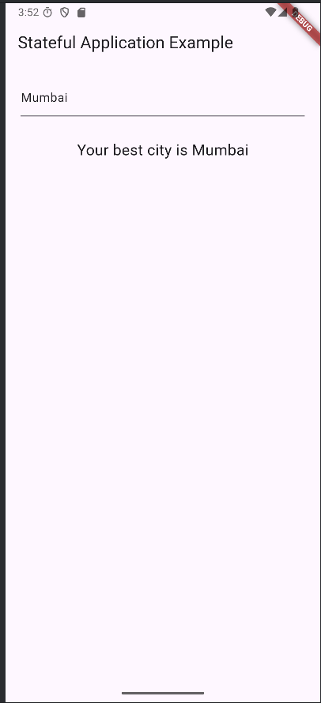

1. **Write a Flutter program to change the background color (demonstrate stateful widget).**

Code:

import 'package:flutter/material.dart';

void main() => runApp(MyApp()); class MyApp extends StatefulWidget { @override

_MyState createState() => _MyState();

}

class _MyState extends State<MyApp> { Color _containerColor = Colors.yellow; void changeColor() {

setState(() {

if (_containerColor == Colors.yellow) {

_containerColor = Colors.red; return;

}

_containerColor = Colors.yellow;

});

}

@override

Widget build(BuildContext context) { return MaterialApp(

title: 'Flutter Demo', theme: ThemeData(

primarySwatch: Colors.purple,

),

home: Scaffold(

appBar: AppBar(title: Text("A Simple App Stateful Widget")), body: Container

(

decoration: BoxDecoration(color: _containerColor)

),

floatingActionButton: FloatingActionButton( onPressed: changeColor,

child: Icon(Icons.add), tooltip: "Book Here",

),

));

}

}

**Output:**

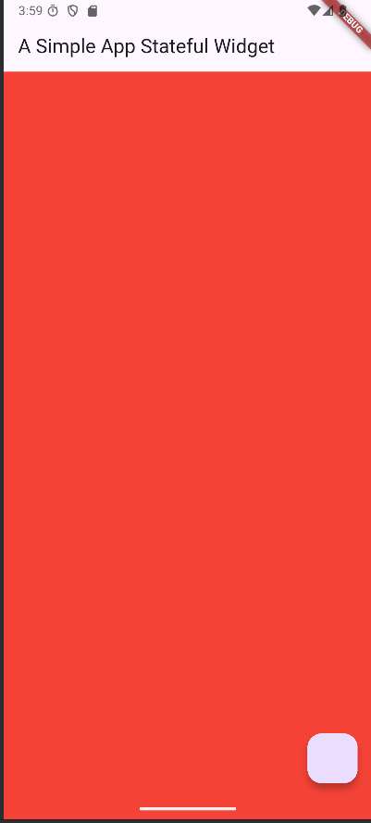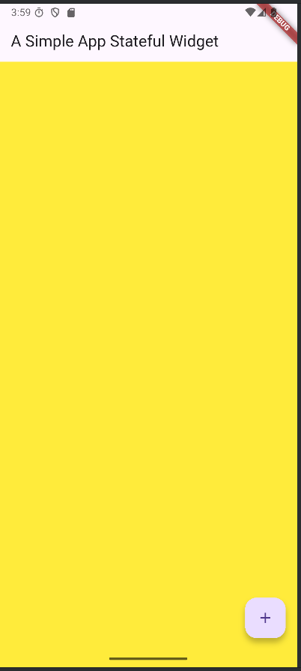

1. **Write a Flutter Program to display fruit list using ListView.**

Code:

import 'package:flutter/material.dart'; void main() {

runApp(const MyApp());

}

class MyApp extends StatelessWidget { const MyApp({super.key}); @override

Widget build(BuildContext context) { return MaterialApp(

title: 'Flutter List Example',

theme: ThemeData(primarySwatch: Colors.blueGrey), home: const MyHomePage(),

);

}

}

class MyHomePage extends StatelessWidget { const MyHomePage({super.key});

// A simple List of strings

final List<String> fruits = const [ 'Apple',

'Dragonfruit', 'Pineapple', 'Mango',

'Orange',

'Grapes',

];

@override

Widget build(BuildContext context) { return Scaffold(

appBar: AppBar(

title: const Text("Fruits List"), backgroundColor: Colors.blueGrey,

),

body: ListView.builder(

itemCount: fruits.length, // total items itemBuilder: (context, index) { return ListTile(

leading: const Icon(Icons.food_bank), title: Text(fruits[index]), // show list item onTap: () {

// show selected item in snackbar ScaffoldMessenger.of(context).showSnackBar( SnackBar(content: Text("You tapped on ${fruits[index]}")),

);

},

);

},

),

);

}

}

**Output:**

:

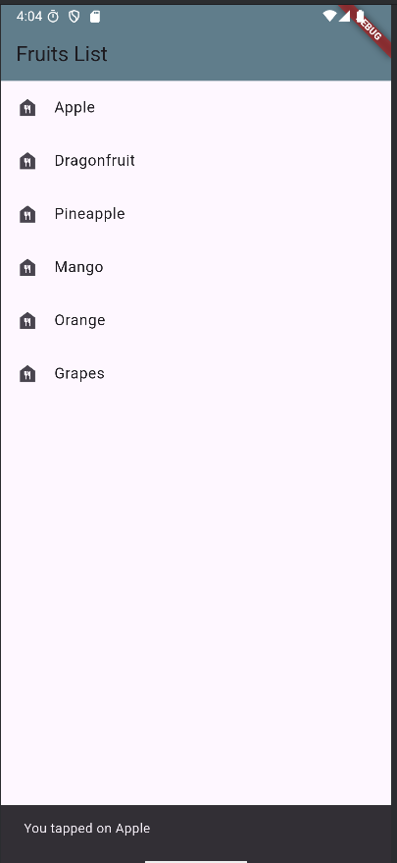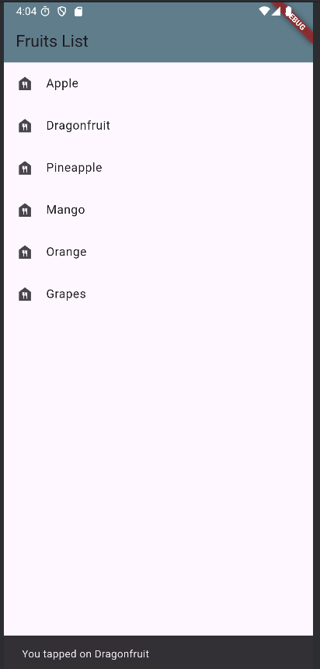

1. **Write a Flutter program to demonstrate navigation (user should be navigated from first screen to second screen).**

Code:

import 'package:flutter/material.dart';

void main() { runApp(MaterialApp( title: 'Flutter Navigation', theme: ThemeData(

// This is the theme of your application. primarySwatch: Colors.green,

),

home: FirstRoute(),

));

}

class FirstRoute extends StatelessWidget { @override

Widget build(BuildContext context) { return Scaffold(

appBar: AppBar(

title: Text('First Screen'),

),

body: Center(

child: ElevatedButton( child: Text('Click Here'), onPressed: () {

Navigator.push( context,

MaterialPageRoute(builder: (context) => SecondRoute()),

);

},

),

),

);

}

}

class SecondRoute extends StatelessWidget { @override

Widget build(BuildContext context) { return Scaffold(

appBar: AppBar(

title: Text("Second Screen"),

),

body: Center(

child: ElevatedButton(

onPressed: () { Navigator.pop(context);

},

child: Text('Go back'),

),

),

);

}

}

**Output:**

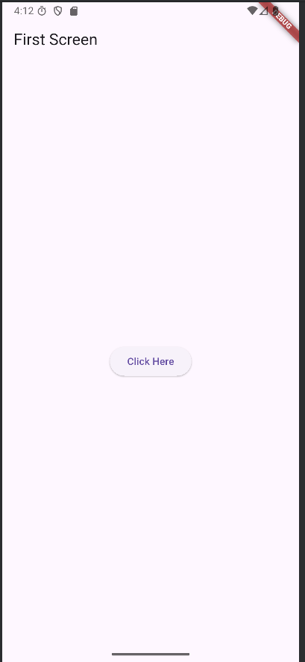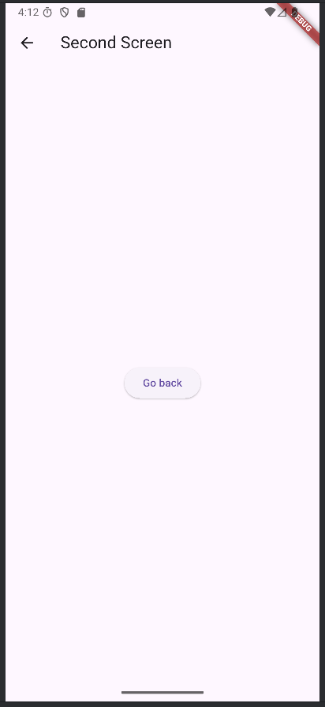

1. **Write a Flutter program to design a Login form using TextField, Check Box, Buttons, Drop down, Switch etc.**

Code:

login_screen.dart

import 'package:flutter/material.dart';

import 'package:login_flutter/home_screen.dart';

class LoginPage extends StatefulWidget { @override

State<LoginPage> createState() => _LoginPageState();

}

class _LoginPageState extends State<LoginPage> { bool _rememberMe = false;

bool _enableNotifications = false; String? _selectedUserType;

final List<String> _userTypes = ['Admin', 'Student', 'Teacher']; @override

Widget build(BuildContext context) { return SafeArea(

child: Scaffold( body: Container(

margin: EdgeInsets.all(24), child: Column(

mainAxisAlignment: MainAxisAlignment.spaceEvenly, children: [

_header(context),

_inputField(context),

_extraOptions(context),

_forgotPassword(context),

_signup(context),

],

),

),

),

);

}

_header(context) { return Column( children: [

Text(

"Welcome Back",

style: TextStyle(fontSize: 40, fontWeight: FontWeight.bold),

),

Text("Enter your credential to login"),

],

);

}

_inputField(context) { return Column(

crossAxisAlignment: CrossAxisAlignment.stretch, children: [

TextField(

decoration: InputDecoration( hintText: "Username", border: OutlineInputBorder(

borderRadius: BorderRadius.circular(18), borderSide: BorderSide.none),

fillColor: Theme.of(context).primaryColor.withOpacity(0.1), filled: true,

prefixIcon: Icon(Icons.person)),

),

SizedBox(height: 10), TextField(

decoration: InputDecoration( hintText: "Password", border: OutlineInputBorder(

borderRadius: BorderRadius.circular(18), borderSide: BorderSide.none),

fillColor: Theme.of(context).primaryColor.withOpacity(0.1), filled: true,

prefixIcon: Icon(Icons.person),

),

obscureText: true,

),

SizedBox(height: 10), DropdownButtonFormField<String>( value: _selectedUserType,

items: _userTypes

.map((type) => DropdownMenuItem( value: type,

child: Text(type),

))

.toList(),

decoration: InputDecoration( hintText: "Select User Type", border: OutlineInputBorder(

borderRadius: BorderRadius.circular(18), borderSide: BorderSide.none),

filled: true,

fillColor: Theme.of(context).primaryColor.withOpacity(0.1),

),

onChanged: (value) { setState(() {

_selectedUserType = value;

});

},

),

SizedBox(height: 10), ElevatedButton( onPressed: () {

Navigator.push( context,

MaterialPageRoute(builder: (context) => HomePage()),

);

},

child: Text( "Login",

style: TextStyle(fontSize: 20),

),

style: ElevatedButton.styleFrom( shape: StadiumBorder(),

padding: EdgeInsets.symmetric(vertical: 16),

),

),

],

);

}

Widget _extraOptions(context) { return Column(

children: [ Row( children: [

Checkbox(

value: _rememberMe, onChanged: (value) { setState(() {

_rememberMe = value!;

});

},

),

Text("Remember Me"),

],

),

Row(

mainAxisAlignment: MainAxisAlignment.spaceBetween, children: [

Text("Enable Notifications"), Switch(

value: _enableNotifications, onChanged: (value) { setState(() {

_enableNotifications = value;

});

},

),

],

),

],

);

}

_forgotPassword(context) {

return TextButton(onPressed: () {}, child: Text("Forgot password?"));

}

_signup(context) { return Row(

mainAxisAlignment: MainAxisAlignment.center, children: [

Text("Dont have an account? "), TextButton(onPressed: () {}, child: Text("Sign Up"))

],

);

}

}

main.dart

import 'package:flutter/material.dart'; import 'package:login/login_screen.dart';

void main() => runApp(MyApp()); class MyApp extends StatelessWidget {

// This widget is the root of your application.

@override

Widget build(BuildContext context) { return MaterialApp(

title: 'Flutter Login UI', debugShowCheckedModeBanner: false, home: LoginPage(),

);

}

}

home_screen.dart

import 'package:flutter/material.dart';

class HomePage extends StatelessWidget { @override

Widget build(BuildContext context) { return (Scaffold(

body: Center(child:Text('Welcome user') ,)

)

);

}

}

**Output:**

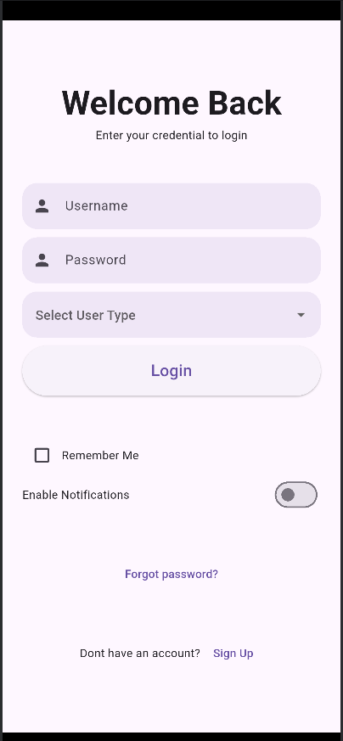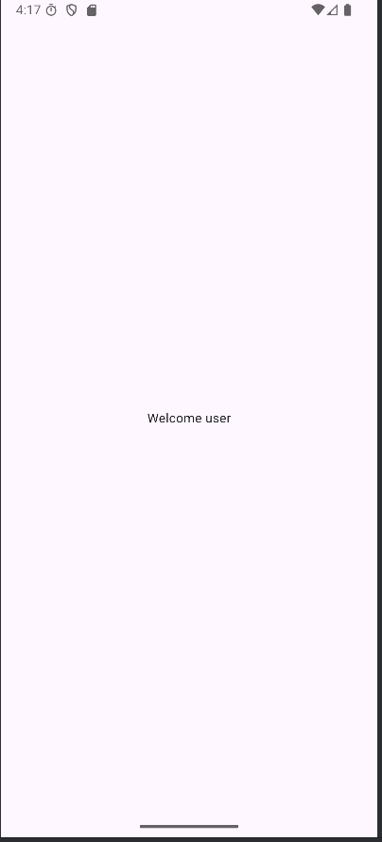

**Module 6 Data Handling in Flutter:**

1. **Write a Flutter program based on RestAPI to fetch data.**

Step 1:

Add dependency in pubsec.yaml https:

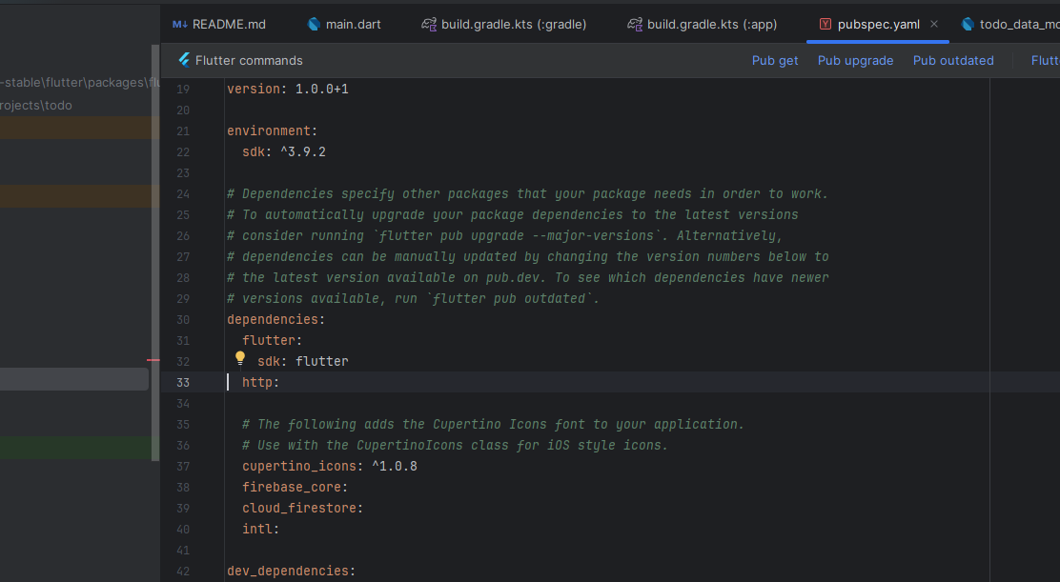

Step 2:

Code in main.dart file import 'dart:async'; import 'dart:convert';

import 'package:flutter/material.dart'; import 'package:http/http.dart' as http;

void main() {

runApp(const MaterialApp( home: HomePage()

));

}

class HomePage extends StatefulWidget {

const HomePage({Key? key}) : super(key: key);

@override

HomePageState createState() => HomePageState();

}

class HomePageState extends State<HomePage> { late final List data;

Future<String> getData() async { var response = await http.get(

Uri.parse("https://jsonplaceholder.typicode.com/posts"), headers: {

"Accept": "application/json"

}

);

setState(() {

data = json.decode(response.body);

});

// ignore: avoid_print

// print(data[1]["title"]); return "Success!";

}

@override

// ignore: must_call_super void initState(){ getData();

}

@override

Widget build(BuildContext context){

return Scaffold(

appBar: AppBar(title: const Text("Listview"), backgroundColor: Colors.blue), body: ListView.builder(

// ignore: unnecessary_null_comparison itemCount: data.length,

itemBuilder: (BuildContext context, int index){ return Card(

child: Text(data[index]["title"]),

);

},

),

);

}

}

**Output:**

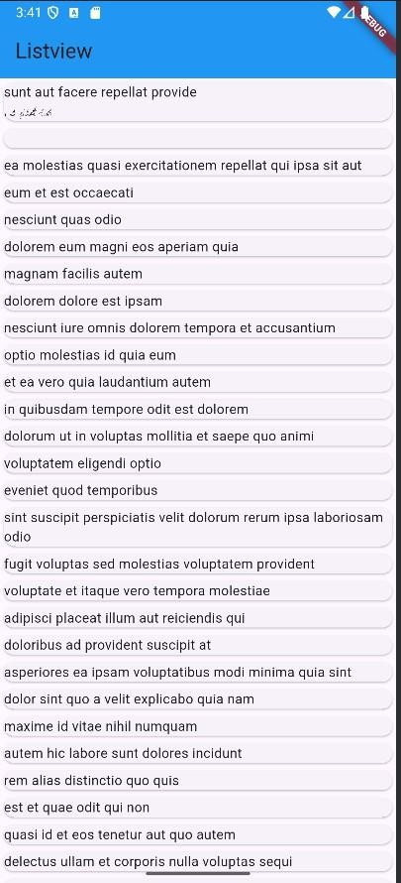

1. **Write a flutter program to demonstrate JSON serialization and Deserialization.**

Step 1. Make usermodel.dart in lib file Add code

class UserModel

{

late String id;

late String fullname; late String email;

// Map to Object

UserModel ({required this.id, required this.fullname, required this.email}); UserModel.fromMap(Map<String , dynamic> map){

this.id = map["id"];

this.fullname = map["fullname"]; this.email = map["email"];

}

// Object to Map

Map <String , dynamic> toMap()

{

return{

"id": this.id,

"fullname": this.fullname, "email": this.email,

};

}

}

Step 2. Main.dartimport 'dart:convert'; import 'package:flutter/material.dart'; import 'package:jasonapp/usermodel.dart';

void main() { runApp(const MyApp());

}

class MyApp extends StatelessWidget {

const MyApp({Key? key}) : super(key: key); @override

Widget build(BuildContext context) { return MaterialApp(

title: 'Flutter Demo', theme: ThemeData(

primarySwatch: Colors.blue,

),

home: HomePage(),

);

}

}

class HomePage extends StatefulWidget { @override

_HomePageState createState() => _HomePageState();

}

class _HomePageState extends State<HomePage> {

UserModel userObject = new UserModel(id: "1", fullname: "ABC", email: ["abc@gmail.com");](mailto:abc@gmail.com)

String userJSON = '{"id": "1", "fullname": "ABC", "email": "[abc@gmail.com"}';](mailto:abc@gmail.com)

@override

Widget build(BuildContext context) { return Scaffold(

body: Center( child: Row(

mainAxisAlignment: MainAxisAlignment.center, children: <Widget>[

ElevatedButton( onPressed: (){

//Serialization

Map<String, dynamic> userMap = userObject.toMap(); var json = jsonEncode(userMap);

print(json.toString());

},

child: Text("Serialize"),

),

SizedBox(width: 20,), ElevatedButton(

onPressed: (){

var decode = jsonDecode(userJSON); Map<String, dynamic> userMap = decode;

UserModel newuser = new UserModel.fromMap(userMap); print(newuser.fullname.toString());

},

child: Text("Deserialize")

),

],

),

),

);

}

}

**Output:**

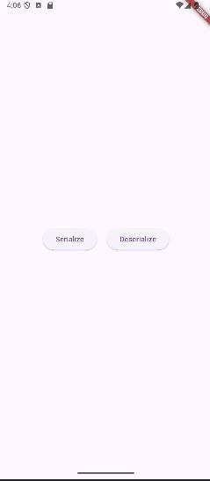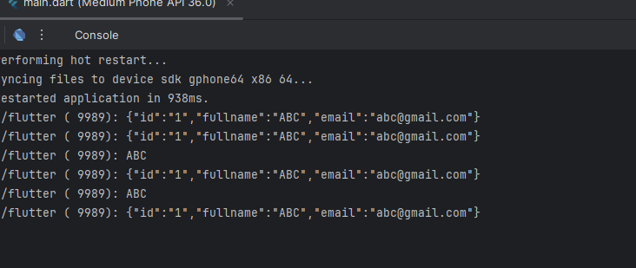

1. **Write a flutter program to perform CRUD operations using sqflite.**

Step 1: Add Dependencies in pubspec.yaml dependencies:

flutter:

sdk: flutter sqflite: ^2.3.3

path_provider: ^2.1.3

Step2: Create a Model Class — user_model.dart class User {

int? id; String name; String email;

User({this.id, required this.name, required this.email});

// Convert a User into a Map. Map<String, dynamic> toMap() { var map = <String, dynamic>{

'name': name, 'email': email,

};

if (id != null) map['id'] = id; return map;

}

// Convert a Map into a User User.fromMap(Map<String, dynamic> map)

: id = map['id'],

name = map['name'], email = map['email'];

}

Step 3: Create the Database Helper — db_helper.dart import 'package:sqflite/sqflite.dart';

import 'package:path/path.dart'; import 'user_model.dart';

class DBHelper {

static final DBHelper _instance = DBHelper._internal(); factory DBHelper() => _instance; DBHelper._internal();

static Database? _db; Future<Database> get db async {

_db ??= await initDB();

return _db!;

}

Future<Database> initDB() async {

String path = join(await getDatabasesPath(), 'users.db');

return await openDatabase(path, version: 1, onCreate: _onCreate);

}

Future _onCreate(Database db, int version) async { await db.execute('''

CREATE TABLE users (

id INTEGER PRIMARY KEY AUTOINCREMENT,

name TEXT, email TEXT

) ''');

}

// Insert a new user

Future<int> insertUser(User user) async { var dbClient = await db;

return await dbClient.insert('users', user.toMap());

}

// Get all users

Future<List<User>> getUsers() async { var dbClient = await db;

List<Map<String, dynamic>> maps = await dbClient.query('users'); return maps.map((user) => User.fromMap(user)).toList();

}

// Update user

Future<int> updateUser(User user) async { var dbClient = await db;

return await dbClient.update('users', user.toMap(), where: 'id = ?', whereArgs: [user.id]);

}

// Delete user

Future<int> deleteUser(int id) async { var dbClient = await db;

return await dbClient.delete('users', where: 'id = ?', whereArgs: [id]);

}

}

Step 4: Create the UI — main.dart import 'package:flutter/material.dart'; import 'db_helper.dart';

import 'user_model.dart';

void main() {

runApp(MaterialApp( debugShowCheckedModeBanner: false, home: HomeScreen(),

));

}

class HomeScreen extends StatefulWidget { @override

State<HomeScreen> createState() => _HomeScreenState();

}

class _HomeScreenState extends State<HomeScreen> { final DBHelper dbHelper = DBHelper();

final TextEditingController nameController = TextEditingController(); final TextEditingController emailController = TextEditingController();

List<User> userList = []; @override

void initState() { super.initState(); refreshUserList();

}

void refreshUserList() async {

final data = await dbHelper.getUsers(); setState(() => userList = data);

}

void insertUser() async {

if (nameController.text.isNotEmpty && emailController.text.isNotEmpty) { await dbHelper.insertUser(

User(name: nameController.text, email: emailController.text)); nameController.clear();

emailController.clear(); refreshUserList();

}

}

void updateUser(User user) async { user.name = nameController.text; user.email = emailController.text; await dbHelper.updateUser(user); nameController.clear(); emailController.clear(); refreshUserList();

}

void deleteUser(int id) async { await dbHelper.deleteUser(id); refreshUserList();

}

void showUserDialog({User? user}) { if (user != null) { nameController.text = user.name; emailController.text = user.email;

}

showDialog( context: context,

builder: (_) => AlertDialog(

title: Text(user == null ? 'Add User' : 'Edit User'), content: Column(

mainAxisSize: MainAxisSize.min, children: [

TextField(

controller: nameController,

decoration: InputDecoration(labelText: 'Name'),

),

TextField(

controller: emailController,

decoration: InputDecoration(labelText: 'Email'),

),

],

),

actions: [ TextButton(

child: Text('Cancel'),

onPressed: () => Navigator.pop(context),

),

TextButton(

child: Text(user == null ? 'Add' : 'Update'), onPressed: () {

if (user == null) { insertUser();

} else { updateUser(user);

}

Navigator.pop(context);

},

),

],

),

);

}

@override

Widget build(BuildContext context) { return Scaffold(

appBar: AppBar(

title: Text('Flutter CRUD using SQFlite'),

centerTitle: true,

),

body: ListView.builder( itemCount: userList.length, itemBuilder: (context, index) { final user = userList[index]; return ListTile(

title: Text(user.name), subtitle: Text(user.email), trailing: Row(

mainAxisSize: MainAxisSize.min, children: [

IconButton(

icon: Icon(Icons.edit, color: Colors.blue), onPressed: () => showUserDialog(user: user)),

IconButton(

icon: Icon(Icons.delete, color: Colors.red), onPressed: () => deleteUser(user.id!)),

],

),

);

},

),

floatingActionButton: FloatingActionButton( onPressed: () => showUserDialog(),

child: Icon(Icons.add),

),

);

}

}

**Output:**

